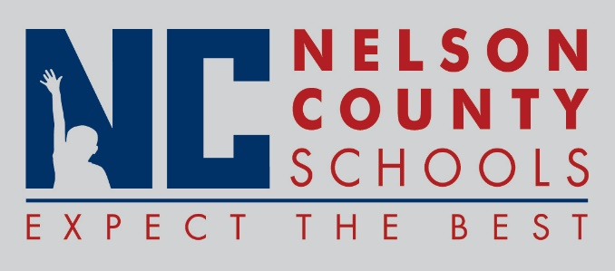

Decision Paper
To: | Nelson County Board of Education
From: | Tom Dekle
cc: | Dr. Anthony Orr, Superintendent
Date: | August 18, 2015
Re: | United Way Grant Applications
The four Nelson County FRYSC units each wish to apply individually for grant funding through Tri-County United Way. Team Up! FRYSC, representing Cox’s Creek, Foster Heights and Old Kentucky Home; Fusion YSC, representing NCHS, Thomas Nelson and Horizons Academy; The NESTT FRYSC representing both Bloomfield schools; and The Village FRYSC, representing Boston, New Haven and the Early Learning Center, wish to apply for funding totaling $7,500 together, in support of specific initiatives for each FRYSC center. Grant funding like this helps each center to provide services programs that go beyond the funding capacity typically expected through regular channels. Services vary depending upon the needs of specific age groups served by each center, and range from mentoring services for older students to promoting early learning and successful transition to school for our younger students. Funds are not used for administrative purposes, but rather are used for activities and programs to promote academic achievement, student well-bing and successful transition into adult life. Uses align well with the mission and vision of United Way, which has typically been very supportive of FRYSC requests for assistance. Matching funds are not required for these requests.
RECOMMENDATION: Approve request for Team Up! FRYSC, The NESTT FRYSC, The Village FRYSC, and Fusion YSC to apply for grant funding through United Way of Nelson County.
RECOMMENDED MOTION: I move that the Nelson County Board of Education approve the grant applications as described.

