Preschool Monthly Report

10.30.23
Current Preschool Numbers
2- 97 (transitioned from First Steps)... 1 in the process
19-98 (3 year olds) +2 from last month
42-99 (4 year olds) +2 from last month
Total enrollment: 63
Still in the works…
2 Students that will potentially transfer in from First Steps (Nov, Feb)
-1 transitioning now
Keep scrolling to see why we are the “ONE” AND ONLY… “LITTLE PANTHER ACADEMY”!!!

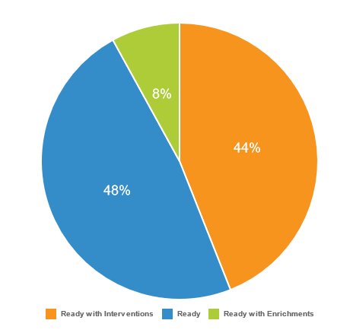
23-24 BRIGANCE Results

OVERALL
- 50 students assessed
  - Ready/ Reading w/ Enrichments 56%
  - Ready w/ Interventions 44%
- LPA Student Results
  - 37 students enrolled this year here… 3 transferred to another district
    - 25/40 = 62.5% Ready/ Ready w/ Enrichments
    - 15/37 = 37.5% Ready w/ Interventions

