Monthly Report

september 2020

This document outlines the activities taken place during the month on the report, including any operational activities, financial activities, and copies of receipts of all expenditures.

Confucius Institute of Western Kentucky / BG Education Management Solutions Inc.

2501 Crossings Blvd., Suite 301E

**Tel** 270-792-9330

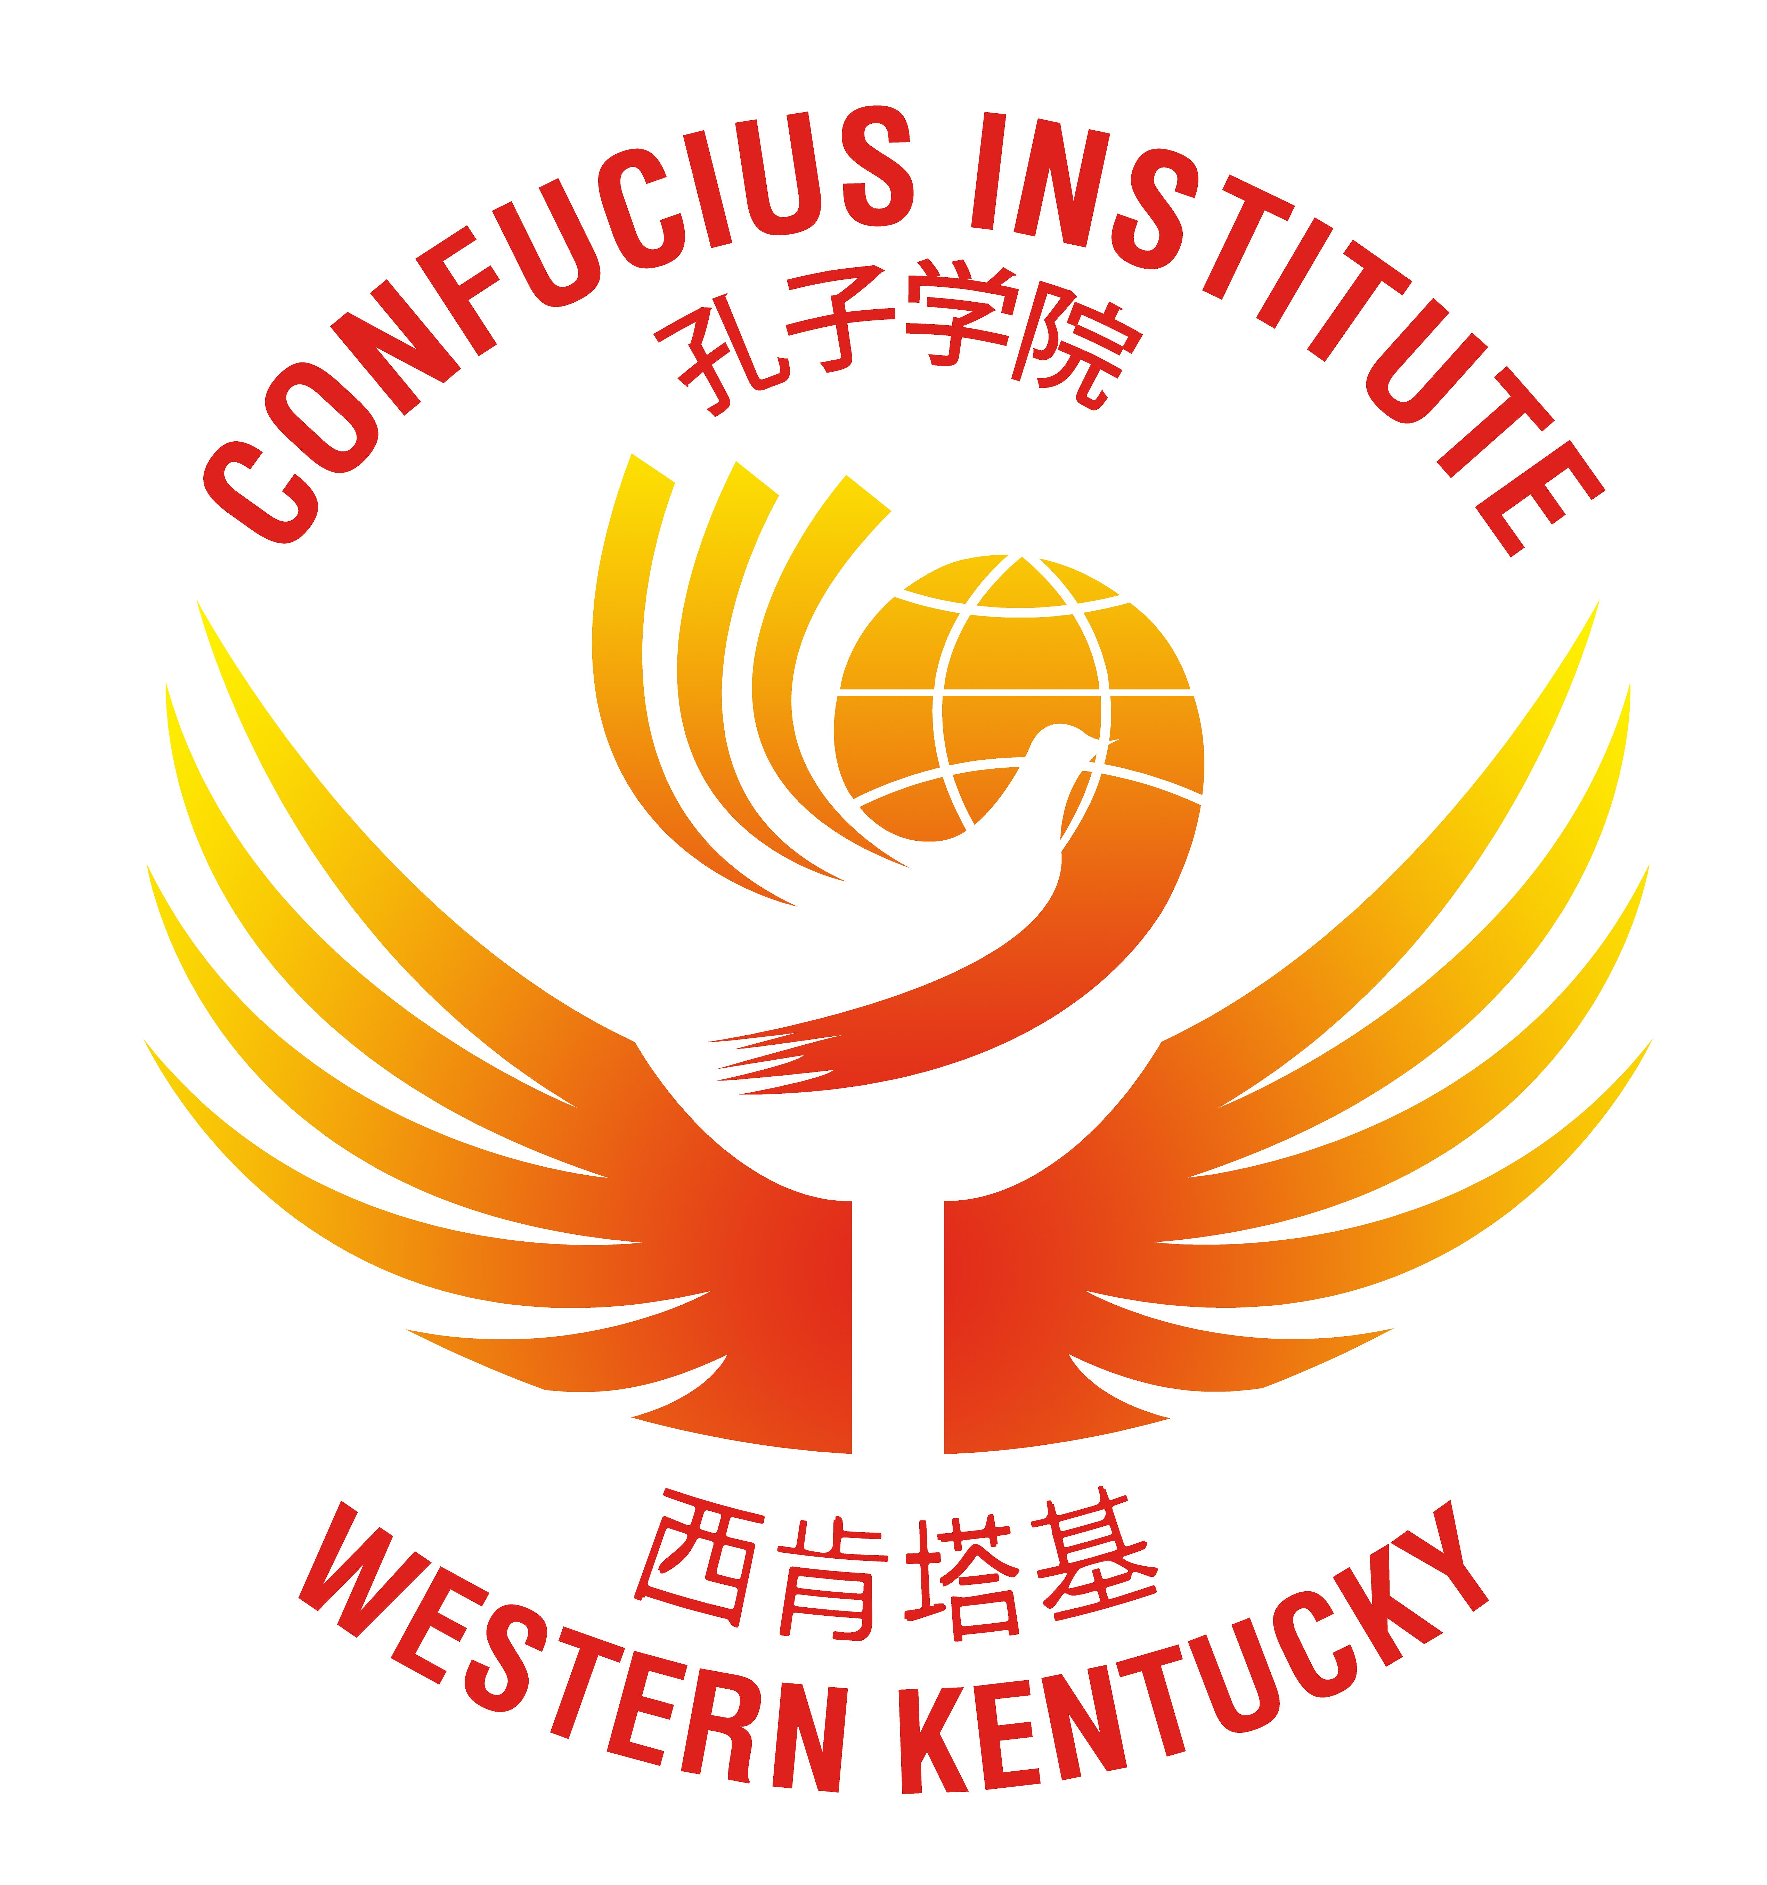

Contents

[To Simpson County Schools 1](#_Toc53153033)

[Financial Summary 2](#_Toc53153034)

[Operational Summary 4](#_Toc53153035)

[Projects in Process 5](#_Toc53153036)

[Contact Information 6](#_Toc53153037)

[Company Information 6](#_Toc53153038)

# To Simpson County Schools

## Strategic Highlights

Since last month’s report, another Chinese teacher has departed for home (Meng Xiuli). This leaves the CIWKY with 25 Chinese teachers, teaching in 26 schools, reaching over 14,000 students. At present the only districts resuming in-face classes are Warren, Barren, and Butler counties. I have made visits to all the teachers in these areas (aside from Butler County as they have been doing MAP Testing). I have also contacted all their principals, and these teachers are doing a very good job. We will continue to reach out to the principals and teachers after the fall break.

## Financial Highlights

As of September 1st the balance in the BG Education Management Solution, Inc. account was $55,250.53. During the month of September 2020, a total of $45,000 was deposited, and a total of $49,977.66 was spent, with the largest expenses coming from my independent contractors, rent and Swivl (observation tool). Billing has been done as of September 9, 2020 in the amount of $150,500.00 in revenues.

## Operating Highlights

The CI of WKY is increasing its footprint of Chinese language for next year. The institute has reached out to several private schools, independent school districts, and some of the districts the institute has lost. Presently, the remainder of the districts/schools have not either started or are providing instruction in an online platform.

## Looking Ahead

All the Fall 2020 scheduled activities have been cancelled through summer 2021.

Please read through the documents and advise of any questions or concerns.

Terrill D. Martin  
Director (Confucius Institute of Western Kentucky)

President & CEO (BG Education Management Solutions Inc.)

# Financial Summary

As of September 1, 2020, the balance was $55,250.53 with a total of $49,977.66 was spent during the month of September 2020 leaving a balance of $50,272.87 as of, September 30, 2020. Due to the uncertainty of receiving additional funds, a frugal approach was taken. Some of the following measures were taken:

* **Chinese International Education Foundation (CIEF) Budget**– The CI of WKY received a total of $508,462.00 was received on 07/20/2020.
* **Billings for Confucius Institute Teachers 2020/2021**– Billings have been submitted to the school districts, and upon receipt, the total revenue will be $150,500.00.

Please see below for a snapshot of expenses and projected revenue for October 2020. In addition, the balance sheet, and receipts of all expenditures (including receipts) are included with this report. The balance on the ledger as of September 30, 2020 is $50,272.87. The funds are not enough to cover the operations; thus, an ACH transfer is requested in the amount of **$0.**



# Operational Summary

**Schools in Kentucky Begin**

Presently, of the school districts in which the CI of WKY are partnered, only 3 have begun face-to-face classes, which are Warren County and Barren County (started 8/24/2020). Butler County Schools began on Monday, September 14, 2020. The remainder of the districts/schools have not either started or are providing instruction in an online platform.

All five new teachers at our institute who have been transferred from other CI’s have all received their certification as of September 8, 2020. Billing has been done as of September 9, 2020 in the amount of $150,500.00 in revenues.

**Chinese International Education Foundation**

Hanban/CIH has changed its name to the Chinese International Education Foundation, which is a non-government owned center. This entity will consist of educational universities (with ties to CI’s abroad) and business leaders. There are two specific changes which the CI of WKY has been made aware of:

* The unit will consist of two different divisions:
  + Teacher Division – This group will continue to provide teachers for the institutes, but there are very strict budgeting guidelines, which means there will be a limit to the number of teachers which a CI can request. I am unsure of the policy at this very point.
  + Budget Division – This group will work with the Chinese University to provide budgets to external Confucius Institutes. This means that each year, the CI will submit their budget to their Chinese university partner, and the Chinese university will approve or deny budgets. The funds will be transferred from our Chinese University.

**North China Electric Power University**

With the new organization CIEF, some of the responsibilities have landed with our Chinese partner university, North China Electric Power University. There was a conference call with Mr. Zhao Zijian who is the new coordinator between our CI and CIEF. They are charged with recruiting and selecting Chinese teachers for our CI, and for personnel management of our CI teachers.

**Teacher Placements 2020/2021**

Before the outbreak, the approach was to ensure we saturated the current districts with teachers at all levels, before exploring to other districts. This approach has been re-evaluated to ensure that we have enough teachers in place to manage the current 2020/2021 teacher level before expanding at all. Please see Appendix A for a status of teachers based on the status for academic year 2020/2021.

# Projects in Process

To be determined.

# Contact Information

|  |  |  |  |  |  |
| --- | --- | --- | --- | --- | --- |
| Terrill D. Martin Director |  | ji Hui program coordinator | |  | Li Bo NCEPU Liaison |
|  |  | C:\Users\Guodong Li\AppData\Local\Microsoft\Windows\INetCache\Content.Word\Ji Hui_meitu_4.jpg | |  |  |
| **Tel** 270-792-9330  [terrill.martin@ciwky.org](mailto:terrill.martin@ciwky.org) | |  | **Tel** 270-945-0900  Ji.hui@ciwky.org |  | +86 13581709587  13581709587@163.com |

# Company Information

Confucius Institute of Western Kentucky / BG Education Management Solutions Inc.

**Tel** 270-792-9330



**Appendix A – Teacher Placement for 2020/2021 Academic Year**

