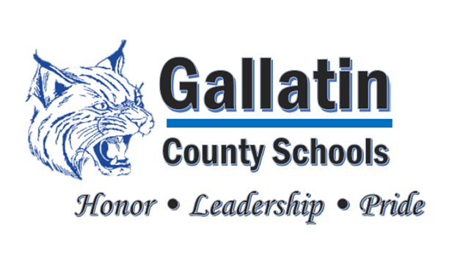

Gallatin County High School

70 Wildcat Circle, Warsaw, KY 41095

Phone 859-567-7640, Fax 859-567-8222

[www.gallatin.kyschools.us](http://www.gallatin.kyschools.us)

EXTREME Commitment to

College and Career Readiness!

*Jon Jones, Principal*

*Angela Lewis, Assistant Principal*

*Kaycee Thompson, Guidance Counselor*

March 23, 2021

We are asking for permission to accept donations for our senior activity account. We would be using these donations to help us pay for end of the year activities for our current senior class. We will be having Senior breakfast, Senior lunches, snacks, etc available for our seniors during that last week of school for them. We are hoping to have some fun activities for them as well. People/companies would be donating monetary donations as well as food donations.

*“Maximizing Student Learning and Achievement”*

Thank you,

Senior Class Sponsors

Rachel Riddle

Becky Watkins