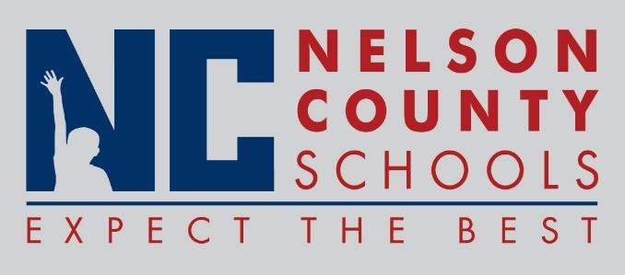

Information Paper
To: | Nelson County Board of Education
From: | Bob Morris Executive Director of Student Support
cc: | Tom Brown
Date: | Dec 7, 2017
Re: | Personnel Notifications

New Hires: Lianne Lewis IC BMS
Niki King Teacher BOS
Donna Bickett IAII NCELC
Brook O’Bryan Cook/Baker NH
Stacy Mattingly Nurse Sub Dis

Transfers:

Reinstatements: None

One Year Certification:

Classified Subs: Suzanne Cox, Alexis Fournier,
Certified Substitute: Kendra Rambo, Joellen Davis, Katie Wheatley, Elizabeth Roach, Katie Wheatley
Student Workers: None

Non-Renewals:

Resignation:

Retirements: Joyce Greenwell

Reprimands/Terminations:

