**Superintendent Report**

October 25, 2023

**Board Items**

* Board Focus: A spotlight on the mental health services in our district featuring Vanessa Kuhn, SPF Project Director; Ehmet will also be in attendance to discuss Grandview.
* Consent Items: Most are the typical, but a few additional include:
  + Requesting an additional instructional assistant for the Preschool due to a student’s Individual Education Plan (IEP). This position will be paid for from the Preschool Partnership Grant.
  + Approve Jenny Hazares to serve on the calendar committee.
  + Approve an MOU with Cultivate Behavioral Health to work with one of our students. This student is currently working with them, and this provides additional support at school. There is no charge for our district as they will bill Medicaid.
* Action Items
  + Approve the final pay application and close out of the wall furring project.
  + Approve the Schematic Design for Grandview Elementary
  + Approve the PILOT agreement.

**Ben Flora Bids**

The bids for Ben Flora came back higher than expected. I have a meeting with Joe Hayes on Monday to discuss further and also working with Kelsey on funding. I will have a recommendation for you before the meeting on Wednesday.

**KSA (Kentucky Summative Assessment) Scores**

We have received our assessment and accountability scores. We are able to share with staff on October 30 and the tentative public release is set for October 31 at 10 p.m. The plan is to provide you with specific details regarding our scores at the November work session or regular meeting.

**Veteran’s Day**

We will once again be hosting a districtwide Veteran’s Day program on Friday, November 10 at 9:00. Veterans will be able to join for breakfast at 8:15 in the lobby of Ben Flora. Students K-12 will gather at the gym where a program will take place to honor our veterans. Please join us if you are available.

**New fleet additions**

The district has purchased a used truck (2021 Ford F-150, single cab with 29,000 miles) for our maintenance department and a new 2024 Kia Carnival van for student transportation needs. ARP ESSER funds were used to purchase the van and the truck was purchased with general fund dollars. Below is a picture of the van, but I didn’t get one of the truck. The van has seating for 8.

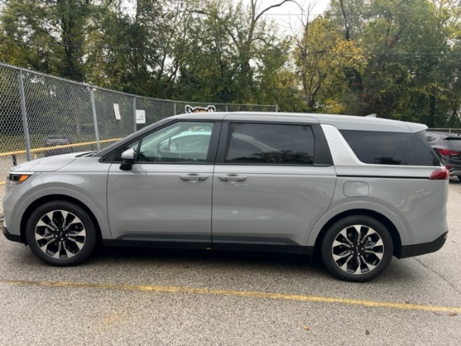

**Upcoming Meetings/Events**

* October 23-31: Red Ribbon Week
* October 25: NKCES Supt. Meeting; One NKY Summit
* October 26: BEF Meeting @6:00
* October 28: GES Fall Festival 12-4
* October 31: Happy Halloween
* November 1: NKYEC Fall Convening
* November 6-7: No School
* November 8: Work Session
* November 10: Veteran’s Day Program- Districtwide @9:00 AM

As always, please let me know if you have any questions or concerns.

Respectfully submitted,

Misty Middleton

Superintendent