**Grandview Elementary**

**Board Report**

**February 24, 2021**

**Good News at GES**

* Students have transitioned wonderfully to in-school instruction. We currently have 21 students continuing to successfully participate in Ms. Means’ virtual classroom.
* The Coffee/Smoothie bar was a hit! This small event does wonders for overall teacher wellness and positive school culture.
* A trial Interactive TV is being installed in Mrs. Ginn’s room. In the near future, all classrooms will receive Interactive TVs to replace the outdated Smart Boards.
* The 2nd COVID vaccine was available to staff on Sunday, February 14th. The vaccine is also available to SBDM members.
* Ms. Qualls and students painted the front windows with cheerful spring flowers.

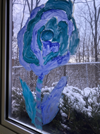

* The GESLeader Spotlight celebrated student artists and amazing staff.
* Spring preliminary data show great improvement in math progress from fall assessments.
* 100th Day celebrations were a success!

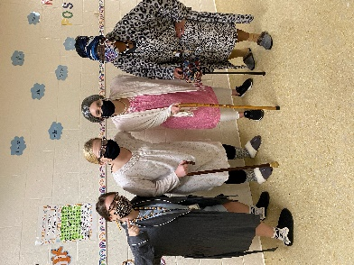

**Professional Development**

Scholastic Guided Reading-A 3-hour Guided Reading professional development will be scheduled for all homeroom and special education teachers in March.

**Assessment**

Intervention teachers are in the process of completing math and reading assessments for every student.

Preliminary math K-3 data looks promising!!

* **K-2nd grade math scores went from 55% Proficient to 83% Proficient!**
* **3rd grade math scores went from 31% Proficient to 76% Proficient!**

Student assessments will be sent home to parent on February 26th. This will include individual student comparative data; 2020 Fall assessments to 2021 Winter assessment.

Virtual parent-teacher conferences will be the week of March 1st- 5th.

***GESLeaders Philosophy***

*Our goal is to build intentional relationships, inspire passionate learners, provide personalized learning, identify leadership in self, staff and students and challenge our team to exceed expectations.*