**Grandview Elementary**

**SBDM Board Report**

**August 23, 2023**

**Social-Emotional and Behavior**

We are excited to begin our new SEB program called Character Strong, Purposeful People.  The teachers will be using it during their daily morning meetings to help build both positive relationships and classroom culture.  The program integrates character development with social emotional learning.  Our first two weeks we will be having a *Kindness Kickoff* and then in September we will focus on Respect as our first monthly character trait.

**Safe Schools**

Allison Craig and Brandon Forshey attended the Safe Schools Institute at NKU on August 3rd.  They were able to hear from the Kentucky Center for School Safety, including Jon Akers (Executive Director of KCSS), Dan Orman (Training Coordinator), and Fred Scroggins (Compliance Officer).  The Institute allowed GES to be more prepared in covering the implementation of threat assessments, handling emergency situations, and how to ensure that we are informed and implementing the steps of the School Safety and Resiliency Act.  The institute gave us a large amount of resources and contacts to make sure we are prepared for a safe and successful school year.

Grandview’s School Safety Team:

Heather Rabe

Brandon Forshey

Sara Teegarden

Allison Craig

Rob Sanders

Kim Swartz

**Academic**

GES Teachers have worked hard to get ready to welcome our K-5 Tigers!

* **JumpStart**: July 31-Aug 1st Incoming Kindergarten students participated in Jumpstart. Students were able to get a sneak peak of what it would be like on the first day of school. They found their classroom, met their teachers, and began learning daily routines and procedures.
* **Scholastic** -ELA: All teachers K-5 attended a 6-hour writing training provided by Scholastic to dive further into planning and assessment in the writing workshop.
* **Eureka- Math:** All teachers K-5 also attended a 6-hour math training provided by Eureka Math2. Eureka implementation will start the 1st day of school.
* **New to the Vue**: New staff members attended a 6-hour training, New to the Vue, that introduced them to the district initiatives and building onboarding.
* **TBC District-wide training:** All teachers attended The Bellevue Classroom training where they were introduced to the updated version of the pillars, now strands, of The Bellevue Classroom. We began our book study using Phenomenal Teaching to dive deeper into each of these strands.
* **Content Pacing Guides**: All teachers K-5 were introduced to the new math, ELA, Science and Social Studies pacing guides. Expectations were set, questions were answered and all were ready to dig in.
* **Extracurricular Clubs:** We had enough staff members sign up to participate in the before and after school program to sustain for the entire year. This will offer our students many intervention and enrichment opportunities.

**Open House** was a huge success! There were so many smiles and hugs as students came in to see their classrooms and meet their teachers.

**1st day of school** was also amazing! Teachers introduced routines and procedures and will continue to emphasize the importance of these over the next few weeks while digging in to the curriculum.

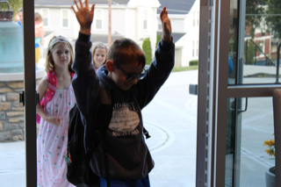 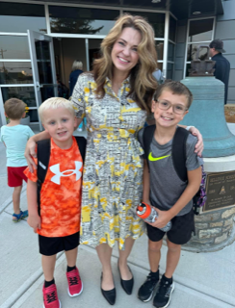 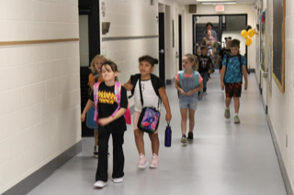

**Upcoming Dates**

* Month of Aug            Teach procedures and expectations
* Aug 16th                          First Day of School!!!! 😊
* Aug 16th-Sept 11th         NSGR (Reading Assessment) & Easy CBM (Math)
* Aug 18th                          Heather in Frankfort for MAF grant
* Aug 18th                          Bus Evacuation

*Taste of Cincinnati* Staff Potluck

                                                        Popcorn for all students 1-2:45pm

* Aug 21st                           Preschool Open House 5-7pm
* Aug 22nd                         Earthquake and tornado drill
* Aug 23rd                          **ERD**-2:15-3:15 PLC Norms
* Aug 23rd-24th                 Transition Days (Not all PreK attend)
* Aug 24th                          Fire and lockdown drill (fire dept. and police will attend)
* Aug 24th                         Character Strong 3:15-5:15pm (Paid training)
* Aug 28th                          First full day of Preschool for ALL students
* Aug 28th-Sept 1st           Character Strong (SEB) Screening
* Aug 30th                         **ERD**- District Wide Active Shooter Training @ BMHS
* Aug 28th-Sept 1st           Fall MAP Assessment week
* Sept 1st                            Skool Aid Assembly- *Student-Teacher Olympics*
* Sept 5th                          21st Century and extracurricular clubs start
* Sept 11th                          Grandparent’s Day (Details TBD)

*Engage ~ Equip ~ Empower*