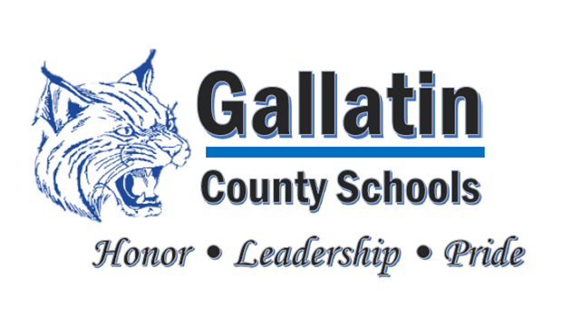

Gallatin County School Nutrition Department

75 Boardwalk, Warsaw, KY 41095

Phone 859-567-5862, Fax 859-567-1920

martha.sebring@gallatin.kyschools.us

**DATE:** January 15, 2019

**TO:** Gallatin County School Board Members

**FROM:** Martha Sebring, School Nutrition Director

**SUBJECT:** Gallatin County Nutrition Department

The Gallatin County Nutrition Department consists of twenty-three employees, including myself. Staff work from four to eight hours per day. I utilize my employees that work in the Breakfast & Lunch Program to cover the Supper Program.

Our main goal is to assure that the students of Gallatin County have nutritious meals so that they can concentrate and further their education to be the best that they can be in life. We know that students cannot learn when they are hungry so we are striving to improve each and every day.

Gallatin County Nutrition Department participates in the National School Breakfast and Lunch Program, Kentucky Department of Agriculture Commodity Program, Farm to School Program, DOD (Department of Defense) Program and we are a member of Kentucky Proud.

The Nutrition Department is self-sufficient which means we do not receive funding for anything other than the meals that we serve. We serve approximately 960 breakfasts, 1250 lunches and 90 supper meals each day. Since we have late buses this number has increased to 150-230 suppers each day.

The majority of our funding comes from the Federal Government through USDA. We participate in CEP (Community Eligibility Provision), which feeds all students at no charge for breakfast and lunch. We also participate in the At-Risk Afterschool Meal Program of the CACFP (Child and Adult Care Food Program), which serves all students, as long as we have a supervised, after school activity, supper at no charge to the student.

We receive approximately $70,000.00 each year in commodities which helps offset the cost of our meals. We also use DOD (Department of Defense) to purchase fresh fruits and vegetables. The amount of commodity money that we receive each year is determined by the number of lunches that we served in the previous year. We receive 0.2350 for each meal served.

We receive the following amounts for each meal served: Breakfast $2.14, Lunch $3.33 + .06 for meeting all the nutritional guidelines. We receive $3.54 for each supper that we serve.

We are a member of OVEC (Ohio Valley Educational Co-operative) and a member of the KEDC (Kentucky Educational Development Co-operative), where I currently serve as a member of the Steering Committee. The Steering Committee is working diligently to assure proper procurement in order to receive better pricing for food and supplies.

Every three years we receive an Administrative Program review and a Procurement review. The Department of Education comes in and reviews all aspects of the Nutrition Program. They look at meal access and reimbursement, meal patterns and nutritional quality, resource management, general program compliance, staffing, procurement methods, , meal counting and claiming, smart snacks, wellness policies and professional standard trainings.

We receive an annual review from the Kentucky Department of Agriculture. Our field representative comes to the school for the review. He looks at all my records and does a review of everything that I am required to do and then we go to one of the schools and review what the manager is required to do. He checks all freezers and coolers to make sure they are working properly and looks at the general condition of the kitchens to make sure all regulations are being met. He checks our paperwork to make sure that we are receiving our commodities in a timely manner and that everything is stored properly.

This is just an overview of our Nutrition Department and will give you a general idea of how we operate and where our funding comes from. If there are any additional questions that you have, I will be happy to answer them. As always, thank you for the continual support that you give to my staff and me.