

**Report to Board of Directors of NKCES November 2017**

**NORTHERN KENTUCKY PARENT LEADERSHIP BASECAMP 101**

Northern Kentucky Parent Leadership Basecamp 101 was held on Saturday, November 4.

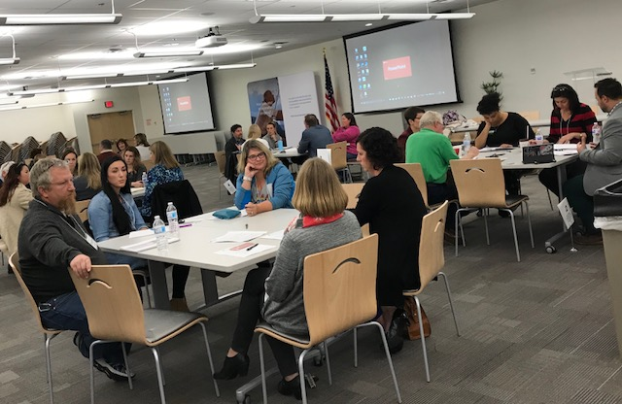

**Twenty parents from the following districts participated in the information-filled day:**

**Kenton, Beechwood, Covington, Campbell, Dayton, Boone, Walton-Verona and Bellevue.**

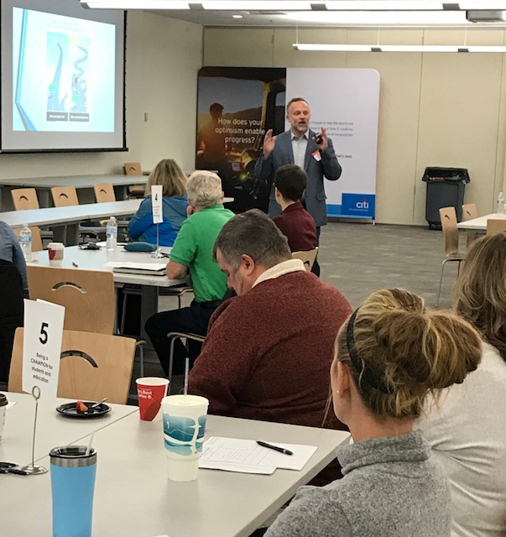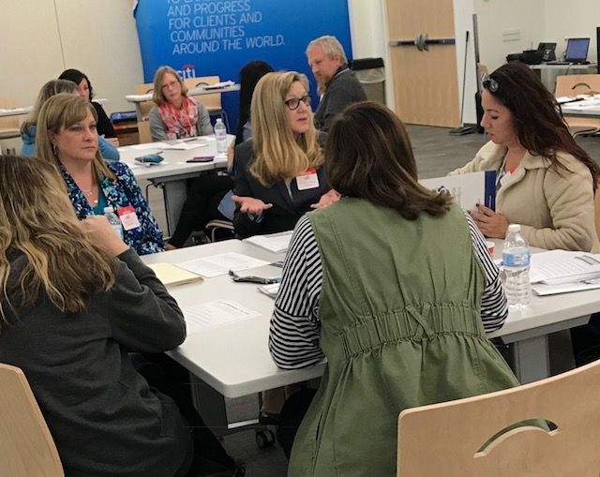

**Jim Detwiler kicks off the day with a Karen Cheser and Dawn Laber lead a Roundtable.**

**powerful (and fun!) parent engagement**

**presentation.**

Big thanks from the Prichard Committee and Helen Carroll to presenters:

Jim Detwiler, Boone County; Karen Cheser and Dawn Laber, Ft. Thomas; Tiffany Gruen, Erlanger-Elsmere; Amy Clancy, Walton-Verona; Ed Massey, Boone County; Paula Jolley; Walton-Verona; Justin Otto, KCEWS; Michael Hackwork, KDE; Julie Pile, 2012 GCIPL Fellow; Jen Hedger, Campbell County; Mike Sipple, All Pro Dads; Billy Riley, NKY Parents for Public Schools

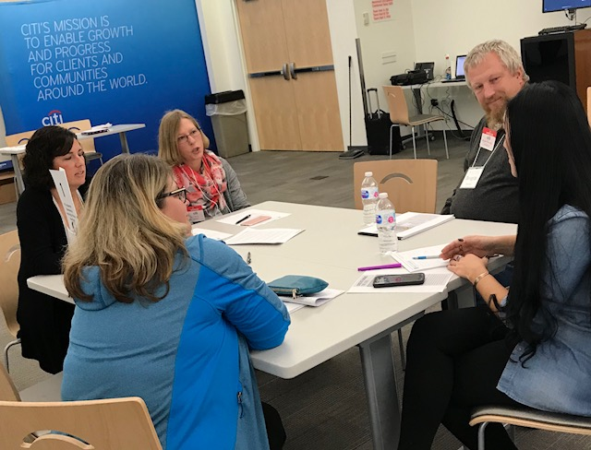

**Hope Street Fellows Tiffany Gruen and Amy Clancy**

**talk with parents about Kentucky Academic Standards**

On evaluations, a few comments about what the parent learned:

* Ways to bridge the communication gap with school leadership; how to communicate in a positive way
* Dual Capacity Building
* Importance of Site Based Council
* Info about the New Accountability System
* My opinion as a parent matters
* Different types of schools: Open Door, Fortress, etc
* The importance of parent involvement in school/student success
* There are ways to initiate change in schools

**For information about future NKY Parent Leadership Basecamps or to connect with GCIPL Fellows**

**and Basecamp participants in your district, contact: Helen Carroll at** [**Carroll.proplan@outlook.com**](mailto:Carroll.proplan@outlook.com) **or by phone at 859-982-4943.**

**Family and Community Engagement Training**

In addition, the Prichard Committee provides a variety of training opportunities for school staff, families, and community members to learn how to work in partnership to support the academic success of all students in their public schools.

We can also customize a training to meet your specific needs.

**For more information on training opportunities, please contact:**

Cory Curl, Associate Executive Director

Prichard Committee for Academic Excellence

271 W. Short St., Ste. 202

Lexington, KY 40507

Phone: (o) 859-233-9849 x222 (c) 615-438-5572

Twitter: @corybird

Email: cory.curl@prichardcommittee.org

www.prichardcommittee.org