Beechwood Independent
Bellevue Independent
Boone County
Bracken County
Campbell County
Covington Independent
Dayton Independent
Erlanger-Elsmere Independent
Fort Thomas Independent
Ludlow Independent
Newport Independent
Northern Kentucky University
Pendleton County
Silver Grove Independent
Southgate Independent
Walton-Verona Independent
Williamstown Independent
UPDATES:
NKCES Board Retreat: The NKCES Board retreat was held in Louisville on June 14-15 with a focus on Continuing our Journey to build collective efficacy to impact students. Sixteen of the Seventeen Board members were able to attend which allowed for rich discussion and forward movement.
Audit: Barnes & Dennig is currently conducting our audit so that we can begin the year with as much information as possible as we move forward with a new team. The results will be shared after we have a complete report.
KASA Happiness Advantage, Regional PLC Presentation & Retreats: Dr. Poe and Team shared key points and Boone County’s Happiness Advantage to an overflowing room. Executive Director Razor, Dr. Weber and Dr. Detwiler presented our regional PLC networks at KASA. NKY had a great representation overall at this conference. Many of our districts held retreats at KASA for team building and beginning of the year planning.
NKCES IDEA Grant Application Update: The KDE approved the release of the additional $25,000 available resulting in a total approval of $998,700. The additional funding was submitted to support mental health, HI and VI, Applied Behavioral Analysis, and explicit instruction.

NKCES Back to School Event: Tom Sexton Furniture sponsored a Back to School Event for our Board and guests on August 2nd. We had approximately 30 in attendance to network and share in some laughter before the year begins. We are appreciative of Tom Sexton Furniture’s generosity.
NKCES Team Kick-Off: We will be hosting a team building retreat for our NKCES Team on August 22-23 to set team expectations, norms and continue to build momentum. This timeframe allows our team to support your district during the busy months of July and August as back to school trainings are held.
Facility: Our new maintenance person, Fred Strange, is evaluating current facilities and making priorities for minor repairs and maintenance. We welcome him on staff and look forward to the improvements to come to our facility.
New Hires: We continue to grow and are fortunate to hire such dynamic educators and staff members. The press release for these team members can be found at the end of the report. The NKCES is excited to welcome the following team members:
Name | Role
Mr. Jon Stratton | Business Manager
Mrs. Alison Teegarden | Literacy Professional Learning Coach
Dr. Laura Clarke | Behavior Professional Learning Coach
Mrs. Jessica Faust | Executive Administrative Assistant
Ms. Shelly Cobb | Payroll and HR Coordinator
Mrs. Christina Sizemore | Administrative Assistant

DoSE Advisory Committee: The newly developed DoSE Advisory Committee met at the end of July. The committee members include: Pam Eklund, Boone County; Adam Liechty, Campbell County; and Sommer Rosa, Ft. Thomas. The goal of this committee is to increase partnership collaboration and communication in an effort to support and guide the region.
Professional Learning: It was a very busy summer for the NKCES and educators across NKY! Our strong partnerships across the region made for a rich and engaging summer of professional learning. Below is a summary of PL for the region:
June 2017
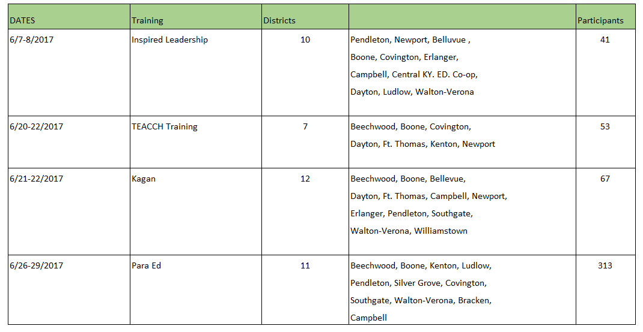

July 2017
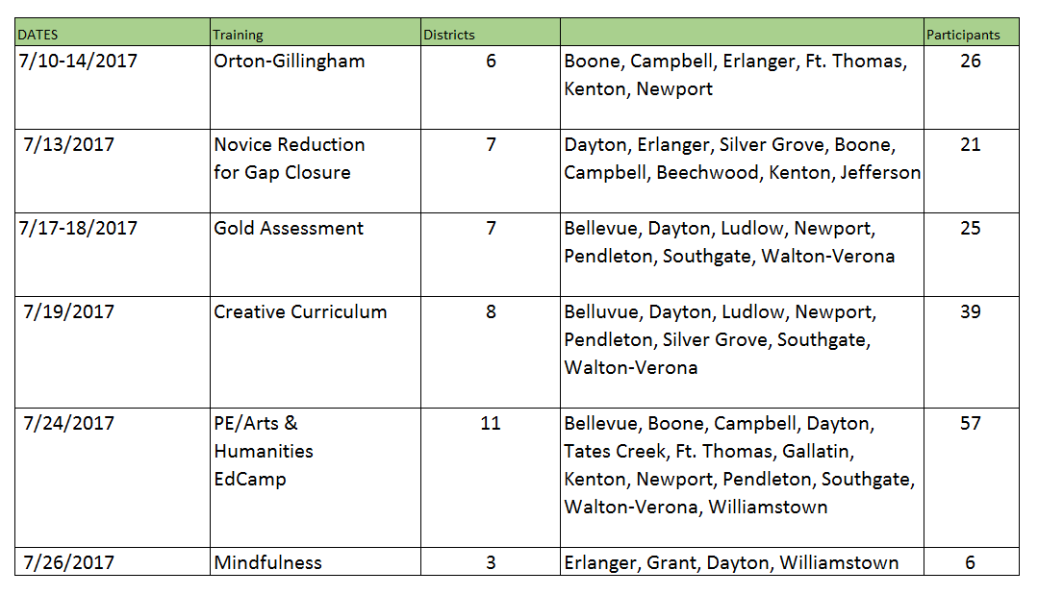

Kagan Tour: The Kagan Tour is returning to NKY on September 28th. In this workshop, educators will experience cutting-edge teaching structures to create classroom success now and forever! In addition, they will learn management tips, how to form effective teams, strategies for creating a cooperative class through teambuilding and classbuilding, and why cooperative learning produces gains when group work often fails. Registration is through the Kagan Website.
Please use the link below to register:
https://www.kaganonline.com/workshops/usa_tour/florence_ky_cl_9_28_2017.php

Continuous Improvement Summit: TURN IN TWO NAMES TO LYNLEE HERTZENBERG FOR FREE REGIISTRATION! During the Kentucky Continuous Improvement Summit, KDE leaders will provide all of the up-to-date information you need to effectively lead your district, school or classroom during the 2017-2018 school year and beyond. The new AdvancED Continuous Improvement System and AdvancED Performance Standards will be revealed. Learn about AdvancED options for accreditation and STEM Certification. Educators from across the state of Kentucky will connect and network during this two-day event. Do not miss out on the opportunity to learn from experts and peers to enhance your continuous improvement efforts. Join the journey!
Featuring Mike Rutherford, President of Rutherford Learning Group, as the Keynote Speaker on September 19!
https://education.ky.gov/school/csip/Documents/Continuous%20Improvement%20Summit%20Flyer.pdf

WHEN WHERE
Monday, September 18, 2017 10am-4pm Lexington Convention Center
Tuesday, September 19, 2017 8:30am-4pm 430 W. Vine St.
Lexington, Kentucky 40507
Early Childhood Symposium: Join us on August 25th from 8:30 to 3:30 at St. Elizabeth Training Center to listen and learn from two childhood experts in brain development and on the effects of a child’s development when trauma is a part of life experiences. Dr. Terrie Rose earned her Ph.D. at the University of Minnesota. She is a licensed child psychologist and the founder of Baby's Space, a full service child development center. Nicki Patton Rowe is an Early Childhood Consultant/Trainer. She is a graduate from the University of Kentucky. She has a Masters in Family Studies with an emphasis in early childhood.
Please use the Link Below to Register:
http://events.r20.constantcontact.com/register/event?llr=jhpqh5dab&oeidk=a07ee93eswre65f91a0
NKCES PLCs: Please be sure to check out our list of PLCs for 2017-2018. It is exciting to see educators from across the region coming together to learning and grow students.
http://nkces.org/regional-plcs/

EL Program Update: NKCES has hired Elizabeth Winkler as our second full-time EL Program Consultant. Elizabeth has eight years of experience at NKCES as an EL Program Consultant and four years of experience as a high school math teacher. Moving forward, each EL Program Consultant will be working with four districts.
Elizabeth Winkler will be working with Dayton, Fort Thomas, Southgate, and Silver Grove. Daniele Novak will be working with Bellevue, Ludlow, Pendleton, and Walton-Verona. Both EL Program Consultants will begin a full-time schedule beginning on August 10th, but are available before that date as needed.
We are currently developing a schedule of EL PD offerings which we plan to distribute in early September. As always, we appreciate the opportunity to serve your districts and encourage you to contact us with any questions or concerns.

Grant Consortium Update: August 2, 2017 In attendance: Bellevue (Deneen Zimmerman); Dayton (Kati Newsome); Newport (Amy Gilkison); Williamstown (Amy Harris); NKCES (Kim Weber, Amy Razor, Vicki Dansberry)

Grant Reports from Districts
Dayton received the SIG grant, but much less than anticipated. Bellevue is working on the Home Depot grant to put air conditioning window units in some rooms. Vicki is working with the Regional Schools Programs on that grant as well, toward playground equipment. Newport is working on a Walmart Community Grant (http://giving.walmart.com/apply-for-grants/local-giving-guidelines).

Grant Status
OJJDP Mentoring Opportunities for Youth Initiative – pending
Prevention of Opioid Misuse in Women – pending for substance abuse coalitions
Professional Development for Arts Educators – pending
Preschool Partnership, Tier 2 and 3 Update – Very good news! Newport will be awarded both of their grants, $75,000 each, after their proposals were “lost in the email” at KDE. Paul Baker followed up when they were not originally awarded and was able to demonstrate that he had submitted them on time, so KDE reviewed them and award both! This brings our total to 13 preschool grants in Northern Kentucky. Congrats to you all, and especially to our newest award winners in Newport!
21st CCLC Update – This funding is threatened at the Federal level. Vicki spoke to Jason at KDE who suspects there might not be a state competition this year. An effort to publicize the critical importance of this funding is underway so we can keep these programs going. A meeting will be held at NKCES PD Room from 9 – 10:30 on August 15 for 21st CCLC coordinators to strategize about a public relations campaign, ending on national Lights On Afterschool day in October. Vicki encouraged grants reps to ask their 21st CCLC folks to attend.
Promise Neighborhoods: In consideration. Webinar in Vicki’s office, 1:00 tomorrow, August 3 for all interested.

Grant Strategies
Theme of the month: Technology. Vicki distributed a list of grant possibilities. Please contact her with questions or interest.
RISE event: Several members will attend this event, featuring a speaker on Kentucky Grant Opportunities from the Kentucky Science and Technology Corporation, on Friday, August 4. To register, use this link: AUGUST 4, 2017 - RISE - RESEARCH & INNOVATION SYMPOSIUM IN EDUCATION.
District Meeting Common Themes: In meetings with Amy Razor and Kim Weber, superintendents and other administrators of all districts identified a number of common themes to be addressed (list attached). Amy and Kim discussed the list and the group talked about how to move grants work toward addressing these themes. College and Career Readiness is one theme that was discussed, focusing on coordinating and publicizing the many community efforts that are ongoing for College and Career Readiness.
The discussion will continue in the months ahead. Amy noted that a discussion among members of the Professional Learning Consortium, Directors of Special Education, and Grants Consortium will be held to encourage targeted collaborative efforts among the three groups.

Grant News
Finalizing Meeting Location for 2017-2018: We will meet at Erlanger-Elsmere BOE until further notice.
Update grant totals: See chart at right.
Crisis Text Line. See attached flyer and http://www.npr.org/2016/04/01/472451687/how-can-text-messaging-save-lives for a valuable tool to promote for use in crisis. The group discussed the extensive training required of volunteers to this text line and viewed the video linked above.

Next Grant Consortium Meeting
September 6, 2017, 8 am
Erlanger-Elsmere Board of Education
500 Graves Ave.
Erlanger, KY 41018

