THIS IS AN INFORMATION PAPER

TO: Hardin County Board Of Education

FROM: The PAC

DATE: September 9, 2021

SUBJECT: PAC NEWS
Barts BLOG – SEPTEMBER 2021
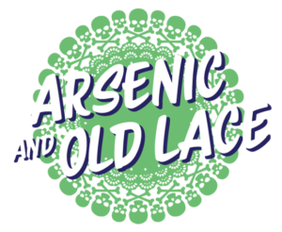
Karloff as Jonathan Brewster in the original production of Arsenic & Old Lace.
It’s interesting how childhood influences shape our lives. I think the first time I realized that you could feel two things simultaneously was when as a child, I watched Boris Karloff as the Frankenstein monster – a character to be both feared and pitied. That dichotomy has, I think, shaped my approach to theatre in many ways, as has the looming presence of Karloff himself.
Right now, we are producing Arsenic & Old Lace, a play tailor-made for Karloff, and I am teaching those monstrous mannerisms I first watched on TV over 40 years ago to Billy Bass as he prepares to play Jonathan Brewster. And while I work with him, Jeff Curtis, who played the monster in our production of Young Frankenstein a couple of years ago, is skillfully cobbling together background music for “Arsenic” from the play’s 1944 film adaptation as well as selections from the Franz Waxman’s horrifyingly comic score for The Bride of Frankenstein.
You know, I can’t help but think that Karloff would be both proud and humbled to know that his work continues to influence the work of others some 85 years after he first created the monster we’ve all come to fear and love.
Watch for the documentary Boris Karloff: The Man Behind The Monster coming out this fall: https://deadline.com/2021/08/boris-karloff-the-man-behind-the-monster-release-date-trailer-1234816441/.
And don’t miss Arsenic & Old Lace in-person and streaming live this month at the PAC: https://thepac.net/arsenic-and-old-lace/
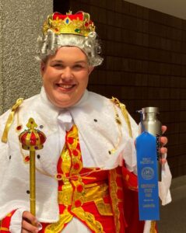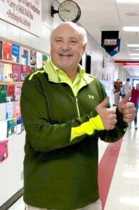
This month The PAC Spotlight shines on…
John Hardin High School’s Brayden Hall and Bluegrass Middle School’s Tracy Arflin.
Catch them onstage together this month at the PAC in Arsenic & Old Lace.
Learn more about them both and all the other PAC Spotlight Ambassadors we’ve recognized over the years.
NOW SHOWING – SEPTEMBER 2021
Sept 16,17 | THE PAC PRESENTS: The PAC ProAm Classical ARSENIC & OLD LACE. Thursday & Friday at 7 PM. Two free performances for Abound Credit Union members. Email was sent by Abound Credit Union to its members on Friday August 27 and tickets were scooped up by Saturday morning. ALL SEATS HAVE BEEN RESERVED. Tickets for 2 remaining public performances are on sale at www.thepac.net or 270-769-8837 X 4 or 5.
Sept 18, 19 | THE PAC PRESENTS: The PAC ProAm Classical ARSENIC & OLD LACE. (120 min.) The chill and chuckle champion of them all! Two sweet elderly aunts help lonely old men die happy…by poisoning them! Rated PG: Includes drinking, mild profanity, and mildly frightening situations. Best for: Grades 5 and above. Friday, 2 & 7 PM. Sunday at 3 PM. Tickets: $19 +$3 fees = $22. Presented in partnership with Abound Credit Union.
Sept 24 | Buffalo Productions presents Glen Rice Family & Friends Concert Series. Best of the Best…Encore. Concert 7 PM. Outside doors open at 6 PM, theatre opens 6:30 PM. Tickets: In advance, $20. At the door, $25. Call the PAC at 270-769-8837 X 4 or 5.

COMING SOON – OCTOBER 2021
October 14-17 | North Hardin High School Choral Department presents BEAUTY & THE BEAST. School Day Performances: Thursday & Friday, 9:30 & 11:30 AM. Public Performances: Saturday, 7 PM and Sunday at 3 PM. All tickets can be reserved through the PAC at www.thepac.net . POC Cassie Lucas 270-351-3167.
October 22, 23 | Central Hardin High School Drama Club presents THE ORPHAN TRAIN. School Day performance, Friday 10 AM, Public performances: Friday, 7 PM & Saturday Matinee, 2 PM. All tickets can be reserved through the PAC at www.thepac.net. POC Sarah Dakin 270-734-0021.
October 28 | John Hardin High School Choral Concert. 7 PM. POC Phyllis Westfall 270-769-8906.
IN REVIEW – AUGUST 2021
During the month of August, the PAC was in production for the PAC PRESENTS Fall ProAm ARSENIC & OLD LACE.
On August 9th, 414 John Hardin High School freshmen and their family members attended an orientation during the “Back To School” event.
On August 10, 136 Hardin County Schools Child Nutrition employees attended a Professional Development day at the PAC.
On August 16, 567 6th, 7th, & 8th grade Bluegrass Middle School students attended a student welcome orientation presented by their principal.
On August 26,27, 7 PAC volunteers placed address labels on more than 9,700 new season brochure cards for 6 hours preparing them for bulk mailing. Thanks to Deirdre Shockley, Joe Repoley, Jim & Karen Davis, Betty Kirby, Olivia Kizinkiewicz, Karen Benham, and all those who volunteered to help.
On August 30, the PAC’s 2021-22 Season of Events tickets WENT ON SALE! Go to https://thepac.secure.force.com/ticket to find out all about them!

