Gallatin County District Response to Intervention (RTI) Plan
April 25th 2011
District RTI Planning Team
Ray Spahn- Assistant Superintendent
Renee Cameron- Director of Special Education Services
Roxann Booth-Principal High School
Curt Bieger- Principal Middle School
Deb Brown- Principal Upper Elementary
Jerraine Dailey- Assistant Principal Upper/Lower Elementary
Sarah Hoffman- Teacher Middle School
Heather Wright- Teacher Middle School

Table of Contents
Definitions and Components- 3
High School Plan- 6
Middle School Plan- 14
Elementary Plan- 22
Monitoring Team- 32

RTI Defined
RTI provides a multi-level prevention system for students who have n=been identified as at-risk.
Components of RTI
Response to Intervention
Universal Screening
Progress Monitoring
Tiered Service Delivery
Data-Based Decision Making
Parental Involvement
Professional Development
Fidelity of Implementation
Tiered Service

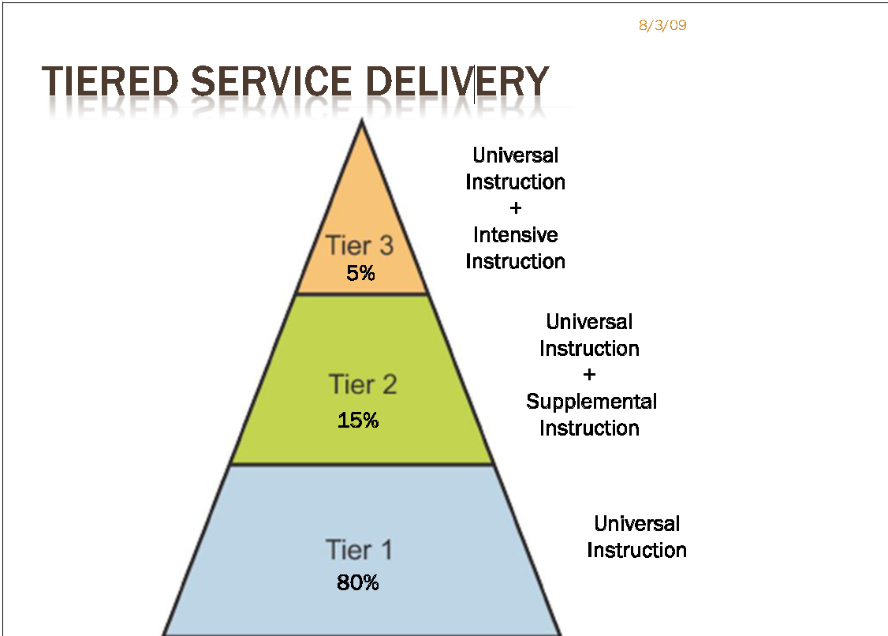

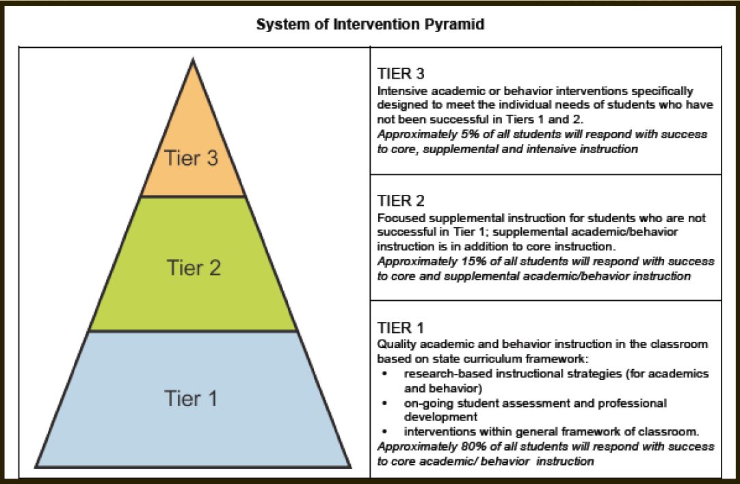

High School RTI

Tier 1 Gallatin County High School
Intervention Team
- Principal, Assistant Principal, or Counselor
- Content Area Departments/Teachers
- Department Heads
- Special Ed Teachers

Team Functions
- On-going assessments
- Flexible Grouping according to individual need of student (academics as well as behaviors)
- Small groups and One-on-One instruction
- Utilize Professional Learning Communities
- Identify students through common assessments, PLAN, ACT, and KCCT
- Utilize CARE groups twice a week
- Utilize Certified teacher through ESS Daytime Waiver

Curriculum and Instruction
- Core Content and Standards Based Curriculum
- Stiggins work-Assessment for Learning
- Lesson plans
- Unit Plans
- Embedded PLAN and ACT strategies, and practice sessions
- Use of flashbacks in all core content areas

Data Planning and Procedures
- KCCT
- PLAN (Both 9th and 10th grade)
- ACT (Both 11th and 12th Grade)
- Think Link
- Teacher Assessments- includes mastery tests, unit assessments and daily assessments.

Universal Screening
- District Product
- District Product
- Plan
- ACT
- District wide Learning Checks.
Progress Monitoring of All Students
- Student folders
- Homework
- Analysis of KCCT, PLAN, and ACT
- Common assessments
- Think Link (Math and reading only)
- Student/Teacher Conferences
- PLC’s- assessment and instruction.

Data Collection Plan
- Data is analyzed by all departments after all major assessments.
- Results are discussed with assistant principal, principal, and Assistant Superintendent.
- Attendance will be monitored by all. Teachers will help make administrators aware of potential attendance issues.
- Discipline issues monitored by Dean of Students

Family and Community Engagement
- STATS with parents
- Parent/ teacher phone calls, emails, and conferences
- Weekly Newsletter
- Mentoring
- PLAN/ACT Night with parents (Winter)
- High School and Beyond (Fall)
- Scheduling Fair (Spring)
- Grades posted to IC weekly for monitoring.

Tier 2 Gallatin County High School

Team Staff Roles

Team Members
- Classroom teachers
- School Within A School teacher
- Daytime ESS Teacher
- Special Education teachers
- Instructional assistants along with certified teacher
- Administrators as deemed appropriate
Team Functions
- Ensure student continues to receive core academic instruction.
- Assist teachers in the efforts to help students struggling in the classrooms, including those in special education.
- Analyze student-specific academic data.
- Identify specific academic concerns for individual students.
- Determine interventions, including frequency and duration of intervention.
- Determine frequency of progress monitoring, including what data will be used for this purpose.
- Use decision rules to determine student’s movement within the tiered model.

Curriculum and Instruction

Reserved for the lowest performing 20% of students who do not meet the benchmarks.
Tier 2 interventions can take place in the classroom or in a pull-out situation.
It is possible to utilize Tier 3 interventions for students in Tier 2, but with less frequency.
Access to high-quality, research-based instructional interventions for identified students:
• Multiple academic or behavior interventions should be used to address student needs.
• Match instructional interventions to student academic and behavioral needs.
◻ Increased frequency of formative academic and behavioral assessments to analyze student response to instructional intervention(s):
• Students should be able to move from one intervention to another within Tier 2 as evidenced by student response to formative assessment.
◻ Professional learning opportunities support all staff members in the implementation of instructional interventions for academic and behavioral needs.
◻ Professional learning opportunities support the intervention team members in the decision-making process of the school’s intervention system.

Progress Monitoring of Students Receiving Supplemental Interventions in Tier 2

The purpose of progress monitoring at Tier 2 is to determine whether the intervention is successful in helping the student learn academic skills at an appropriate rate. The decision making team determines the process for monitoring students’ progress, which students would benefit from additional instruction (intervention) and when students move through intervention levels. This includes the type of assessment, method of data collection and the tracking of student performance to monitor individual student’s academic or behavior progress over time. The data collected should assist the intervention team as they meet in determining the effectiveness of the academic or behavior intervention.

Progress is monitored frequently to determine whether the intervention is successful in helping the student learn at an appropriate rate. Students receiving interventions in the supplemental level are generally monitored every two weeks, but can be monitored more frequently or less often, based on the data collection plan developed by the design team and the protocol of the intervention.

Curriculum based measures (CBM) are commonly used for progress monitoring as well as for universal screening.

Data Collection Plan

Brain Child (computers)
*Individual meetings weekly
*Frequency of data collection is always available (it can be checked any time on the computer)
*if 80% is met in ALL categories they are released.
*if it’s not working then we evaluate whether to move them to Tier 3.

Probes
*Pre-Test is given for baseline data from probe.
*hand-on activities are mostly used
*worksheets and other practice are also utilized.
*probe (test) is given about every 3 weeks.
*if they are above 80% on FINAL probe then they are released.
*if it’s not working then we evaluate whether to move them to Tier 3.

Strategies for Family and Student Engagement for Students in Tier 2

- Tier 1 strategies should be continued.
- Families are informed on interventions used along with the expected outcomes.
- At least bi-monthly, families are informed of their children’s academic or behavioral progress or any lack of progress.
- Families are provided specific training on how to assist their children with the academic or behavioral areas of need identified.

Tier 3 Gallatin County High School
Intervention Team
Team Members
- administrator
- district office representative
- designated classroom teachers
- special education teachers
- individual who can interpret and critically analyze assessments and data (i.e., school psychologist, curriculum coach)
- other specialists (i.e., reading specialist, behavior specialist, ELL specialist)
- interventionist
- family and community members

Team Functions
- Ensure student continues to receive core academic and behavior instruction.
- Analyze student-specific academic and behavioral data.
- Identify specific academic or behavioral concerns for individual students.
- Determine interventions, including frequency and duration of interventions.

Curriculum and Instruction
Tier 3 interventions should take place after Tier 2 interventions have not been successful. These should be limited to 1-5% of the student population.
- Research based intervention,
- Small group- 1-5.
- 4-5 Days per week.
- 9-18 weeks.
- Interventions should match the skill deficit.

Professional learning opportunities support:

- all teachers in the knowledge and understanding of the school’s Tier III program
- staff members who will implement Tier III instructional interventions for academics and behavior
- the intervention team members in the decision-making process of the school’s intervention system
Progress Monitoring of Students Receiving Intensive Intervention in Tier 3

- Frequent monitoring- minimum weekly.

Strategies for Family and Community Engagement in Tier 3

- Tier 1 and 2 academic or behavior strategies should be continued.
- Families are informed on any changes in interventions used along with the expected outcomes.
- Families are at least weekly informed of their child’s progress or any lack of progress.

Middle School RTI

Tier 1 Middle School
Intervention Team
- Principal, Assistant Principal or Counselor.
- Grade Level Team
- Parents
- Curriculum coaches

Team Functions
Team members may be asked to perform any of the following functions:
- Design and implement core academic and behavior curriculum:
  - Select universal screeners for academics and behavior.
  - Select / train staff on instructional strategies for academics and behavior.
  - Provide professional learning opportunities.
  - Compile professional resources and materials.
- Involve family and community stakeholders in learning:
  - Develop and implement communication plan.
  - Develop activities that provide meaningful family involvement in the school.
- Assist teachers in the efforts to help students struggling in the classrooms, including those in special education.
- Consider all educational areas that affect or interfere with student achievement and success — academics, behavior and health.
- Review school data to make informed decisions about curriculum, instruction and assessment:
  - Examine achievement, behavior and other data.
  - Identify data patterns.
  - Identify specific concerns from school test reports, schoolwide/ classroom behavior data, and subgroup data.
- Prevent school failure by considering the whole child, recognizing that more than one issue frequently contributes to student struggles.

Curriculum and Instruction
- Core curriculum must be effective for 80-85% of all students
- All students are taught a curriculum that aligns academic and behavioral expectations to Kentucky’s Common Core Content or Program of Studies across content areas and grade levels.
- Staff members participate in an analysis that determines the alignment of instructional techniques across content areas and grade levels.
- Effective academic and behavior instruction is accessible to all students.
- Effective classroom discussion, questioning and learning tasks through the use of Thoughtful Education strategies.
- Focused, descriptive and qualitative feedback that enables learners to progress through homework, tests, exit strategies and bell ringers.
- Clearly defined learning and behavior targets in student-friendly language. (I Can)
- Models of student work/behavior that meet the learning/behavior target and that do not meet the learning/behavior target.
- Student engagement in self-assessment, self-reflection and peer-analysis based on the learning or behavior target.
- Differentiation of Instruction.
Data Planning and Procedures
- Contracted Assessment Provided by district
- EXPLORE
- Learning Check developed by teachers
- Teacher Assessments- includes mastery tests, unit assessments and daily assessments.

Universal Screening
- District Product
- EXPLORE
- Learning Check developed by teachers
Progress Monitoring of All Students
- Monitoring sheets
- Student folders
- Homework
- Student/Teacher Conferences
- PLC’s- assessment and instruction.

Data Collection Plan
- Data is analyzed by all departments after all major assessments.
- Results are discussed with principal and Assistant Superintendent.
- Attendance will be monitored by all. Teachers will help make administrators aware of potential attendance issues.
- Discipline tracking- monitored and shared by the KYCID team.

Family and Community Engagement
- STATS with parents.
- Develop plans with parents
- Mentoring
- Report card night.
- Grades posted to IC weekly for monitoring.

Tier 2 Intervention

Team Staff Roles

Team Members
- Classroom teachers
- School Within A School teacher
- Daytime ESS Teacher
- Special Education teachers
- Instructional assistants along with certified teacher
- Administrators as deemed appropriate

Team Functions
- Ensure student continues to receive core academic instruction.
- Assist teachers in the efforts to help students struggling in the classrooms, including those in special education.
- Analyze student-specific academic data.
- Identify specific academic concerns for individual students.
- Determine interventions, including frequency and duration of intervention.
- Determine frequency of progress monitoring, including what data will be used for this purpose.
- Use decision rules to determine student’s movement within the tiered model.

Curriculum and Instruction
Reserved for the lowest performing 20% of students who do not meet the benchmarks.
Tier 2 interventions can take place in the classroom or in a pull-out situation.
It is possible to utilize Tier 3 interventions for students in Tier 2, but with less frequency.
Access to high-quality, research-based instructional interventions for identified students:
• Multiple academic or behavior interventions should be used to address student needs.
• Match instructional interventions to student academic and behavioral needs.
◻ Increased frequency of formative academic and behavioral assessments to analyze student response to instructional intervention(s):
• Students should be able to move from one intervention to another within Tier 2 as evidenced by student response to formative assessment.
◻ Professional learning opportunities support all staff members in the implementation of instructional interventions for academic and behavioral needs.
◻ Professional learning opportunities support the intervention team members in the decision-making process of the school’s intervention system.

Progress Monitoring of Students Receiving Supplemental Interventions in Tier 2

The purpose of progress monitoring at Tier 2 is to determine whether the intervention is successful in helping the student learn academic skills at an appropriate rate. The decision making team determines the process for monitoring students’ progress, which students would benefit from additional instruction (intervention) and when students move through intervention levels. This includes the type of assessment, method of data collection and the tracking of student performance to monitor individual student’s academic or behavior progress over time. The data collected should assist the intervention team as they meet in determining the effectiveness of the academic or behavior intervention.

Progress is monitored frequently to determine whether the intervention is successful in helping the student learn at an appropriate rate. Students receiving interventions in the supplemental level are generally monitored every two weeks, but can be monitored more frequently or less often, based on the data collection plan developed by the design team and the protocol of the intervention.

Curriculum based measures (CBM) are commonly used for progress monitoring as well as for universal screening.

Data Collection Plan

Brain Child (computers)
*Individual meetings weekly
*Frequency of data collection is always available (it can be checked any time on the computer)
*if 80% is met in ALL categories they are released.
*if it’s not working then we evaluate whether to move them to Tier 3.

Probes
*Pre-Test is given for baseline data from probe.
*hand-on activities are mostly used
*worksheets and other practice are also utilized.
*probe (test) is given about every 3 weeks.
*if they are above 80% on FINAL probe then they are released.
*if it’s not working then we evaluate whether to move them to Tier 3.
Strategies for Family and Student Engagement for Students in Tier 2

- Tier 1 strategies should be continued.
- Families are informed on interventions used along with the expected outcomes.
- At least bi-monthly, families are informed of their children’s academic or behavioral progress or any lack of progress.
- Families are provided specific training on how to assist their children with the academic or behavioral areas of need identified.

Tier 3 Middle School
Intervention Team
Team Members
- administrator
- district office representative
- designated classroom teachers
- special education teachers
- individual who can interpret and critically analyze assessments and data (i.e., school psychologist, curriculum coach)
- other specialists (i.e., reading specialist, behavior specialist, ELL specialist)
- interventionist
- family and community members
Team Functions
- Ensure student continues to receive core academic and behavior instruction.
- Analyze student-specific academic and behavioral data.
- Identify specific academic or behavioral concerns for individual students.
- Determine interventions, including frequency and duration of interventions.

Curriculum and Instruction
Tier 3 interventions should take place after Tier 2 interventions have not been successful. These should be limited to 1-5% of the student population.
- Research based intervention,
- Small group- 1-5.
- 4-5 Days per week.
- 9-18 weeks.
- Interventions should match the skill deficit.

Professional learning opportunities support:

- all teachers in the knowledge and understanding of the school’s Tier III program
- staff members who will implement Tier III instructional interventions for academics and behavior
- the intervention team members in the decision-making process of the school’s intervention system
Progress Monitoring of Students Receiving Intensive Intervention in Tier 3

- Frequent monitoring- minimum weekly.
Strategies for Family and Community Engagement in Tier 3

- Tier 1 and 2 academic or behavior strategies should be continued.
- Families are informed on any changes in interventions used along with the expected outcomes.
- Families are at least weekly informed of their child’s progress or any lack of progress.

Elementary School RTI

Lower Elementary Tier 1
Universal Screening
- District (awaiting decision)
- Currently using Think Link and ITBS
- Learning Checks
Progress Monitoring of All Students
- Analysis of Formative Assessments (State Assessments)
- End of Unit Check
- Student feedback
- Homework
- Student/Teacher Conferences
- PLC’s- assessment and instruction.
Data Collection Plan
- Data is analyzed and collected by Teams, Coaches and Administrators.
- Student work is analyzed and discussed by teams regularly in PLC’s.
- Attendance is monitored.
- Discipline is kept on Infinite Campus
Family and Community Engagement
- Nightly parental communication as needed in Agenda
- Parent Teacher Conferences.
- Grades posted to IC Portal for monitoring.
- Website
- ESL
- Common Mission/Vision
- Student Handbook
- Volunteer Program
- 4-H
- Parent Workshops
- Classroom Newsletters
- Assessment Results sent home to parents
- Yearly Home Visits with all students before school begins
- Family Literacy Night
- Family Math Night
- Family Arts & Humanities Night

Upper Elementary Tier 2
Universal Screening
- District (awaiting decision)
- Currently using Think Link and ITBS
- District Learning checks
Progress Monitoring of All Students
- Analysis of Formative Assessments (State Assessments)
- Student Data Folders
- End of Unit Check
- Student feedback
- Homework
- Learning Checks
- Student/Teacher Conferences
- PLC’s- assessment and instruction.
Data Collection Plan
- Data is analyzed and collected by Teams, Coaches and Administrators.
- Student work is analyzed and discussed by teams regularly in PLC’s.
- Attendance is monitored.
- Discipline is kept on Infinite Campus
Family and Community Engagement
- Nightly parental communication as needed in Agenda
- Parent Teacher Conferences.
- Grades posted to IC Portal for monitoring.
- Website
- ESL
- Common Mission/Vision
- Student Handbook
- Volunteer Program
- 4-H
- Parent Workshops
- Principal/Classroom Newsletters
- Assessment Results sent home to parents
- Home Visits for Core 5 students

Tier 2 interventions UE/LE

Team Staff Roles

Team Members
LE and UE

- Principal, Assistant Principal or Counselor
- Homeroom Teacher and/or referring teacher
- Curriculum Coaches
- Special Education Rep
- Speech and/or Occupational Therapist; if needed
- Behavior Consultant; if needed
- District Office Rep and/or School Psychologist; if needed
- School Nurse; if needed
- Social Worker and/or Agency Rep; if needed
- Family and/or community member; if needed

Team Functions
- Define the problem in a clear statement
- Develop plan of action
- Set a baseline score and a goal
- Set time-line and amount of intervention
- Implementation, monitoring and scheduling of research-based-interventions
- Assist in the plan of action; if deemed necessary (name specific persons to do intervention(s))
- Gather, analyze and evaluate student data and progress (includes rate of progress based on peer levels)
- Determine next step and evaluate plan
- Address RTI on Report Cards, conference and/or letter

Curriculum and Instruction

- Only 5-15% of students are provided services at this level (Students show at-risk behaviors or perform at a rate deemed lower than that of their peers)
- Continual use of research-based instruction and programs
- Use of differentiation instruction strategies and practices based on student learning styles to improve performance/behavior
- Formative Assessments may increase in order to collect data
- Students receive targeted skill instruction that is more intensive than that of the “regular” classroom instruction
- Supplemental intervention of additional instruction at least 3 times a week (in addition to the regular classroom instruction)
- Small group targeted positive behavior support and/or interventions in addition to general school/class expectations
- Use a variety of teaching- learning processes to fit the needs of the student (instructional changes based on assessment of student)
- Students will follow the CHAMPS Program
- Students will follow School Expectations & Guidelines for Success (see School Handbook for details)

Progress Monitoring of Students Receiving Supplemental Interventions in Tier 2

- Teachers and RtI Tier Team will continuously monitor and measure student performance, growth and instructional practices based on the data collected from the student over time. The team will make decisions based on data to continue or discontinue interventions.
- Formal and Informal Formative Data such as the following may be used to allow immediate interventions and to make decisions:
- IOWA, ITBS and KCCT
- Short content/skill specific assessments
- Report Cards
- Standardized Tests
- Rating Scales
- Work Samples
- Teacher/student feedback
- Rubrics
- Probes or Curriculum Based Measurement
- Classroom/Student Observations
- Behavioral Log/Chart
- Discipline Referrals
- Attendance Data
- Ongoing student collected Data based on individual and peer performances
- Research-Base -Programs (School or District Level)
- Computer Based Programs
- Reading and Math Checklist/Skills (Literacy First, SNAP, Accelerated Math….)
- Think Link
- Learning Checks
- SMART goals
- Earobics
- Study Island
- Teacher constructed probes and/or assessments
- Other resources deemed necessary or available

- Information will be shared on a regular basis with Team Members and Teachers (Meeting dates/times TBA)
- Parent communication should occur on a monthly basis of each intervention and student status

Data Collection Plan

- Universal Screenings conducted Fall, Winter and Spring and other assessments will be monitored by each Grade Level Team during PLC’s bi-weekly
- Students who do not meet the Proficient Level or at least a 75% will be entered into the RtI Program (the the lowest 5-15% of students)
- A baseline data point will be established, interventions will conducted one-on-one or in small groups, data will be collected for 6-12 weeks (may be pullout or in the regular classroom)
- Data will be reviewed by the Tier Team and the Grade Level representative upon the conclusion of the intervention timeline
- Students who have a Proficient Level and/or 75% may exit the RtI Program
- If interventions and the RtI process are not successful for the student then the Tier Team and Grade Level Representative must consider evaluation for Tier 3
- During the RtI Process a probe should be given at least every 1-2 weeks on the targeted intervention
- All data should be kept for each probe and/or assessment given during RtI
- After 4 weeks the teacher may discontinue, continue or change the intervention as necessary to meet the student’s goal
- After 8 weeks of Tier 2 interventions a teacher may request a Tier Team meeting to consider moving a student to the next level at that time necessary steps will be taken based upon each child’s individual needs
- All Special Education request must be documented and referred through the Tier Team

Strategies for Family and Student Engagement for Students in Tier 2

- All strategies, procedures and data completion should remain in effect as in Tier 1
- Monthly family communications
- Teacher/Parent Workshops Fall, Winter and Spring
- Open communication through phone, email, agendas and conferences occur as needed

Tier 3 Interventions UE/LE
Intervention Team
Team Members

LE and UE

- Principal, Assistant Principal or Counselor
- Homeroom Teacher and/or referring teacher
- Curriculum Coaches
- Special Education Rep and/or Director
- Speech and/or Occupational Therapist; if needed
- Behavior Consultant; if needed
- District Office Rep and/or School Psychologist; if needed
- School Nurse; if needed
- Social Worker and/or Agency Rep; if needed
- Family and/or community member; if needed

Team Functions
- Ensure student continues to receive core academic and behavior instruction.
- Analyze student-specific academic and behavioral data
- Re-define the problem in a clear statement if needed
- Determine next step and re-evaluate plan (including who, what, where and when)
- Identify specific academic or behavioral concerns for individual students
- Set new and/or adjusted baseline score and a goal
- Address RTI on Report Cards, conference and/or letter
- Decide if an intervention change is necessary, including frequency and duration and/or intensity
- Determine if a student should move up/down in a Tier of Intervention level
- Determines discontinuation of intervention(s) and/or Removal from T3
- Supplies list of available resources and forms of required documentation
- Examines documentation and data to determine if a request for testing is necessary for Special Education Referral
- Adjust student schedule; if deemed necessary
- Help provide Professional Development and/or information to staff on RtI

Data Collection Plan

- Tier 3 placement is for 1-5% of the lowest performing students (Scoring below 50% and/or below the Apprentice/Novice Level)
- Tier 3 students will be monitored by each Grade Level Team during PLC’s bi-weekly
- A new baseline data point will be established, interventions will be conducted 1:1 or 1:2
- Data will be collected for 6-12 weeks (pullout of the regular classroom may be required)
- Data will be reviewed by the Tier Team and the Grade Level representative upon the conclusion of the intervention timeline
- During the T3 process a probe should be given at least twice a week on the targeted intervention
- Data should be kept for each probe and/or assessment given
- After 4 weeks the teacher/team may discontinue, continue or change the intervention as necessary to meet the student’s goal if not successful
- If interventions and the RtI process are not successful for the student then the Tier Team may request that the teacher/parent consider a Special Education referral
- All Special Education requests must be documented and referred through the Tier Team

Curriculum and Instruction

- Only 1-5% of students are provided services at this level (Students show at-risk behaviors or perform at a rate deemed lower than that of their peers after receiving Tier 2 interventions)
- Continual use of research-based instruction and programs at a more intense level
- Supplemental intervention of additional instruction at least 4-5 times a week (this may replace the regular classroom instruction)
- Students receive intense targeted skill instruction than that of the T2 instruction
- Use of differentiation instruction strategies and practices based on student learning styles to improve performance/behavior
- At least 2 different interventions must be tried if unsuccessful in first plan(frequency and time may also increase)
- One-on-one targeted positive behavior support and/or interventions
- Formative Assessments may increase in order to collect data

- Use a variety of teaching- learning processes to fit the needs of the student (instructional changes based on assessment of student)

Progress Monitoring of Students Receiving Intensive Intervention in Tier 3

- Teachers and RtI Tier Team will continuously monitor and measure student performance, growth and instructional practices based on the data collected from the student over time, as well as, during Tier 3 interventions.
- Formal and Informal Formative Data as noted in T2 may be used to allow immediate interventions and to make decisions for T3
- All resources deemed necessary or available should be used
- Parent communication should occur on a weekly basis of each intervention and student status Classroom teacher or interventionist should report progress or lack of progress to parents weekly
- Information will be shared on a regular basis with Team Members and Teachers (Meeting dates/times TBA)

Strategies for Family and Community Engagement in Tier 3
- All strategies, procedures and data completion should remain in effect as in Tier 1
- Weekly family communications
- Teacher/Parent Workshops Fall, Winter and Spring
- Open communication through phone, email, agendas and conferences occur as needed
- Tier 3 meetings; if deemed necessary

BEHAVIOR INTERVENTION TIERS
LE & UE

TIER I –
- Classroom interventions performed by teacher
- Follow classroom rules and procedures as taught and rehearsed
- Re-teach classroom rules and procedures as needed
- Use CHAMPS or similar classroom behavior management techniques
- Reward and Praise classroom systems
- Individual Behavior Chart

TIER II –
- Referral to office administrator:
- Administrator assesses the situation and follows district-wide Code of Conduct
- Consequences range from a conference to time-out , loss of privileges to isolated lunch, detention to suspension depending on the infraction—Parent may be contacted
- Student Contract
- Grade level team-wide intervention plan
- Tracking of discipline issues kept on Infinite Campus and/or by teacher

TIER III –
- Student may be referred to School Guidance Counselor for independent or small group program/counseling
- Parent Conference with Teacher and/or Tier Team
- Mentor Program

TIER IV –
- Parents may provide medical, social and/or mental evaluation /treatment
- Student may be charged with Beyond Control and referred to the CDW office
Please note that the Tier Team and/or Administration may make decisions based on individual situations as needed.

District Monitoring Team
The purpose of the district monitoring team is to determine the impact of the school RTI Plans.
Items to Be Monitored
- Semi -Annual student progress.
- Consistency in referrals.
- Impact of research based programs.
- Evaluation of plan on a yearly basis.
- Data related to percentage of students being monitored by RTI and their success at each building.
Members
One Central Office Administrator
Two Principals
Two Curriculum Coaches

