**CONSENT ITEM A**

**January 22, 2024**

**OLDHAM COUNTY BOARD OF EDUCATION**

**CONCERN**

Consider Approval of Field Trips Requesting Overnight Stay & Field Trips Requesting Use of Common Carrier.

**DISCUSSION**

The following are field trips requesting overnight stay and trips requesting use of a common carrier:

|  |  |  |  |  |
| --- | --- | --- | --- | --- |
| **SCHOOL** | **GROUP** | **LOCATION/DATE** | **JUSTIFICATION** | **INSTR. DAYS LOST** |
| OCMS | Choir | Galt House  February 7-8, 2024 | **Overnight: KMEA**  Parents | 2 |
| Kenwood Station | STLP | Rupp Arena  March 27, 2024 | **Overnight:**  Jefferson Tours | 1 |
| SOHS | Band | Galt House  February 7-8, 2024 | **Overnight: KMEA**  parents | 2 |
| NOMS | KYA | Galt House  March 10-12, 2024 | **Overnight: KUNA**  parents | 2 |
| NOMS | Chorus | Cathedral of Assumption  February 9, 2024 | **Overnight:**  Jefferson Tours | 1 |
| ALL HS | GATES | Northern Ohio Colleges  Feb 27-28, 2024 | **Overnight: Gates College Blitz**  Motorcoach | 2 |
| NOHS | Girls Track | Mobile, AL  March 21-24, 2024 | **Overnight: Out of State Competition**  Sandollar Transportation | 1 |
| SOHS | Choir | Hyatt Regency  February 7, 2024 | **Overnight: KMEA All State**  Parents | 3 |
| NOHS | Y Club | Marriott  March 24-26, 2024 | **Overnight: KUNA**  Parents | 2 |
| NOHS | Swim | Lexington, KY  February 22-24, 2024 | **Overnight: State Competition**  Parents | 2 |

**RECOMMENDATION**

Approve the field trips as attached and described above, pursuant to the condition that students not traveling on school buses, with their parents, or with a Board employee whose insurance carrier has named OCBE as an additional named insured, will be transported to and from their destination on an approved charter bus(es) and school(s) shall obtain written evidence of liability.

On a motion by _______________, seconded by _______________, the Board approved the field trips as attached and described above, pursuant to the condition that students not traveling on school buses, with their parents, or with a Board employee whose insurance carrier has named OCBE as an additional named insured, will be transported to and from their destination on an approved charter bus(es) and school(s) shall obtain written evidence of liability. ( , )

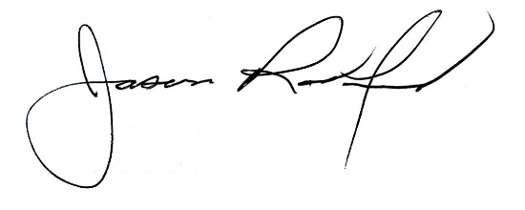

*Suzanne Hundley, Board Chair Jason Radford, Superintendent/Secretary*