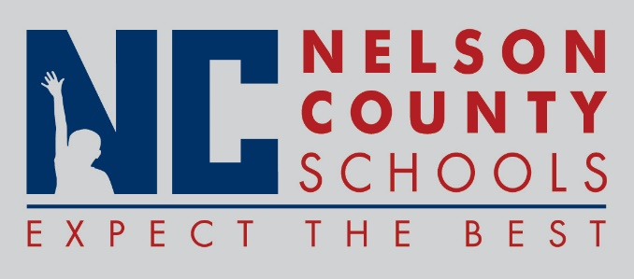

Decision Paper
To: | Nelson County Board of Education
From: | Tom Dekle
cc: | Dr. Anthony Orr, Superintendent
Date: | May 4, 2017
Re: | New Skills For Youth Grant (NSFY) initiative

Nelson County Schools is working together with Washington County Schools and other interested parties to pursue grant funding for the development and funding of a Regional Career Academy in collaboration with the KY Dept. of Education. This initiative is designed to expand career pathways studies to our students and explore ways to align and develop educational programs in our schools to provide rigorous and connected learning opportunities from which students may choose. Funds are being sought through the New Skills For Youth Grant. This initiative involves building partnerships with regional business and industry partners, postsecondary representatives, economic developers, regional workforce investment boards, other school districts and representatives of our parents and students.
RECOMMENDATION: Approve a resolution in support of the New Skills For Youth initiative and this districts cooperation toward the planning of a Regional Career Academy to help serve the needs of our students.

RECOMMENDED MOTION: I move that the Nelson County Board of Education approve a Resolution as presented, in support of this initiative.

