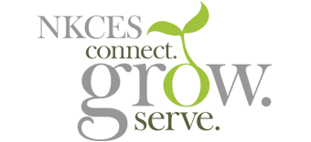
July 2020
This has been a summer full of connections, collaboration, and learning in NKY schools.
youtu.be

