Communication Updates- May 2020
Candace Gibson- Communication and Outreach Coordinator

NUE Vue
The NUE Vue webpage launched on April 30th, and was very well received on all social media platforms. Nothing but positive feedback from families so far! Current communication and promotion for NUE Vue options will continue through June, and more in-depth features of NUE Vue components will begin in July.

Another sub-page for the Q5 Summer learning program was also created and launched this month, giving students and families a description of all of our course offerings this summer. At the time of this report, there are more than 60 students who have signed up for the Q5 summer program

Website
The district website is currently undergoing review to see what areas can be improved. Goals for the summer include expanding the Athletics and Preschool websites, and creating a robust Intranet that will give staff easy access to vital information.

Graduation Photo Projects
This year, we are continuing the Preschool Graduation Photo project, and will also add a “Kinderbration” Class of 2033 photo project for our Kindergarten class. Examples of the Preschool Project are shown below:
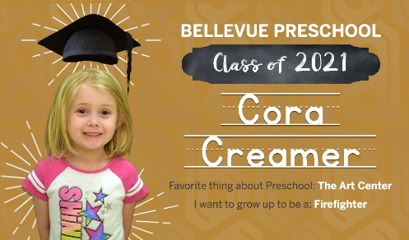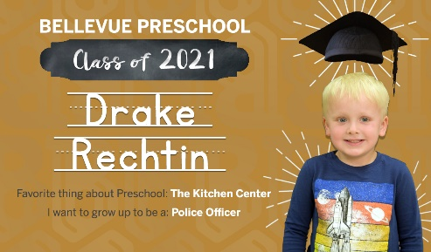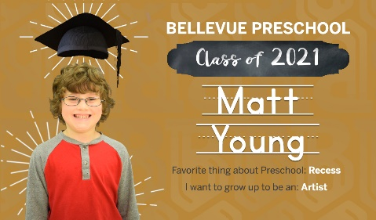

Social Media
Social media is buzzing with end of year event announcements. Families are excited to celebrate our students! Our audience reach remains at average of around 11,000 impressions, but engagement among our audience (likes, comments, shares) are up 40% from the previous month. We also gained a new 13 Facebook followers this month, (most in direct response to the NUE Vue launch), and a number of new Twitter followers throughout the state.
FACEBOOK MONTHLY IMPACT
Average post reach per month | 10,49
Average post engagement per month | 6,134
New followers | 13

MAILCHIMP- NEWSLETTER IMPACT (based on numbers from the latest edition)
Total Subscribers | 274 (one new subscriber)
Avg. % of subscribers who engage via email | 46%
Social media impressions per week | 554 (Facebook), 179 (Twitter)

