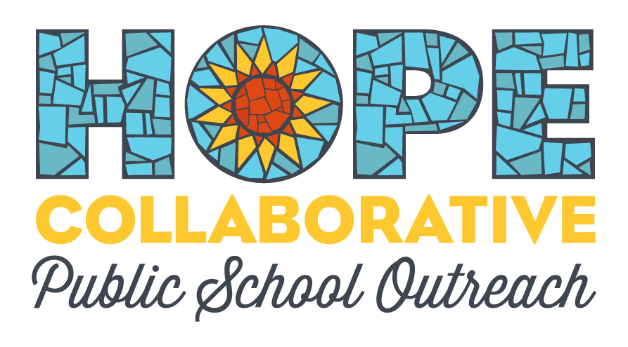
Data Collection Summary
Goal
Hope Collaborative is seeking permission to gather data in relation to the socioeconomic status of the student population it serves within Elizabethtown Independent Schools. Specifically, Hope Collaborative is asking to be given an aggregated percentage of all students who have participated in their program who also receive free or reduced lunch.
Intent
Hope Collaborative will use this information to both assess the scope and effectiveness of their program, while also using this data to apply for grants and other forms of support.
Method
This data will be gathered by a Hope Collaborative staff member sending a list of all students who have participated in our program over the previous school year to an Elizabethtown Independent Schools staff member with access to this data. That Elizabethtown Independent Schools staff member will then calculate the overall percentage and send this back to the Hope Collaborative staff member. No data will be linked to any specific student or school.

