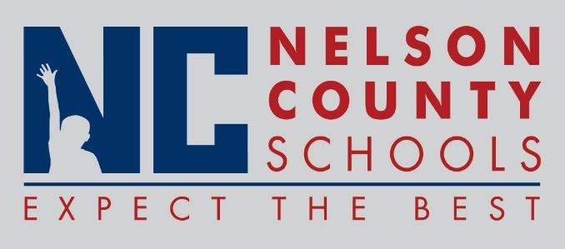

Decision Paper
To: | Nelson County Board of Education
From: | Bob Morris, Director of Student Support
cc: | Dr. Anthony Orr, Superintendent
Date: | July 18 , 2017
Re: | Contractual Agreement for Physical Health Services with Communicare.

RECOMMENDATION: Approve Contractual Agreement for Physical Health Services with Communicare.

RECOMMENDED MOTION: I move that the Nelson County Board of Education Approve the Contractual Agreement for Physical Health Services with Communicare.

