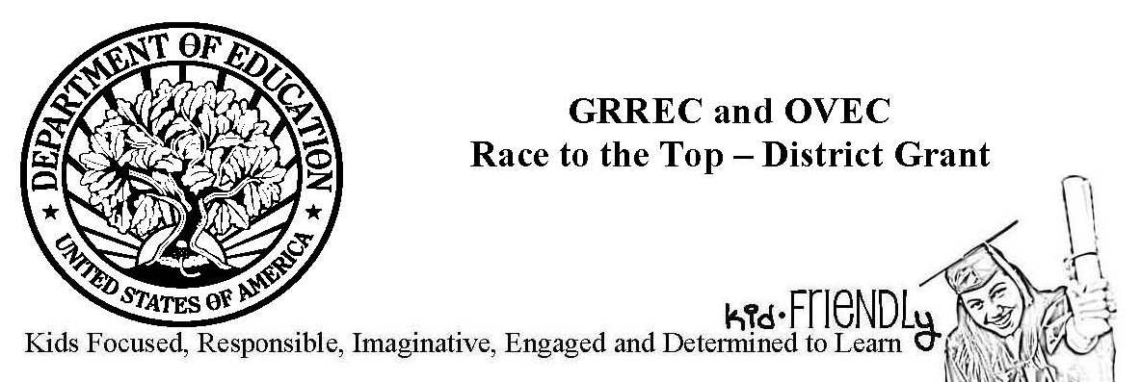

Overview
In October, GRREC and OVEC submitted an application to the US Department of Education’s Race to the Top – District competition. Out of 372 applications, GRREC’s and OVEC’s proposal was named as one of 61 finalists. On December 11, 2012, US Secretary of Education, Arne Duncan announced sixteen grantees for the competition. GRREC’s and OVEC’s proposal—kid-FRIENDLy (Kids Focused, Responsible, Imaginative, Engaged and Determined to Learn)—was one of the winning applications. The grant award is $40 million.

Districts
Adair County Schools, Campbellsville Independent Schools, Carroll County Schools, Caverna Independent Schools, Cloverport Independent Schools, Daviess County Schools, Green County Schools, Hart County Schools, Henry County Schools, Logan County Schools, Metcalfe County Schools, Monroe County Schools, Owen County Schools, Owensboro Independent Schools, Russell County Schools, Shelby County Schools, Simpson County Schools, Spencer County Schools, Taylor County Schools, Trimble County Schools, Union County Schools, and West Point Independent Schools

Activities
kid-FRIENDLy features four key components. Through a Students as Leaders focus, the project will develop a schoolhouse culture of leadership, in which students build daily habits of goal-setting, teamwork, critical thinking, communication, creativity, and problem solving. The Leaders Developing Leadership component provides support to principals in leading change, improving teacher performance, and making data-based decisions. The project also focuses on Competency-based Teaching. This component of the project will support schools as they shift from focusing on course completion to mastery of standards. Students will be able to move fluidly from standard to standard rather than grade to grade. The project seeks Personalized Learning for All Students by shifting the places, times, and ways students learn. Personalized learning strategies include online and off-campus work environments, flipped classrooms, student teaming, and emphasis on students’ learning needs, preferences, and responsibility.

Support
The grant provides resources for the four key components. These resources include consultants, professional development, technology, curricular resources, and staffing (regional: project manager, student leadership coach, cognitive coaches; district: college/career ready counselor).

