THIS IS A DECISION PAPER
TO: HARDIN COUNTY BOARD OF EDUCATION
FROM: Teresa Morgan, SUPERINTENDENT
DATE: AUGUST 18, 2016
SUBJECT: APPROVAL OF SCHOOL WIDE FUNDRAISERS
FACTS:
Hardin County Schools utilize appropriate Redbook fundraising practices to procure funds to provide a wide variety of enriching activities. From discovery field trips to athletic equipment our schools, through their sponsors and community partners, provide valuable and much needed items for students to reach higher and achieve more.
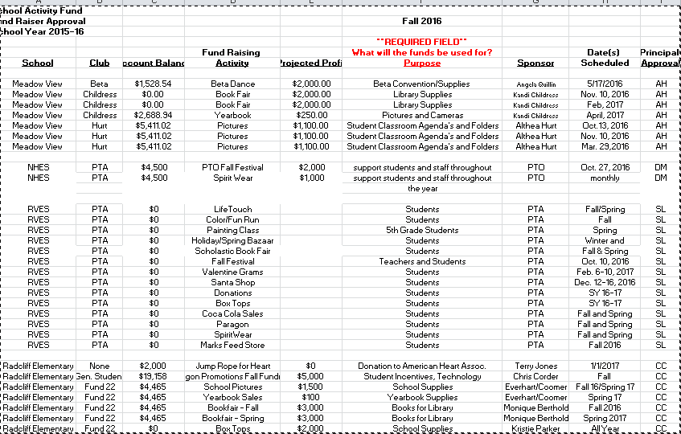
RECOMMENDATION
I RECOMMEND THE BOARD APPROVE THESE SCHOOL WIDE FUNDRAISING ACTIVITIES.
RECOMMENDED MOTION
I MOVE THE BOARD APPROVE THESE SCHOOL WIDE FUNDRAISING ACTIVITIES.

