Principal Written Reports- ACSHS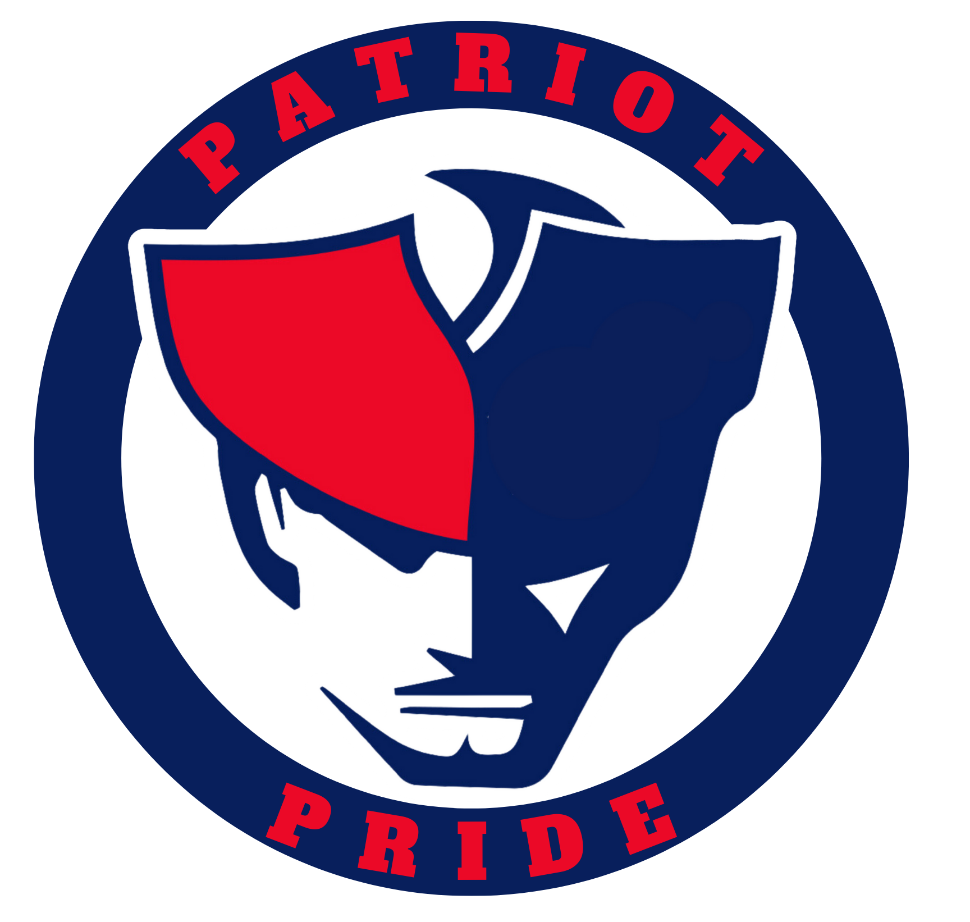
Problem of Practice LINK
Sep 2026

September PPT

1. What are you most proud of?
What I am most proud of as we start this school year is the continued growth of our school culture and the willingness of our staff to focus on what is best for students. We have started the year with a clear emphasis on student ownership, engagement, and making learning more meaningful.

Most importantly, I’m proud that we are not satisfied with simply maintaining where we are. Our staff is continuing to learn, adjust, and work together to provide students with a better experience at ACSHS. We still have areas where we need to improve, but I believe we have started this year with a clear direction and a strong commitment to our students.”

2. What challenge are you currently working through?
One of our biggest challenges this year is strengthening Tier 2 support within our daily classroom instruction. Our data shows that we still have learning gaps, and we know that Tier 1 instruction alone will not meet the needs of every student.
Our focus is helping teachers use formative assessment data to identify students who have not yet mastered a skill and then provide targeted Tier 2 instruction through small groups, reteaching, differentiation, and additional practice.
The goal is to respond to learning gaps earlier, rather than waiting until students fall significantly behind. If we can make Tier 2 a stronger and more consistent part of our lessons, we believe we can close gaps, reduce the number of students needing Tier 3 intervention, and move more students toward proficiency.

3. What are you learning?
What we are learning is that strong Tier 1 instruction is important, but it is not enough by itself to close all of our learning gaps. We have to be more intentional about identifying what individual students have not mastered and responding quickly through Tier 2 instruction.

This is also reinforcing that student achievement improves when students clearly understand what they are learning, where they are in that learning, and what they need to do next.

4. What support do you need from the district or Board?
The biggest support we need from the district and Board is simply your continued understanding and support. We are working extremely hard at ACSHS to make the changes necessary to improve student learning and close achievement gaps.
We know that meaningful improvement takes time, and not every change will produce immediate results. We hope they understand that our decisions are intentional, student-centered, and focused on making ACSHS better for every student.
Walkthrough for the year: Humphrey , Vernon , Roy , Lemily
Culture, Climate, and Behavior
Behavior | Aug | Sept
Skipping | 2 | 0
Disrespectful Behavior/Defiance | 3 | 3
Fighting | 0 | 0
Vaping | 2 | 1
Percentage of students with Zero Behavior Incidents: 97%

Aug 2026

Summary from the 25-26 School year

Student Ownership

1. What are you most proud of?
I’m most proud of the direction we are moving with student ownership of learning at ACSHS. Last year, our science department piloted the use of proficiency scales and a more competency-based approach. We saw students having a better understanding of what they were expected to learn, where they were in their learning, and what they needed to do to improve.
This year, we are expanding that work into more classrooms, particularly in English and math. What excites me is that we are moving the conversation away from simply, “What grade did I get?” toward “What do I actually know, and what do I need to learn next?” I believe that is an important shift for our students and our school.

2. What challenge are you currently working through?
Our biggest challenge continues to be consistency in strong Tier 1 instruction and student engagement. We have some classrooms where students are doing the thinking, talking, explaining, and taking real ownership of their learning. Our challenge is making that experience consistent for every student, every day.
Our leadership team is focusing our PLC work, learning walks, proficiency scales, learning targets, and success criteria around that goal. We want to make sure these aren't just things we do—we want to see evidence that they are actually changing what students are doing and learning in the classroom.

3. What are you learning?
One thing I continue to learn as a leader is that doing more doesn't necessarily mean getting better results. Sometimes the best thing we can do is narrow our focus and get really good at a few things that matter.
For us, that means staying focused on teacher clarity, strong Tier 1 instruction, meaningful feedback, and student ownership. I'm also learning that when teachers understand the why behind the work and have a voice in how we move forward, we get much stronger implementation.

4. What support do you need from the district or Board?
We have momentum, and we want to protect that momentum.
Our goal is pretty simple: every student in every classroom should know what they are learning, know where they are in that learning, and know what they need to do next to get better. That's the direction we're headed at ACSHS.

Walkthrough for the year: Humphrey , Vernon , Roy , Lemily
Culture, Climate, and Behavior
Behavior | Aug
Skipping | 2
Disrespectful Behavior/Defiance | 3
Fighting | 0
Vaping | 2
Percentage of students with Zero Behavior Incidents

