

Allen County Primary Center
721 New Gallatin Road, Scottsville, KY 42164
P: 270-618-7200 F: 270-618-7206
Leah Renfrow, Principal Robby Calvert, Assistant Principal Matt Shepherd, Assistant Principal
Jamie Rector, Instructional Coach Cassie Allen, School Counselor Diane Towe, School Counselor Hannah Erwin, FRC Coordinator ACPC Principal’s Report – September 2026
Walkthrough Data
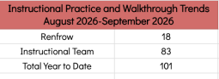
Student Learning and Intervention Data
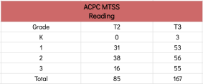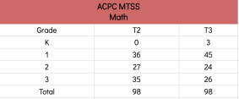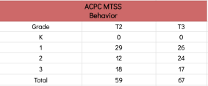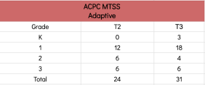
Culture, Climate, and Behavior Data
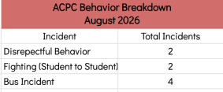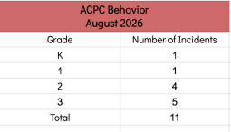
Additional Data
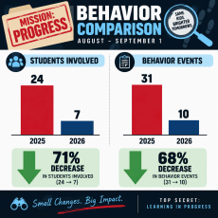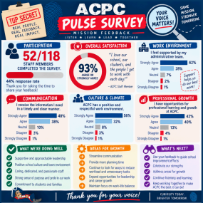Summary
Allen County Primary Center continues to build strong momentum as we move further into the 2026–27 school year. Since the last Board meeting, our focus has remained on strengthening Tier 1 instruction, responding intentionally to student needs, and maintaining a positive school culture. Our instructional leadership team has provided frequent opportunities to monitor implementation, celebrate effective practices, and identify areas where additional support may be needed.
Our MTSS work is also becoming increasingly responsive as additional student data becomes available. These numbers reflect our commitment to identifying needs early and providing targeted intervention rather than waiting for students to fall further behind. Adaptive and behavioral supports are also being provided based on individual student needs.
We are especially encouraged by the positive start to the year in school culture and behavior. This strong beginning reflects the intentional work of our staff to establish routines, teach expectations, build relationships, and create classrooms where students are ready to learn.
Beyond the numbers, there is a great deal of excitement at ACPC. Students are settling into strong instructional routines, teachers are using collaborative planning to analyze student learning and determine next steps, and our Walk to Read and Walk to Math structures are providing students with instruction targeted to their current needs. We are continuing to move our work beyond simply implementing programs toward examining whether our leadership supports are changing teacher practice and improving the daily learning experiences of students.
Overall, ACPC has begun the year with a strong emphasis on high-quality instruction, early intervention, instructional monitoring, and a positive culture. We are proud of the work already underway and excited to continue using our data to celebrate progress, identify areas for growth, and ensure that every Patriot receives the support needed to be successful.

