THIS IS A DECISION PAPER

TO: HARDIN COUNTY BOARD OF EDUCATION

FROM: TERESA MORGAN, SUPERINTENDENT

DATE: AUGUST 20, 2026

SUBJECT: APPROVAL OF CHANGE ORDERS 13 and 14 FOR THE CHILD NUTRITION CONSTRUCTION PROJECT

ISSUE:
Change Order 13 is an increase of $3921.00 to Gene Ray Electric to furnish circuits for the kitchen hood. Change Order 14 is an increase of $2065.00 to Gene Ray Electric for light fixtures in the corridor at the front of the freezer.

FACTS:
Change Order 13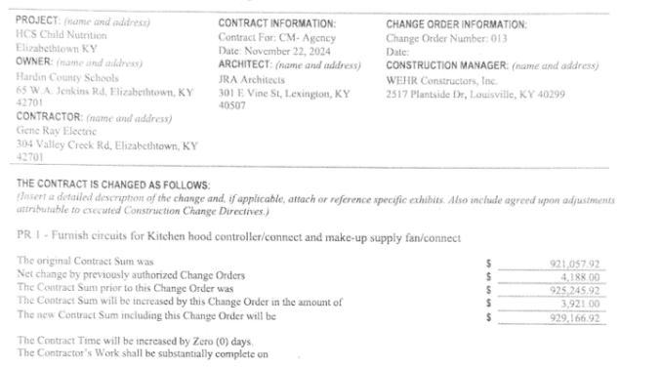

Change Order 14
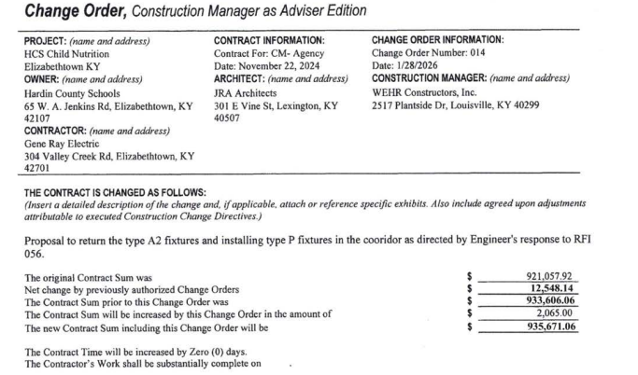

RECOMMENDATION
I RECOMMEND THE BOARD APPROVE CHANGE ORDERS 13 and 14 FOR THE CHILD NUTRITION CONSTRUCTION PROJECT.

RECOMMENDED MOTION
I MOVE THE HARDIN COUNTY BOARD OF EDUCATION APPROVE CHANGE ORDERS 13 and 14 FOR THE CHILD NUTRITION CONSTRUCTION PROJECT.

