MEMORANDUM OF UNDERSTANDING BETWEEN
Fort Thomas Independent School District And
Dayton Independent School District And
Bellevue Independent School District

This Memorandum of Understanding (“MOU”), effective on this day of , 2026 (“Effective Date”), is entered into and between Fort Thomas Independent School District (“Fort Thomas”) a public school district and Dayton Independent District (“Dayton”) a public school district and Bellevue Independent School District a public school district (“Bellevue”), all school districts exist under the laws of the Commonwealth of Kentucky, together herein referred to as “Parties”;

WHEREAS, Fort Thomas, Dayton, and Bellevue desire to continue utilizing Campbell County’s Area Technology Center for its students;
WHEREAS, it is the Parties understanding that Campbell County School District has expressed it no longer has the capacity to transport students from Fort Thomas, Bellevue, and Dayton to the Area Technology Center (“ATC”) located in Campbell County; and
WHEREAS, Fort Thomas, Dayton, and Bellevue school districts desire to collaborate to ensure that their ATC students are transported; and

WHEREAS, the Parties desire to set forth their respective rights, duties, obligations, to facilitate the transportation for Fort Thomas, Dayton, and Bellevue students to the Campbell County ATC;
NOW, THEREFORE, in consideration of the following mutual promises, covenants, and conditions, the Parties hereto agree as follows:

RESPONSIBILITIES OF FORT THOMAS:

- Fort Thomas shall provide a bus driver and cover any and all benefits for his/her employment by the district.
- Fort Thomas shall provide or maintain insurance to cover both the driver and any of its respective students utilizing the transportation.

- Fort Thomas shall be responsible for any maintenance for the bus.

- Fort Thomas shall maintain the bus in an operable and safe condition to transport the students to and from the Campbell County ATC.

RESPONSIBILITIES OF BELLEVUE

- Bellevue shall provide a bus driver and cover any and all benefits for his/her employment by the district.
- Bellevue shall provide or maintain insurance to cover both the driver and any of its respective students utilizing the transportation.
- Bellevue shall be responsible for any maintenance for the bus.

- Bellevue shall maintain the bus in an operable and safe condition to transport the students to and from the Campbell County ATC.

RESPONSIBILITIES OF DAYTON

- Dayton shall provide a bus driver and cover any and all benefits for his/her employment by the district.
- Dayton shall provide or maintain insurance to cover both the driver and any of its respective students utilizing the transportation.
- Dayton shall be responsible for any maintenance for the bus.

- Dayton shall maintain the bus in an operable and safe condition to transport the students to and from the Campbell County ATC.

TERM:
The term of this MOU shall run through the end of the 2026-2027 school year or until July 1, 2027; whichever date occurs first and will auto renew each school year unless written notice is given by either party. Either party may terminate this MOU at any time for any reason upon 30 day written notice to the other parties.

MISCELLANEOUS:
- The agreement detailed herein addresses the ATC transportation and nothing in this agreement shall be construed as an obligation for any of the Parties to provide transportation outside of the ATC routes.
- Nothing herein will be deemed to create any form of partnership, principal-agent relationship, employer-employee relationship, or joint venture between the parties hereto. Neither Party has any authority to bind or obligate the other Party in any manner whatsoever. This MOU does not constitute either Party as an agent of the other Party. No Party shall be responsible in any way for any obligation or liability incurred or assumed by the other Party.

- All Parties agree they will comply with all applicable federal, state and local laws, rules and regulations.

- Bellevue, Dayton and Fort Thomas authorize the transportation of its students under the terms and arrangement described above. Dayton shall provide transportation for AM ATC routes. Fort Thomas and Bellevue will provide transportation for PM ATC routes.
- The Parties warrant that they are not engaged in a joint enterprise or joint venture, and that the benefits and obligations arising under this MOU are only applicable to the signing Parties.

- No Party waives any legal defenses conferred to them under either state or federal law, including defenses of sovereign or governmental immunity.

- This Memorandum of Understanding shall be governed and construed under the laws of the Commonwealth of Kentucky, with jurisdiction lying in the Campbell County Circuit Court.

IN WITNESS WHEREOF, the Parties Have Executed This Memorandum of Understanding as of the Dates Indicated Below:

BY: Fort Thomas Independent Public School District
Signature:

Name:
Date:

Title:

BY: Dayton Independent School District

Signature:
Name:

Date:

Title:

BY: Bellevue Independent School District
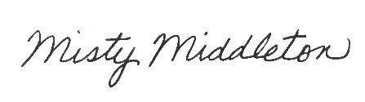
Signature:____________________________
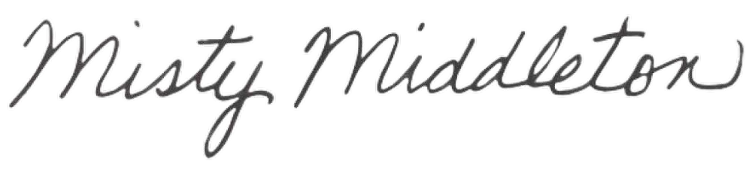
Name: Misty Middleton

Date: August 19, 2026

Title: Superintendent

