
CERTIFIED EVALUATION PLAN
2026-2027

530 Perryville Rd
Harrodsburg, Kentucky 40330
(859) 733-7000

Jason Booher
Superintendent

BOARD MEMBERS
Mr. Randy Phillips, Chairperson
Mrs. Amy Hart
Mr. Billy Montgomery
Mrs. Amber Franceschi
Mr. Cliff Prewitt
Approved: XXXXXXXXX

COMMITTEE MEMBERS:
Nicky Keller, Teacher
Nekita Johnson, Administrator
Sara Cunningham, Teacher
Jaziel Guerra, Administrator
Leewood Arnold, Teacher
Jason Bryant, Administrator
Haley Spivey, Teacher
Mike Floro, Administrator

Jason McAllister, District Instruction
Facilitator/Designated Contact Person
Revised: May 2026

Mercer County Schools
Certified Personnel Evaluation Plan Committee
Meeting Summary Report

The Mercer County Schools Certified Evaluation Committee met in May 2026, to finalize teacher and administrator evaluation systems for Mercer County Schools. The following state recommendations were met and unanimously approved by the committee:
- The evaluation criteria and process used to evaluate certified school personnel shall be explained to and discussed with the evaluatee no later than the end of the evaluatee’s first thirty (30) calendar days of reporting for employment each school year. (704 KAR 3:370)
- All certified school personnel who have not attained continuing service status shall receive an annual summative evaluation and shall incorporate the formative data collected during the Kentucky Teacher Internship Program (if funded). (KRS 156.557)Option 2
- All certified school personnel who have attained continuing service status shall receive a summative evaluation once every five (5) years. (KRS 156.557)
- Each evaluator will be trained, tested, and approved in the use of appropriate evaluation techniques (KRS 156.557).
- This plan requires a summative evaluation of certified school personnel to be documented in writing and to be included in the evaluatee’s official personnel record. (704 KAR 3:370)
- The local evaluation plan provides for the right to a hearing as to every appeal, an opportunity to review all documents presented to the evaluation appeals panel, and a right to presence of evaluatee’s chosen representative (KRS 156.557).
- The evaluation plan process will not discriminate on the basis of age, race, color, national origin, religion, sex, disability, or any other protected characteristic, as required by all applicable federal, state, and local law.
- The local board of education shall review, as needed, the district’s certified evaluation plan to ensure compliance with KRS 156.557 and this administrative regulation. If a source of evidence is added or removed from the certified evaluation plan or if a decision rule or calculation is changed in the summative rating formula, the revised certified evaluation plan shall be reviewed and approved by the local board of education. If the local board of education determines the changes do not meet the requirements of KRS 156.557, the certified evaluation plan shall be returned to the certified evaluation committee for revision.
- The local board of education approved the evaluation plan as recorded in the minutes of the meeting. (704 KAR 3:370)
Table of Contents
1 - Introduction and Evaluation Plan for Certified Staff Page 5
2 - Evaluation Procedures (ALL Certified Personnel) Page 8
3 - Appeals Process (ALL Certified Personnel) Page 13
4 - Retention of Records (ALL Certified Personnel) Page 16
5 - TPGES / OPGES / Other District Certified Evaluation Plan Page 17
6 – TPGES / OPGES Professional Growth and Effectiveness Page 20
7 – PPGES and OTHER DISTRICT CERT Page 28
8 – Standards Page 35
9 – Certified Evaluation Timeline Page 41
10 - KRS, KAR and School District Policy Evaluation Documents Page 42

- INTRODUCTION
The Mercer County School System recognizes and accepts the responsibility for providing capable and effective certified personnel to meet the learning needs of all students. The evaluation process for certified staff is the instrument used to develop a school's most important resource--an expert certified staff member. The instructional capability of certified staff members determine the effectiveness of student learning. The researched-based instructional goals of the evaluation process are aligned with state and national standards. Evaluation is a means to determine to what extent best practices are implemented, to identify areas for professional growth, and to maintain an able, enthusiastic staff. Evaluation will lead to a more confident and productive staff by placing an emphasis on professional growth. The evaluation process is a collaborative process, and all results shall be confidential. This evaluation plan is in accordance with KRS 156.557, the statute governing the certified personnel evaluation program and 704 KAR 3:370 as amended by the Kentucky Board of Education.
This plan combines administrator/teacher appraisal with improvement strategies which emphasizes interaction between the evaluator and the evaluatee. The evaluation process focuses on teacher/administrative best practices that are research-based, provide for evaluating the evaluatee individually, and places importance on both the strengths and the areas of needed growth. The Mercer County Certified Personnel Evaluation Plan has been developed by an equal number of teachers and administrators. 704 KAR 3:370 Section 1(7); Section 2(1).
The evaluation plan is a means for increasing the knowledge, skills, and self-confidence of all teachers and administrators in the Mercer County School District, but the true measure of this plan’s effectiveness will be determined by the educational successes of Mercer County students. This plan has been approved by the local board of education (704 KAR 3:370 Section 2 (2)). If any substantive change is made to this evaluation plan, the local board of education shall utilize an evaluation committee, as provided in Section 5 of this administrative regulation, in formulating the revision. A revision to the plan shall be reviewed and approved by the local board of education and submitted to the Kentucky Department of Education for approval (704 KAR 3:370 Section 4).
PURPOSE
The purpose of the Mercer County Certified Evaluation System is to:
1. Improve the overall instructional program for the educational success of students.
2. Maintain effective communication and a high level of trust between teachers & administrators.
3. Identify and promote effective teaching practices and maintain a high level of performance.
4. Provide a measure of performance accountability.
5. Provide training for evaluators to assist in improving instructional leadership.
6. Provide information for developing a high quality professional development program that is aligned with the district and school improvement plans.
7. Provide information to be used in contract decisions.
8. Assure compliance with state and national laws.

PRE-EVALUATION STAGE (PREPARATION FOR NEW CYCLE)
Certified Staff Orientation - An orientation discussion is required no later than the end of 30 calendar days after certified staff in the school district have reported to work on an annual basis. At the beginning of each school year, certified staff will be provided information about the evaluation system to include standards / performance criteria, procedures, specific goals and objectives of the Comprehensive School Improvement Plan. The intent of the orientation is for certified staff to become knowledgeable of the evaluation system. [704 KAR 3:370, Section (2) (g)]

ASSIGNMENT OF EVALUATION SYSTEM FOR CERTIFIED EMPLOYEES
The Framework for Teaching will be used for all certified teachers in the district, including pre-school, special education and alternative setting teachers.
The Specialist Frameworks will be used for all Media Specialists, Counselors, Speech and Language Pathologists, School Psychologists, Special Education Consultants, both building-level and district Instructional Coaches, ELL Teachers, and GT Teachers.
Professional Standards for Educational Leaders (PSEL) will be used for all building-level principals and assistant principals.
Other District Certified Performance Standards will be used for all certified district administrators.

FORMATIVE EVALUATION (KRS 156.557 Section (3) (b) and 704 KAR 3:370 Section 2 (e))
A component of the system which requires the evaluator to observe the teacher/administrator in the classroom/instructional environment and to interact with the teacher/administrator about the results. More specifically, each formative evaluation will include:
-Observing the teacher and/or administrator and students in the instructional setting;
-Documenting specific information for interacting with the teacher/administrator;
-Analyzing the results in preparation for a conference with the teacher/administrator;
-Conferencing with the teacher/administrator to identify strengths and areas for growth;
-Developing strategies for growth;
-Assisting the teacher/administrator with implementing these strategies; and
-Reviewing evidence of standards/performance criteria provided by evaluatee or evaluator.

The number of observations will be determined by the procedures described in this manual. The results of all formative observations will be considered by the evaluator in developing the summative report.

SUMMATIVE EVALUATION (KRS 156.557 Section (3) (b) and 704 KAR 3:370 Section 2 (e)) -A stage of the system which leads to a summary of all evaluation results gathered during the total evaluation cycle.
The summative evaluation marks the end of the cycle and requires a report of the evaluatee's status on all performance criteria and a review of the current individual professional growth plan.
Summative Report-The evaluator will complete a report rating the teacher/administrator on all performance measures, with appropriate statements to help clarify the performance of the evaluatee and will be shared at the summative conference.
Summative Conference-Evaluatee and evaluator will meet to discuss the evaluatee's performance during the total evaluation cycle. Both strengths and needs for growth will be discussed. An individual professional growth plan for addressing the performance of the evaluatee during the next evaluation cycle will begin to be developed.

PROFESSIONAL GROWTH PLAN - A plan whereby the evaluatee develops goals, objectives, and activities for becoming more proficient as a teacher or administrator. The individualized plan includes an objective(s), a plan for achieving the objective(s), and a method for evaluating the success of the plan. The individualized professional growth plan shall be aligned with specific goals and objectives of the district/school improvement plan.
All certified staff below the level of Superintendent shall annually develop or review Individual Professional Growth Plans.

CERTIFIED STAFF PORTFOLIO (OPTIONAL) – A collection of data based and organized on standards/performance criteria by the evaluatee. A portfolio may be used to enhance and provide documentation of the performance criteria for the summative evaluation.

- EVALUATION PROCEDURES
EVALUATION CYCLE
The Mercer County Certified Personnel Evaluation System is individualized in that each certified person is evaluated independently of all others including observations, conferences, reports, and plans for improvement.

The length of the cycle is as follows:
Non-tenured teachers One (1) year
Tenured certified teachers (all roles) Five (5) years
Counselors One (1) year for first two years in role
Five (5) years after that.
Principals/Other District Cert Every year for non-tenured.
Five (5) years for tenured.
Teacher evaluation is an ongoing process. The summative evaluation shall be a composite of observed data collected throughout the entire cycle. Each cycle will include formative evaluation(s), a summative evaluation and an individual professional growth plan. A schedule for teacher evaluation will be published annually.

CERTIFIED STAFF MISSING 60 OR MORE CONSECUTIVE DAYS
For a tenured teacher or other certified evaluatee in their summative year who does not report for work sixty (60) or more consecutive school days, the summative cycle will be extended to the following school year. A non-tenured certified staff member who does not report for work sixty (60) or more consecutive school days will utilize the late hire evaluation cycle after consultation with their evaluator.

EVALUATION CYCLE FOR LATE HIRES
The evaluation cycle for late hires will depend on when the evaluatee was hired during the year. For all certified employees hired on or before 60 consecutive instructional days, all components of the evaluation cycle will be required by the evaluatee. For individuals hired after the 60th instructional day, the following adjustments will be made:
Teachers – Evaluatee will receive one full observation from their primary evaluator. The evaluatee will complete a Professional Growth Plan and Self-reflection within 30 working days of date of hire.
Principals / Assistant Principals – Evaluatee will be required to receive two site visits from their supervisor.
All other certified staff – will receive one formal observation / site visit and will submit a Professional Growth Plan within 30 working days of the date of hire.

EVALUATEE
Evaluatees for the Certified Personnel Evaluation System include all certified school employees assigned to a school (part and full-time) except the principal, assistant principal, and counselor(s). Itinerant teachers shall be assigned a primary evaluator and this assignment will be determined by the district.
EVALUATOR
The immediate supervisor (normally the principal or assistant principal for teachers; superintendent or designee for administrators) shall serve as the evaluator of the employees covered by the evaluation plan. The district will train the primary evaluators in the local evaluation process. The primary evaluator, with the exception of a district board of education member, shall be trained, tested, and approved as an evaluator by the Kentucky Department of Education (KRS 156.557 Section (5) (c2). Administrator/Evaluator means a certified staff person who devotes the majority of his employed time to service in the position for which administration certification is required by the Education Professional Standards Board in Title 16 KAR.

OBSERVATIONS
Teachers – Evaluatees on a one (1) year evaluation cycle shall be observed two times each year* by their evaluator. Evaluatees on a five (5) year evaluation cycle shall have a mini and two full observations by their evaluator over their five-year cycle, as shown in the graphic below:
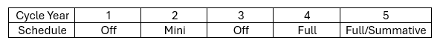
All observations will be scheduled. Additional scheduled or unscheduled observations may be requested by either the evaluator or evaluatee. Multiple observations for tenured teachers shall occur when observations are unsatisfactory.
*Additional observations by the evaluator are always allowable as needed.

All Administrators and Other District Certified Staff - Evaluatees on a yearly or an every five (5) year cycle shall be observed no fewer than two times. Observations will be scheduled. Additional scheduled or unscheduled observations may be requested by either the evaluator or evaluate. Multiple observations for tenured teachers shall occur when observations are unsatisfactory.

All observations are conducted openly. If requested by the teacher, observations by another teacher trained in the teacher’s content area or by a curriculum content specialist shall be provided. The selection of the third-party observer shall, if possible, be determined through mutual agreement by evaluator and evaluatee. A teacher who exercises this option shall do so, in writing to the evaluator, by no later than February 15 of the academic year in which the summative evaluation occurs. If the evaluator and evaluatee have not agreed upon the selection of the third-party observer within five (5) working days of the teacher’s written request, the evaluator shall select the third-party observer.

DATA COLLECTION DOCUMENTATION AND REPORTING
The results of each observation shall be documented by the evaluator in preparation for a conference with the evaluatee. All formative and summative evaluation reports shall be in writing and on official report forms provided by the school district. Data collection tools (i.e. scripting, narratives, forms, etc.) are considered part of the official evaluation report. All information collected shall be shared and copies of such information given to all parties. During the cycle, the evaluatee shall be rated on each performance criteria, both formally and informally observed, i.e. walk through. A copy of the report (formative or summative) will be provided to the evaluatee during the conference. All reports will be signed by both the evaluator and evaluatee to confirm that the report has been completed and reviewed by both parties. Copies of the evaluation shall be given to the evaluatee (certified staff/administrators).

CONFERENCE
Conference means a meeting involving the evaluator and the certified employee (including administrators) being evaluated. The purpose is to provide feedback from the evaluator and to analyze the results of observation(s) and other information to determine accomplishments and areas for growth. This will lead to establishment or revision of an individual professional growth plan.
During the formative stage, the evaluator shall hold a post-observation conference with the evaluatee within five working days from the time of observation to discuss the results. If needed, the evaluator and evaluatee will develop strategies for follow-up activities. A written report is required. (704 KAR 3:370 Section 2 (c))

PERFORMANCE CRITERIA
The standards for measuring the performance of certified staff are called Performance Measures. (704 KAR 3:370 Section 8) The report will serve as a guide for the conference but will not necessarily include all of the details discussed with the evaluatee. The formative evaluation report may be revised as a result of the conference. The evaluatee shall be provided a copy of the report which shall be signed by both the evaluatee and evaluator. The signatures verify that each party had an opportunity to study the report and to discuss the contents in a conference. The signature of the evaluatee does not signify agreement with the evaluation results or the suggestions.

CERTIFIED EVALUATION SUMMATIVE INFORMATION The summative instrument is designed to provide a summary of all data collected during the evaluation cycle. The evaluatee will be provided an opportunity to react in writing to the total summative report on a form provided by the school district, within ten working days from the date of the conference. Teacher reaction forms may be obtained from the evaluator. Summative evaluations for itinerant teachers will be completed by the primary evaluator. The primary evaluator will complete the summative evaluation form in collaboration with evaluators to whom the evaluatee is assigned. The summative conference may be attended by all evaluators. The summative forms will become part of the evaluatee’s official personnel file. Summative evaluations for administrators shall occur annually in their first two years, then on a three-year cycle going forward.

INDIVIDUAL PROFESSIONAL GROWTH PLAN
All certified staff below the level of superintendent shall, jointly with the evaluator, develop a plan for professional growth. The individual professional growth plan will be aligned with the specific goals and objectives of the Comprehensive School/District Improvement Plans. The forms provided by the school system shall be used for providing a written description of the plan. The plan shall be signed by both parties, each of whom shall retain a copy. Signatures show that parties agree with the plan.

All certified personnel shall have an annual review of their individual professional growth plans regardless of whether they are being formally evaluated or not. Provisions for the superintendent’s professional growth shall be pursuant to KRS 156.111.

The following items are included in the growth plan:
1. Performance Measure Component - The area(s) that shall be targeted for growth should be marked.
2. Professional Growth Goal - The objective(s) describe desirable outcomes. The outcomes should be specific, measurable, and directly related to the needs. The evaluator will initial and date the form to indicate the objective(s) has been met. Objectives not met must be carried forward.
3. Action Plan - Professional Learning, Resources / Support Needed and Measures of Goal Attainment identified
4. On-going Reflection – Progress toward professional growth goal with revisions / modifications noted as needed
5. Summative Reflection – Assess the level of attainment towards the professional growth goal at the end of the year and determine next steps
6. Evaluatee's comments - Any statement the evaluatee would like to make.
7. Evaluator's comments - Any statement the evaluator would like to make.

INSTRUMENT FOR ALL DISTRICT CERTIFIED STAFF
All of the evaluations, with the exception of the superintendent, shall be on approved forms to become part of the official personnel file of each certified employee. (KRS 156.557 Section (5) (1)) The formative evaluation instruments are designed to facilitate the evaluation process. They serve as both a rating system and a link to the summative report. The formative instruments provide for rating the administrator/teacher against individual performance criteria. For each criterion, there is a set of indicators and a rating rubric. Together they assist the evaluator in assessing, recording, and communicating specific strengths and areas for improvement. The evaluator observes the evaluatee using the criteria and indicators as a basis for the observation and analysis of teaching. Evaluatees are reminded that classroom observations are not the only means of collecting data for the evaluation plan. Indicators serve, in part, as evidence the performance criteria have been met. After all data has been considered, the evaluator rates the evaluatee by selecting a descriptive statement that most nearly matches the evaluation results.

The rating rubric is comprised of four (4) separate evaluation descriptors of teacher/administrator behaviors:
- Exemplary
- Accomplished
- Developing
- Ineffective
Because individual education program (IEP) goals are student-specific, IEP goals may inform, but shall not be used as a single source of evidence for any performance measure. Space is provided for written comments that will help clarify the rating and identify indicators not observed. Space is also provided at the end of the report for written comments from the evaluatee and evaluator (teacher/administrator). An opportunity for a written response by the evaluatee shall become an official part of the personnel file. (704 KAR 3:370 Section 2 (j))

INDIVIDUAL CORRECTIVE ACTION PLAN
In the event that the evaluatee consistently performs at a level below district standards, fails to achieve growth plan objectives, or there is a need for an immediate change, the evaluator may establish an Individual Corrective Action Plan (ICAP). The specific process for growth/corrective action is located on pages 95-101. The ICAP Team consists of the evaluator and evaluatee. Additional members may include a resource administrator (selected by the evaluator) and a teacher mentor (selected by the evaluatee). The teacher mentor must be selected from a list of teachers provided by the principal. Upon selection by the evaluatee, the teacher mentor will have training by the principal regarding ICAP procedures and process. The ICAP Team is initiated and developed by the primary evaluator after it is found that the certified staff member does not meet district standards. The ICAP Team is monitored by the primary evaluator.

- APPEALS PROCESS
An appeals panel is established in accordance with KRS 156.557 and 704 KAR 3:370. If the evaluatee is dissatisfied with the summative evaluation results (content and/or due process), he/she may submit to the evaluator and superintendent a written response to the report, a copy of which will be attached to the evaluation report and placed in the evaluatee's file.

At the request of a certified staff member, he/she may appeal to a panel formed for that purpose. The panel is comprised of three members. Certified school employees shall elect two members and alternates. The board of education shall appoint one certified member and one alternate. Only certified school employees of the Mercer County Board of Education are eligible to serve on the panel. Members are elected / appointed for a one year term and may be re-elected / re-appointed. In the election of the appeals panel members, the persons receiving the first and second greatest number of votes shall be members of the appeals panel. The persons receiving the third and fourth greatest number of votes shall be designated as alternates. An alternate will serve on the panel under the following circumstances: 1) A member of the panel wishes to make an appeal; 2) Illness or circumstances beyond a member’s control prevents attendance; 3) A relative of a panel member is appealing; or 4) A member has been prejudiced in the appeal being considered.

Release time shall be provided for appeals panel members at the discretion of the superintendent. Funding for panel expenses will be provided from the district's general fund. The election process shall take place during August/September of each year. The election shall be conducted by the District Contact Person using the following criteria:
-Open nomination
-Secret Ballot
-One Person/One Vote
-All certified employees given the opportunity to vote.

The appeals panel shall select a chairperson from the panel members. The chairperson shall be responsible for scheduling and facilitating the activities of the panel and for communicating on behalf of the panel to all parties involved in any appeal. District panel members may seek training through the District Contact Person.

To appeal an evaluation, the evaluatee must make a written request for a hearing to the appeals panel within five (5) working days from the summative conference date. A copy is to be sent to the evaluator and superintendent. The evaluatee can either allow the appeals panel to decide the matter based on written documents alone or request a hearing.
If a hearing is not requested by the certified personnel on the Certified Evaluation Appeals Form, the panel will decide the matter based on written documents submitted by the evaluatee and evaluator. At any time, either the appellant or the evaluator may concede in writing to the Chairperson, and the process will be terminated. Based on the issues identified in the certified personnel’s appeal documentation, the panel shall determine whether the employee has demonstrated that a procedural violation has occurred under the District’s evaluation plan and whether the summative evaluation is supported by the evidence.

If a hearing is requested, the panel will conduct a hearing within fifteen (15) working days from the date of receipt of the letter of request. The evaluatee and evaluator will be invited to appear at the hearing. Both parties may be represented by a person(s) of their choice. All discussions between the panel members, evaluatee, and evaluator about the case shall be confined to the hearing(s). There must be an opportunity, five (5) days in advance of the hearing, for the evaluator and evaluatee to adequately review all documents that are to be presented to the district evaluation appeals panel. After completing the hearing, the panel will declare the evaluation as valid or invalid and make a recommendation to the superintendent for action within three (3) working days of the panel's decision.
The hearing will adhere to the following format:
- Reading of the written appeal by the panel Chairperson.
- Questioning of the evaluatee and/or evaluator by the panel.
- Presentation of relevant evidence and witnesses by the evaluatee in support of the appeal.
- Presentation of relevant evidence and witnesses by the evaluator in support of the summative evaluation.
- Follow-up questioning by panel of any witnesses, evaluatee, and/or evaluator.
- Dismissal of hearing.

The panel's recommendation must include one of the following:
-uphold the original evaluation;
-rule in favor of the appellant, either in part or in whole;
-remove the summative or any part of the summative from the personnel file;
-recommend a new evaluation by a second certified evaluator;
-initiate appeals / hearings process in accordance with board policy: 3.18.AP11
If the panel recommends a second evaluation, the superintendent shall appoint an evaluator from a list of three candidates nominated by the evaluatee. The evaluatee shall select the three candidates from a list of all qualified evaluators employed by the Mercer County Board of Education.

The second evaluation shall be reported to the superintendent, who shall make all final decisions about the status of the evaluatee. Any evaluatee who feels that any content and/or due process issues were violated may appeal the decision to the State Board for Elementary and Secondary Education Appeals Panel. Consult board policy for further information regarding the evaluation/appeals process.

BURDEN OF PROOF – The certified employee appealing to the panel bears responsibility to provide evidence to refute or challenge the findings of the evaluation. The evaluator is responsible for providing documentation related to the evaluation and may respond to any statements made by the employee and may present written records that support the summative evaluation. Each party may have a representative (legal or non-legal counsel) present during the hearing process.

SUPERINTENDENT – The superintendent shall receive the panel’s recommendation and cause it to be attached to the original evaluation form and filed in the employee’s personnel file. The superintendent may hold a hearing, order another evaluation by a second certified evaluator, and/or take such actions as recommended by the appeals panel. In the case of a new evaluation, both evaluations shall be included in the employee’s personnel file with appropriate annotations. The superintendent shall notify all parties of his/her decision within ten (10) working days after receipt of the appeals panel’s recommendation.

APPEAL TO THE KENTUCKY BOARD OF EDUCATION – Regardless of either the appeals panel or superintendent’s recommendations/decisions any certified employee who feels that the local district is not properly implementing the evaluation plan according to the way it was approved by the Kentucky Department of Education shall have the opportunity to appeal to the Kentucky Board of Education (704 KAR 3:370 Section 12).

- RETENTION OF RECORDS
A performance evaluation file shall be established for each certified employee by his/her immediate supervisor (evaluator). The evaluator shall maintain that file in his/her office for the duration of time that the certified employee remains his/her subordinate. If a teacher/administrator is transferred to another school in the district, the supervisor who has the teacher’s/administrator’s performance records shall transfer them to the receiving supervisor (superintendent/principal/evaluator). If a teacher/administrator leaves the school district’s employ, his/her file shall be kept on file in the office of the superintendent or may be destroyed as per the advice of the board of education’s legal counsel.

- CERTIFIED TEACHER (TPGES), CERTIFIED SCHOOL LEVEL PROFESSIONALS (OPGES) AND OTHER DISTRICT LEVEL CERTIFIED PROFESSIONAL GROWTH AND EFFECTIVENESS SYSTEM

PROFESSIONAL GROWTH AND EFFECTIVENESS SYSTEM OVERVIEW
Effective teaching and school leadership depend on clear standards and expectations, reliable feedback, and the tools, resources and support for professional growth and continuous improvement. The Kentucky Department of Education, with the guidance and oversight of various steering committees, has designed, developed, field tested and piloted a new statewide Professional Growth and Effectiveness System (PGES).
Professional Growth and Effectiveness System – Certified Teacher
The vision for the Professional Growth and Effectiveness System (PGES) is to have every student taught by an effective teacher. The goal is to create a fair and equitable system to measure teacher effectiveness and act as a catalyst for professional growth.
Roles and Definitions
- Artifact: A product of a certified school personnel’s work that demonstrates knowledge and skills.
- Assistant Principal: A certified school personnel who devotes the majority of employed time in the role of assistant principal, for which administrative certification is required by EPSB.
- Certified Administrator: A certified school personnel, other than principal or assistant principal, who devotes the majority of time in a position for which administrative certification is required by EPSB.
- Certified School Personnel: A certified employee, below the level of superintendent, who devotes the majority of time in a position in a district for which certification is required by EPSB.
- Conference: A meeting between the evaluator and the evaluatee for the purposes of providing feedback, analyzing the results of an observation or observations, reviewing other evidence to determine the evaluatee’s accomplishments and areas for growth, and leading to the establishment or revision of a professional growth plan.
- Evaluatee: A certified school personnel who is being evaluated.
- Evaluator: The primary evaluator as described in KRS 156.557(5)(c)2.
- Formative Evaluation: Is defined by KRS 156.557(1)(a).
- Full Observation: An observation conducted by a certified observer that is conducted for the length of a full class period or full lesson.
- Improvement Plan: A plan for improvement up to twelve months in duration for:
  - Teachers and other professionals who are rated ineffective in professional practice and have a low overall student growth rating.
  - Principals who are rated ineffective in professional practice and have high, expected, or low overall student growth rating.
- Job Category: A group or class of certified school personnel positions with closely related functions.
- Local Contribution: A rating based on the degree to which a teacher, other professional, principal, or assistant principal meets student growth goals and is used for the student growth measure.
- Mini Observation: An observation conducted by a certified observer for 20-30 minutes in length.
- Observation: a data collection process conducted by a certified observer, in person or through video, for the purpose of evaluation, including notes, professional judgments, and examination of artifacts made during one (1) or more classroom or worksite visits of any duration.
- Observer Certification: A process of training and ensuring that certified school personnel who serve as observers of evaluatees have demonstrated proficiency in rating teachers and other professionals for the purposes of evaluation and feedback.
- Observer calibration: The process of ensuring that certified school personnel have maintained proficiency and accuracy in observing teachers and other professionals for the purposes of evaluation and providing feedback.
- Other Professionals: Certified school personnel, except for teachers, administrators, assistant principals, or principals.
- Performance Criteria: The areas, skills, or outcomes on which certified school personnel are evaluated.
- Performance Rating: The summative description of a teacher, other professional, principal, or assistant principal evaluatee’s performance, including the ratings listed in Section 8 of this administrative regulation.
- Principal: A certified school personnel who devotes the majority of employed time in the role of principal, for which administrative certification is required by the Education Professional Standards Board pursuant to 16 KAR 3:050.
- Professional Growth and Effectiveness System: An evaluation system to support and improve the performance of certified school personnel that meets the requirements of KRS 156.557(1)(b), (2), and (3) and that uses clear and timely feedback to guide professional development.
- Professional Growth Plan: An individualized plan for a certified personnel that is focused on improving professional practice and leadership skills, aligned with performance standards and the specific goals and objectives of the school improvement plan or the district improvement plan, built using a variety of sources and types of data that reflect student needs and strengths, evaluatee data, and school and district data, produced in consultation with the evaluator, and includes: (a) Goals for enrichment and development that are established by the evaluatee in consultation with the evaluator; (b) Objectives or targets aligned to the goals; (c) An action plan for achieving the objectives or targets and a plan for monitoring progress; (d) A method for evaluating success; and (e) The identification, prioritization, and coordination of presently available school and district resources to accomplish the goals.
- Professional Practice: The demonstration, in the school environment, of the evaluatee’s professional knowledge and skill.
- Professional Practice Rating: The rating that is calculated for a teacher or other professional evaluatee pursuant to Section 9 of this administrative regulation and that is calculated for a principal or assistant principal evaluatee pursuant to the requirements of Section 9 of this administrative regulation.
- Self-Reflection: The process by which certified personnel assesses the effectiveness and adequacy of their knowledge and performance for the purpose of identifying areas for professional learning and growth.
- Student Voice Survey: The student perception survey provided by the department that is administered annually to a minimum of one (1) district-designated group of students per teacher evaluatee or a district designated selection of students and provides data on specific aspects of the instructional environment and professional practice of the teacher or other professional evaluatee.
- Summative Evaluation: Is defined by KRS 156.557(1)(b).
- Teacher: A certified school personnel who has been assigned the lead responsibility for student learning in a classroom, grade level, subject, or course and holds a teaching certificate under 16 KAR 2:010 or 16 KAR 2:020.
- Working Condition’s Survey Goal: a school improvement goal set by a principal or assistant principal every two (2) years with the use of data from the department-approved working conditions survey.

For Additional Definitions and Roles, please see 704 KAR 3:370 Professional Growth and Effectiveness System.

- CERTIFIED TEACHER (TPGES), CERTIFIED SCHOOL LEVEL PROFESSIONALS (OPGES) PROFESSIONAL GROWTH AND EFFECTIVENESS SYSTEM
The Kentucky Framework for Teaching
The Framework for Teaching (and the related Specialist Framework) is designed to support student achievement and professional practice through these four measures:
Planning – Instruction – Environment - Professionalism
Evaluators are required to use the following sources of evidence in determining overall ratings:
- Professional Growth Planning and Self-Reflection
- Observation
- Student Voice
Evaluators may also use these additional sources of evidence to help in determining overall ratings:
- Program Review Evidence
- Team-developed Curriculum Units and Lesson Plans
- Communication Logs
- Timely, targeted feedback from walkthroughs or informal observations
- Student data records
- Student work
- Minutes from committee / department / team meeting minutes
- Video lessons
- Engagement in professional organizations
- Products of practice
- Action research
- Other sources of evidence identified by principal / submitted by teacher
All components and sources of evidence supporting an educator’s professional practice ratings will be completed and stored as either hard copies or through electronic means at the building level.

Professional Growth Planning and Self-Reflection
The Professional Growth Plan will address realistic, focused, and measurable professional goals. The plan will connect data from multiple sources including classroom observation feedback, data on student growth and achievement, school / district improvement plans and professional growth needs identified through self-assessment and reflection. In collaboration with the administrators, teachers will identify explicit goals which will drive the focus of professional growth activities, support, and on-going reflection.

Reflective practices and professional growth planning are iterative processes. The teacher (1) reflects on his or her current growth needs based on multiple sources of data and identifies an area or areas for focus; (2) collaborates with his or her administrator to develop a professional growth plan and action steps; (3) implements the plan; (4) regularly reflects on the progress and impact of the plan on his or her professional practice; (5) modifies the plan as appropriate; (6) continues implementation and ongoing reflection; (7) and, finally, conducts a summative reflection on the degree of goal attainment and the implications for next steps. Teacher self-reflection will be focused on professional growth goals, student growth goals and identified areas of need through principal, walkthroughs and other sources of evidence.

All certified teachers will participate in self-reflection and professional growth planning each year as required by the state. All teachers shall complete and submit the self-reflection and professional growth plan to their building principal by October 1st (Or 30th calendar day for an individual hired after September 1st). The self-reflection shall identify a minimum of one area for professional growth. With each PGP submission, the principal will either (A.) APPROVE the PGP as written. (B.) Request revisions to the PGP and send it back with instructions . (C.) Reject the PGP and request a conference with the teacher. The principals will do a mid-year review of all PGP’s to verify the plan of action taken and monitor progress of goal attainment. A final check will be made of all PGP’s prior to the end of the school year to determine if goal attainment has been achieved. The type of growth plan is determined by the growth planning matrix found in this document. Teachers who are employed once the school year has started will have their submission and revision dates established by their building principal.
Required
- All teachers will participate in self-reflection and professional growth planning each year.
- All teachers will document self-reflection and professional growth planning on district-approved documents.
Self-Reflection and Professional Growth Planning Timeline:
Step | Timeline
- Complete initial self-reflection process;  - Identify a minimum of one component from Kentucky Framework for Teaching to target for professional growth;  - Write a professional growth plan and submit for principal or designee approval | Returning Certified Staff:  By October 1  OR  Newly Hired , Late Hired or Transferred Staff:  Within 30 days of employee’s reporting for employment (or by October 1 if hired before Sept. 1)
- Implement action plan | Immediately upon principal or designee plan approval
- Reflect on the Professional Growth Plan and modify the plan if appropriate (any modifications must be resubmitted and approved by the principal or designee) | Ongoing
- Mid-year review  - Submit evidence of action plan implementation to principal or designee and document evidence. | Returning Certified Staff:  No later than the 110th day of instruction. PGP will be revisited during the midyear conference.  OR  Newly Hired , Late Hired or Transferred Staff:  Date to be determined by the principal or designee and teacher.
- Submit summative self-reflection | No later than the last day of the evaluatee’s current contract

Pre-Observation Conference (Teachers ONLY)
The evaluator and evaluatee will meet to discuss classroom observation sessions. The conference is required for:
- Certified teachers new to the school district;
- Teachers on a one-year evaluation cycle;
- Teachers on continuing contract status and scheduled for formative observation and;
- Teachers being re-evaluated as deemed necessary by the evaluator.
Observation
The observation process is one source of evidence to determine teacher effectiveness that includes supervisor observation for each certified teacher in the summative year. Supervisor observations will use the same instruments. The supervisor observation will provide documentation and feedback to measure the effectiveness of a teacher’s professional practice. Only the supervisor observation will be used to inform and calculate a summative rating. The rationale for the observation is to encourage continued professional learning in teaching and learning through critical reflection.

Observation Model
The observation model must fulfill the following minimum criteria:
- A minimum of Two (2) observations (All certified and other certified evaluatees) in the summative cycle, conducted by the supervisor all which must occur in the final year of the cycle.
- Final observation is conducted by the supervisor and is a full observation.
- All observations must be documented on district-approved forms.

The Progressive Observation Model
In the summative year of the cycle, the principal or designee will conduct a minimum of two (2) full observations for non-tenured and one (1) for tenured, consisting of a full class or lesson observation. At each observation interval, the observer will provide meaningful, just in time, feedback. The principal or designee may increase the length, frequency, and nature of observations conducted for the purpose of evaluation based on the individual needs and/or performances of evaluatee.

Observation / Workplace Visit Conferencing
Observers will adhere to the following observation conferencing requirements
- Conduct observation conference within five (5) working days.
- The summative evaluation conference shall be held at the end of the summative evaluation cycle.
- Pre-observation communication may occur through written electronic correspondence or face to face at the discretion of the principal. If the teacher requests face to face communication, the principal must meet face to face.
- Pre-observation communication must be completed within three (3) working days prior to the scheduled observation.
- Post-observation communication shall occur through a face to face conference within five (5) working days following the observation. With agreement from both parties, the post conference may occur through video-conferencing if necessary to fulfill the five (5) working day deadline.
- Pre- conference forms are used at the discretion of the school – the school may use their own form.
. Observation / Workplace Visit Schedule
- Observations may begin after the evaluation criteria and process is shared with the evaluatee, which must be completed within the evaluatee’s first 30 calendar days of reporting for employment.
- One observation by the supervisor should be completed in each semester of the year.

Evaluator Certification
All administrators serving as a primary evaluator must complete the Initial Certified Evaluation Training prior to conducting summative evaluations. All evaluators must be trained, tested and approved according to 704 KAR 3:370 Section 6. Prior to conducting observations or site visits, evaluators will be trained in effective observation and conferencing techniques, in providing clear and timely feedback, in establishing and assisting with a professional growth plan and in summative decision techniques. Each evaluator will attain a minimum of six (6) hours annually of personnel evaluation system training approved by EILA credit, as established in 704 KAR 3:325.

Student Voice
The Student Voice Survey is a confidential survey collecting student feedback on specific aspects of the classroom experience and teaching practice.
Required
- All teachers will participate in the state-approved Student Voice Survey annually with a minimum of one identified group of students.
- There will be two district-determined windows during the school year for students to be given the student voice survey, but teachers will only participate in one survey window each year.
- Student selection for participation must be consistent across the district.
- The Student Voice Survey will be administered during the school day in the school.
- Survey data will be considered only when six (6) or more students are respondents. Teachers with less than six (6) students will not have the survey data used as formative data by their supervisor.
- The Instructional Supervisor will be the District Student Voice Survey Point-of-Contact.
- Each principal will establish the process for determining the student group(s) who will participate in the survey, ensuring equal access to all students.
- Each principal will identify the timeline for administration of the Student Voice Survey.
- Results will be used as a source of evidence for Professional Practice.
- Formative years’ data will be used to inform Professional Practice in the summative year.
- The survey will be administered in the school.
- Principals and teachers may agree on additional student survey data to be given in the event the class surveyed has not completed the survey in good faith or because of teacher concerns regarding validity.
- All Student Voice survey data may be finalized and shared with the teacher as soon as it is available and must be shared no later than the summative conference with the primary evaluator.
- Students with IEPs, 504 Plans, and/or Limited English Proficiency Plans will receive the requisite support to ensure equal access while protecting confidentiality of all parties.

Products of Practice/Other Sources of Evidence
Teachers may provide additional evidence to support assessment of their own professional practice. This evidence should yield information related to the teacher’s practice within the measures.
Required
- observations conducted by certified supervisor observer(s)
- self-reflection and professional growth plans
Other Evidence
- Student Voice Survey(s)
- Program Evidence
- Team-developed Curriculum Units and Lesson Plans
- Communication Logs
- Timely, targeted feedback from walkthroughs or informal observations
- Student data records
- Student work
- Minutes from committee / department / team meeting minutes
- Video lessons
- Engagement in professional organizations
- Products of practice
- Action research
- Other sources of evidence identified by principal / submitted by teacher

Determining the Summative Rating
Supervisors are responsible for determining a Summative Rating for each teacher at the conclusion of the summative evaluation year. The Summative Rating is determined by the educator’s ratings (Exemplary, Accomplished, Developing or Ineffective) on the performance measures of Planning, Environment, Instruction and Professionalism. The evaluator determines the performance measure ratings based on professional judgment informed by evidence that demonstrates the educator's performance against the measures and decision rules that establish a common understanding of performance thresholds to which all educators are held.

The Kentucky Framework for Teaching stands as the critical rubric for providing educators and evaluators with concrete descriptions of practice associated with specific performance measures. Each element describes a discrete behavior or related set of behaviors that educators and evaluators can prioritize for evidence-gathering, feedback, and eventually, evaluation. Supervisors will organize and analyze evidence for each individual educator based on these concrete descriptions of practice.

Supervisors and educators will be engaged in ongoing dialogue throughout the evaluation cycle. All evidence used to produce certified school personnel's overall performance rating shall be included in the documentation of the summative evaluation. The process concludes with the evaluator’s analysis of evidence and the final assessment of practice in relation to performance described under each performance measure at the culmination of an educator’s cycle.

An educator’s Summative Rating is determined using the following steps:
- Determine the individual performance measure ratings through the use of sources of evidence and professional judgment.
- Apply district decision rules for determining an educator’s Summative Rating.

CRITERIA FOR DETERMINING SUMMATIVE RATING OF TEACHERS, OTHER PROFESSIONALS (SPECIALISTS) AND OTHER DISTRICT CERTIFIED
IF… | THEN…
Environment and Instruction are rated INEFFECTIVE | Summative Rating shall be INEFFECTIVE
Environment OR Instruction are rated INEFFECTIVE | Summative Rating shall NOT be ACCOMPLISHED
Planning OR Professionalism are rated INEFFECTIVE | Summative Rating shall NOT be EXEMPLARY
Environment and Instruction are rated DEVELOPING | Summative Rating shall be DEVELOPING
Two Measures (CANNOT be both Environment and Instruction) are rated DEVELOPING and two Measures are rated ACCOMPLISHED | Summative Rating shall be ACCOMPLISHED
Two Measures are rated DEVELOPING and two Measures are rated EXEMPLARY | Summative Rating shall be ACCOMPLISHED
Two Measures are rated ACCOMPLISHED and two Measures are rated EXEMPLARY | Summative Rating shall be EXEMPLARY
Professional Growth Plan and Summative Cycle - Based on the overall Professional Practice rating and Student Growth rating, the type of Growth Plan and the cycle length is determined w/the chart below:
PROFESSIONAL GROWTH AND CYCLE FOR TENURED TEACHERS AND OTHER PROFESSIONALS
Exemplary  Accomplished | FIVE-YEAR CYCLE - SELF-DIRECTED GROWTH PLAN  - Goals set by teacher with evaluator input  - Plan activities are teacher directed and implemented with colleagues  - Formative review annually  - Summative occurs at the end of year 3
Developing | FIVE-YEAR CYCLE - SELF-DIRECTED GROWTH PLAN  - Goal(s) set by teacher /evaluator input; one must address professional practice  - Formative review annually
Ineffective | ONE YEAR DIRECTED GROWTH PLAN  - Goal determined by evaluator  - Goals focused on low performance/outcome area  - Plan activities designed by evaluator with educator input  - Formative review at midpoint - Summative at end of plan

- PRINCIPAL, ASSISTANT PRINCIPAL and OTHER DISTRICT CERTIFIED - PPGES
Evaluators will look for trends and patterns in practice across multiple types of evidence and apply their professional judgment based on this evidence when evaluating a principal. The role of evidence and professional judgment in the determination of ratings on standards and an overall rating is paramount in this process. However, professional judgment must be grounded in the common framework identified: The Principal Performance Standards.
Professional Standards for Educational Leaders
PSEL are designed to support student achievement and professional best-practice through the standards of Mission, Vision and Core Values; Ethics and Professional Norms; Equity and Cultural Responsiveness; Curriculum, Instruction and Assessment; Community of Care and support for Students; Professional Capacity of School Personnel; Professional Community for Teacher and Staff; Meaningful Engagement of Families and Community; Operations and Management; School Improvement. Included in the Performance Standards are Performance Indicators that provide examples of observable, tangible behaviors that provide evidence of each standard. The Performance Standards provide the structure for feedback for continuous improvement through individual goals that target professional growth, thus supporting overall student achievement and school improvement. Evidence supporting a principal’s or assistant principal’s professional practice will be situated within one or more of the 10 standards. Performance will be rated for each standard according to the four performance levels: Ineffective, Developing, Accomplished, and Exemplary. It is projected that most principals or assistant principals will maintain an Accomplished rating, but will occasionally have exemplary performance on standards at any given time. The summative rating will be a holistic representation of performance, combining data from multiple sources of evidence across each standard.

The use of professional judgment based on multiple sources of evidence promotes a more holistic and comprehensive analysis of practice, rather than over-reliance on one individual data point or rote calculation of practice based on predetermined formulas. Evaluators will also take into account how principals respond to or apply additional supports and resources designed to promote student learning, as well as their own professional growth and development. Finally, professional judgment gives evaluators the flexibility to account for a wide variety of factors related to individual principal performance. These factors may include school-specific priorities that may drive practice in one standard, an educator’s number of goals, experience level and/or leadership opportunities. Contextual variables may also impact the learning environment, such as unanticipated outside events or traumas.

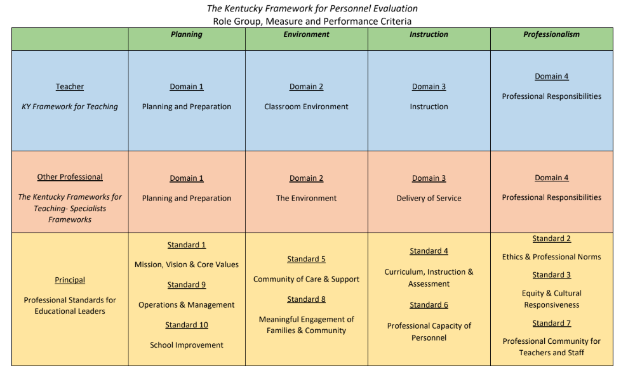

Evaluators must use the following categories of evidence in determining overall ratings:
Required Sources of Evidence For Principal and Other District Certified:
  - Professional Growth Planning
  - Self-Reflection
  - Site-Visits (principals and assistant principals only)
  - Mid-year reviews
  - Working Conditions Goal (principals and assistant principals only)

Evaluators may use the following categories of evidence in determining overall ratings:
- Other Measures of Student Learning
- Products of Practice
- Other Sources

Professional Practice
The following sections provide a detailed overview of the various sources of evidence used to inform Performance Measure Ratings.
Professional Growth Planning – completed by principals & assistant principals and other district certified.
The Professional Growth Plan will address realistic, focused, and measurable professional goals. The plan will connect data from multiple sources including site-visit conferences, data on student growth and achievement, and professional growth needs identified through self-assessment and reflection. Self-reflection improves practice through ongoing, careful consideration of the impact of leadership practice on student growth and achievement.
- All principals will participate in professional growth planning each year.
- All assistant principals will participate in professional growth planning each year.
- All other district certified will participate in professional growth planning each year.
- The initial self-reflection and professional growth plan conference to discuss and approve professional growth goals shall be completed by October 1 or within the first 90 calendar days of the administrator’s contract.
- The progress of professional growth planning will be reviewed between the principal and evaluator during a mid-year review.
- An end-of- year review on the Professional Growth Plan shall be held between the principal and evaluator prior to or during the summative conference.
- PGP will be documented on district-approved forms.
Self-Reflection – completed by principals & assistant principals and other district certified.
- All principals will participate in self-reflection each year.
- All assistant principals will participate in self-reflection each year.
- All other district certified will participate in self-reflection each year.
- The initial self-reflection and professional growth plan conference to discuss and approve professional growth goals shall be completed by October 1 or within the first 90 calendar days of the administrator’s contract.
- Self-reflection will be documented on district-approved forms.

Site-Visits – completed by supervisor of principal – formal site visits are not required for assistant principals
Site visits are a method by which the superintendent may gain insight into the principal’s practice in relation to the standards. During a site visit, the superintendent will discuss various aspects of the job with the principal, and will use the principal’s responses to determine issues to further explore with the faculty and staff. Additionally, the principal may explain the successes and trials the school community has experienced in relation to school improvement.
- Conducted at least twice each year for one hour or more. One visit will be conducted prior to the end of the first semester and one visit prior to the end of the second semester. (Formal site-visits are not required for the assistant principal.)
- A conference (electronic or face-to-face) between the principal and evaluator will be held within five working days of each site visit. If the principal or superintendent requests face to face communication, the conference must occur face-to-face.
- Evidence to support the Principal Performance Standards will be gathered during the site visit to assist the evaluator in assigning a rating.
- Late hires are required to have two site-visits. However, timelines may be adjusted to meet the requirement.
Mid-Year Review: Superintendent or designee shall provide mid-year ratings at the mid-year conference to each principal which will occur by the 110th day of instruction. Principals shall provide mid-year ratings at the mid-year conference to each assistant principal, which will occur by the 110th day of instruction.

Working Conditions Goal (Goal inherited by Assistant Principal)
Principals are responsible for setting a two-year Working Conditions Growth Goal that are connected to the PSEL Standards and are based on the most recent TELL Kentucky Survey. The principal’s effort to accomplish the Working Conditions Growth Goal is a powerful way to enhance professional performance and, in turn, positively impact school culture and student success.
- Developed following the completion of the TELL Kentucky Survey.
- Minimum of one 2-year goal.
- The progress of the working condition goal will be reviewed between the principal and evaluator during both mid-year reviews and at summative conference at the end of year 1.
- The principal and evaluator will use the following rubric to measure the progress of the working conditions goal:
Ineffective | Developing | Accomplished | Exemplary
Below established baseline | Below 10% of WC Growth Goal without going below the established baseline | Either: 1) Within 10% of meeting WC Growth Goal OR 2) 80%-89% staff agreement on identified goal | Either: 1) Above WC Growth Goal OR 2) 90%-100% staff agreement on identified goal

Products of Products of Practice/Other Sources of Evidence
Principals/Assistant principals may provide additional evidence to support assessment of their own professional practice. These evidence should yield information related to the principal’s/assistant principal’s practice within the standards.
- SBDM Minutes
- Faculty Meeting Agendas and Minutes
- Department/Grade Level Agendas and Minutes
- Team Meeting Agendas and Minutes
- Leadership Team Agendas and Minutes
- Instructional Round/Walk-through documentation
- Budgets
- EILA/Professional Learning experience documentation
- Surveys
- Professional Organization memberships
- Parent/Community engagement surveys
- Parent/Community engagement events documentation
- School schedules
- Other sources of evidence identified by superintendent / submitted by principal

Determining the Summative Rating
Superintendents are responsible for determining a Summative Rating for each principal and other district certified and principals are responsible for determining the Summative Rating for each assistant principal at the conclusion of their summative evaluation year. The Summative Rating is informed by the principal / assistant principal's ratings (Exemplary, Accomplished, Developing or Ineffective) on the four performance measures of Planning, Environment, Instruction and Professionalism.
Required:
- Superintendent shall provide mid-year ratings at the mid-year conference to each principal or other district certified, which will occur by the 110th day of instruction. Principals shall provide mid-year ratings at the mid-year conference to each assistant principal, which will occur by the 110th day of instruction.
- The summative conference will take place by the last workday in the month of April for both principals and assistant principals.
- Use professional judgment and data to determine a rating on each of the four performance measures of Planning, Environment, Instruction and Professionalism. The Planning and Environment performance measures contain two standards to rate. Therefore, if there is a conflict, the rating for Organizational Management (Planning) and School Climate (Environment) shall weigh more heavily than the rating for Human Resources (Planning) and Communication / Community Relations (Environment) in order to complete the four performance measure ratings.
- All evidence used to produce certified school personnel's overall performance rating shall be included in the documentation of the summative evaluation.
- Use decision rules to determine a Summative Rating.

Other District Certified Staff will be required to have Self-Reflection, Growth Plans and Mid-Year Reviews.

CRITERIA FOR DETERMINING A PRINCIPAL, OTHER DISTRICT CERTIFIED OR OTHER BUILDING LEVEL ADMINISTRATOR’S SUMMATIVE RATING
IF… | THEN…
Environment and Instruction are rated INEFFECTIVE | Summative Rating shall be INEFFECTIVE
Environment OR Instruction are rated INEFFECTIVE | Summative Rating shall NOT be ACCOMPLISHED
Planning OR Professionalism are rated INEFFECTIVE | Summative Rating shall NOT be EXEMPLARY
Environment and Instruction are rated DEVELOPING | Summative Rating shall be DEVELOPING
Two Measures (CANNOT be both Environment and Instruction) are rated DEVELOPING and two Measures are rated ACCOMPLISHED | Summative Rating shall be ACCOMPLISHED
Two Measures are rated DEVELOPING and two Measures are rated EXEMPLARY | Summative Rating shall be ACCOMPLISHED
Two Measures are rated ACCOMPLISHED and two Measures are rated EXEMPLARY | Summative Rating shall be EXEMPLARY

Professional Growth Plan and Summative Cycle
Based on the overall Professional Practice rating and Student Growth rating, the type of Professional Growth Plan and the length of the summative cycle is determined using the chart below.

PROFESSIONAL GROWTH AND CYCLE FOR PRINCIPALS
ASSISTANT PRINCIPALS AND OTHER DISTRICT CERTIFIED
Exemplary  Accomplished | Shall have a minimum of Professional Growth Plan developed by Evaluatee
Developing | Shall have a minimum of a Professional Growth Plan developed by Evaluatee
Ineffective | Shall have a minimum of a Professional Growth Plan, for a duration of up to one (1) year, developed by the Evaluator

- STANDARDS
Charlotte Danielson’s Framework for Teaching, 2011 - Adapted for Kentucky Department of Education

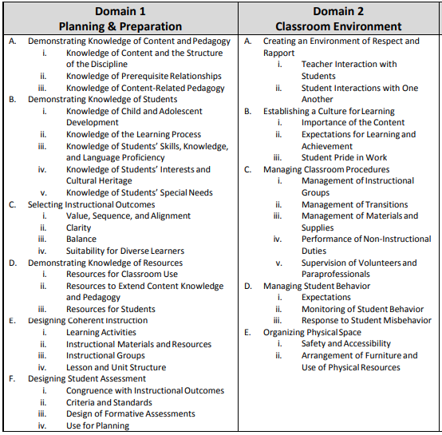

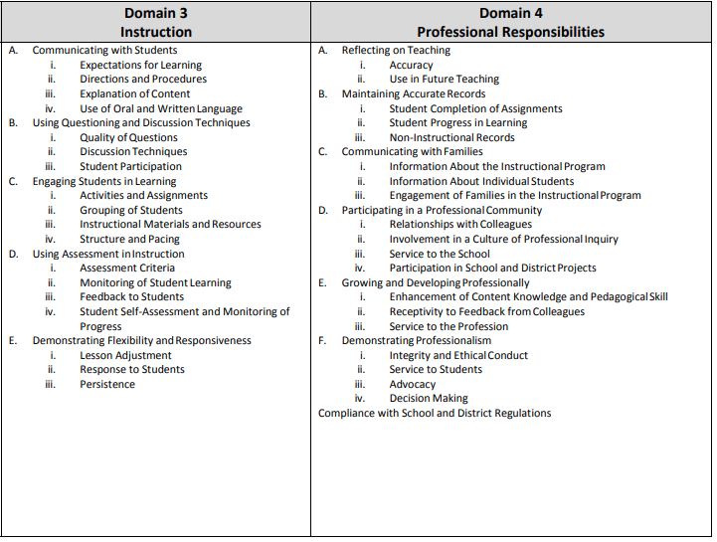
Charlotte Danielson’s Framework for Teaching – School Counselors
Adapted for Kentucky Department of Education, 2015
https://education.ky.gov/teachers/PGES/TPGES/Documents/OPGES%20Framework%20School%20Guidance%20Counselors.pdf

Charlotte Danielson’s Framework for Teaching – Library Media Specialist
Adapted for Kentucky Department of Education, 2015
https://education.ky.gov/teachers/PGES/TPGES/Documents/OPGES%20Framework%20School%20Library%20Media%20Specialists.pdf

Charlotte Danielson’s Framework for Teaching – Therapeutic Specialists
Adapted for Kentucky Department of Education, 2015
https://education.ky.gov/teachers/PGES/TPGES/Documents/OPGES%20Framework%20therapeautic%20specialists.pdf

Charlotte Danielson’s Framework for Teaching – School Psychologists
Adapted for Kentucky Department of Education, 2015
https://education.ky.gov/teachers/PGES/TPGES/Documents/OPGES%20Framework%20school%20psychologists.pdf

Charlotte Danielson’s Framework for Teaching – Instructional Specialists
Adapted for Kentucky Department of Education, 2015
https://education.ky.gov/teachers/PGES/TPGES/Documents/OPGES%20Framework%20Instructional%20Specialists.pdf

MERCER COUNTY SCHOOLS
Other District Certified Performance Standards
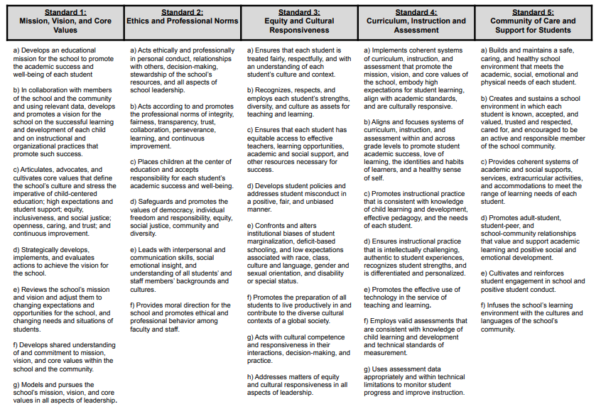

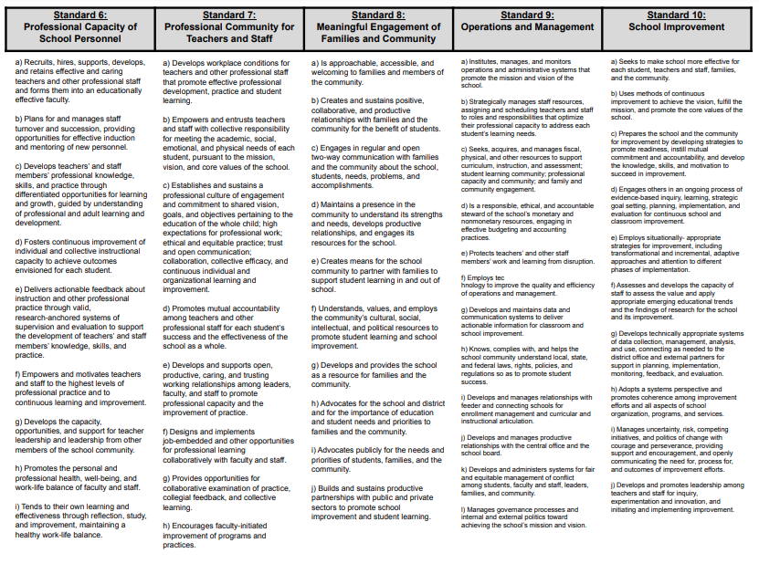

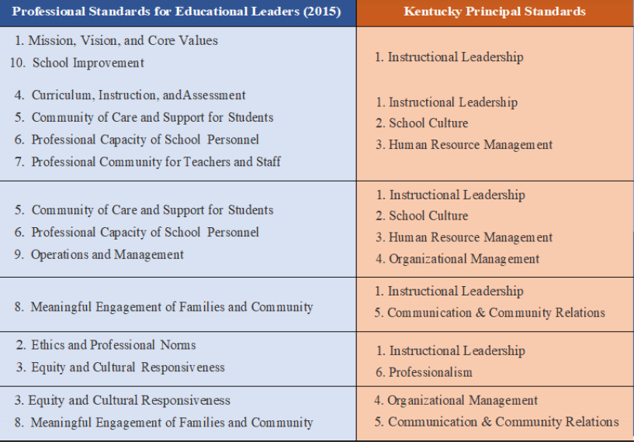
- CERTIFIED EVALUATION TIMELINE
1. Certified Staff Explanation / Discussion  [704 KAR 3:345, Section (5)(2)] | No later than the end of the first month of reporting for employment for each school year.
2. Notification of non-tenured and tenured - teachers to be evaluated | No later than the end of the first month of reporting for employment for each school year.
3. Formative observation for non-tenured and tenured teachers/administrators completed | March 27
4. Final conference summative report completed | April 24
6. Summative evaluation reports submitted to Central Office | April 30
5. Review / Finalize all certified staff members’ professional growth plan | October 1

*Complete event on or before date listed.

- STATUES AND REGULATIONS
Kentucky Revised Statutes, Kentucky Administrative Regulations,
and Mercer County Schools Board Policy
156.557 Definitions -- Statewide framework for teaching -- District personnel evaluation system -- Summative evaluations -- Appeals – Prohibition against disclosure of confidential information -- Limits on reporting of evaluation results.
(1) As used in this section:
(a) "Formative evaluation" means a continuous cycle of collecting evaluation information and providing feedback with suggestions regarding the certified employee's professional growth and performance; and
(b) "Summative evaluation" means the summary of, and conclusions from, the evaluation data, including formative evaluation data that:
1. Occur at the end of an evaluation cycle; and
2. Include a conference between the evaluator and the evaluated certified employee and a written evaluation report.
(2) The Kentucky Department of Education, in consultation with the Kentucky teacher and principal steering committees and other groups deemed appropriate by the commissioner of education, shall develop a statewide framework for teaching that shall promote the continuous professional growth and development of skills needed to be a highly effective teacher or a highly effective administrator in a school or district.
(3) Each district shall develop and implement a personnel evaluation system aligned with the
statewide framework for teaching established in subsection (2) of this section that shall:
(a) Use multiple measures of effectiveness;
(b) Include both formative and summative evaluation components;
(c) Measure professional effectiveness;
(d) Support professional growth;
(e) Have at least four (4) performance levels;
(f) Be used to inform personnel decisions;
(g) Be considerate of the time requirements of evaluators at the local level and shall not require that all certified school personnel have a formal summative evaluation each year; and
(h) Rate teachers or administrators by multiple measures instead of a single measure.
(4) The performance criteria by which teachers and administrators shall be evaluated shall include but not be limited to:
- Performance of professional responsibilities related to his or her assignment, including attendance and punctuality and evaluating results;
(b) Demonstration of effective planning of curricula, classroom instruction, and classroom management, based on research-based instructional practices, or school management skills based on validated managerial practices;
- Demonstration of knowledge and understanding of subject matter content or administrative functions and effective leadership techniques;
- Promotion and incorporation of instructional strategies or management techniques that are fair and respect diversity and individual differences;
- Demonstration of effective interpersonal, communication, and collaboration skills among peers, students, parents, and others;
- Performance of duties consistent with the goals for Kentucky students and mission of the school, the local community, laws, and administrative regulations;
(g) Demonstration of the effective use of resources, including technology;
(h) Demonstration of professional growth;
(i) Adherence to the professional code of ethics; and
(j) Attainment of the teacher standards or the administrator standards as established by the
Education Professional Standards Board that are not referenced in paragraphs (a) to (i) of this subsection.
(5) The following provisions shall apply to each school district's personnel evaluation system:
(a) Certified school personnel, below the level of superintendent, shall be evaluated;
(b) The evaluation system shall include formative evaluation and summative evaluation components; and(c) The Kentucky Board of Education shall adopt administrative regulations incorporating written guidelines for a local school district to follow in implementing the personnel evaluation system and shall require the following:
- All evaluations of certified school personnel below the level of the district superintendent shall be in writing on evaluation forms and under evaluation procedures developed by a committee composed of an equal number of teachers and administrators;
- The immediate supervisor of the certified school personnel member shall be designated as the primary evaluator. At the request of a teacher, observations by other teachers trained in the teacher's content area or curriculum content specialists may be incorporated into the formative process for evaluating teachers;
- All monitoring or observation of performance of a certified school personnel member shall be conducted openly and with full knowledge of the personnel member;
- Evaluators shall be trained, tested, and approved in accordance with administrative regulations adopted by the Kentucky Board of Education in the proper techniques for effectively evaluating certified school personnel. Evaluators shall receive support and resources necessary to ensure consistent and reliable ratings;
- The personnel evaluation system shall include a plan whereby the person evaluated is given assistance for professional growth as a teacher or administrator. The system shall also specify the processes to be used when corrective actions are necessary in relation to the performance of one's assignment;
- The system shall require annual summative evaluations for each teacher or other professional who has not attained continuing service status under KRS 161.740 or continuing status under KRS 156.800(7). The system shall require summative evaluations at least once every three (3) years for a teacher or other professional who has attained continuing service status under KRS 161.740 or continuing status under KRS 156.800(7), principals, assistant principals, and other certified administrators; and
- The training requirement for evaluators contained in subparagraph 4 of this paragraph shall not apply to district board of education members.

(6) (a) Each superintendent shall be evaluated according to a policy and procedures developed by the local board of education and approved by the department.
(b) The summative evaluation of the superintendent shall be in writing, discussed and adopted in an open meeting of the board and reflected in the minutes, and made available to the public upon request.
(c) Any preliminary discussions relating to the evaluation of the superintendent by the board or between the board and the superintendent prior to the summative evaluation shall be conducted in closed session.
(7) The Kentucky Board of Education shall establish an appeals procedure for certified school personnel who believe that the local school district failed to properly implement the evaluation system. The appeals procedure shall not involve requests from individual certified school personnel members for review of the judgmental conclusions of their personnel evaluations.
(8) The local board of education shall establish an evaluation appeals panel for certified school
personnel that shall consist of two (2) members elected by the certified employees of the local district and one (1) member appointed by the board of education who is a certified employee of the local board of education. Certified school personnel who think they were not fairly evaluated may submit an appeal to the panel for a timely review of their evaluation.
(9) The Kentucky Department of Education may annually provide for on-site visits by trained personnel to review and ensure appropriate implementation of the evaluation system by the local school district. The department shall provide technical assistance to local districts to eliminate deficiencies and to improve the effectiveness of the evaluation system.
(10) The disclosure, pursuant to KRS Chapter 61, of any data or information, including student growth data, that local school districts or the Department of Education collect on individual classroom teachers under this section is prohibited.
(11) The results of evaluations conducted under this section shall not be included in the accountability system described in KRS 158.6455 and no reporting requirements related to these results shall be imposed upon the local school districts by the Department of Education.
Effective: April 10, 2017
History: Amended 2017 Ky. Acts ch. 156, sec. 1, effective April 10, 2017. -- Amended 2013 Ky. Acts ch. 55, sec. 1, effective June 25, 2013. – Amended 2010 Ky. Acts ch. 157, sec. 1, effective July 15, 2010. -- Created 2000 Ky. Acts ch. 527, sec. 4, effective July 14, 2000.
Legislative Research Commission Note (7/15/2010). The internal numbering of subsection (4) of this statute has been modified by the Reviser of Statutes from the way it appeared in 2010 Ky. Acts ch. 157, sec. 1, under the authority of KRS 7.136(1).
704 KAR 3:370. Kentucky Framework for Personnel Evaluation.
RELATES TO: KRS 156.557, 156.800(7), 161.740
STATUTORY AUTHORITY: KRS 156.070, 156.557(2), (5)(c), (7)
NECESSITY, FUNCTION, AND CONFORMITY: KRS 156.557(2) and (5)(c), and (7) require the Kentucky Board of Education to promulgate administrative regulations to establish a statewide framework for the purposes of supporting and improving the performance of all certified school personnel, to develop written guidelines for local school districts to follow in implementing a system of evaluation for certified school personnel, and to establish an appeals procedure for certified school personnel. This administrative regulation establishes a statewide framework to support and improve the performance of all certified school personnel as well as an appeals procedure for certified school personnel.
Section 1. Definitions. (1) "Assistant principal" means a certified school personnel who devotes the majority of employed time in the role of assistant principal, for which administrative certification is required by the Education Professional Standards Board pursuant to 16 KAR Chapter 3.
(2) "Certified administrator" means a certified school personnel, other than principal or assistant principal, who devotes the majority of employed time in a position for which administrative certification is required by the Education Professional Standards Board pursuant to 16 KAR Chapter 3.
(3) "Certified evaluation plan" means the procedures and forms for evaluation of certified school personnel below the level of superintendent developed by an evaluation committee and meeting all requirements of the Kentucky Framework for Personnel Evaluation.
(4) "Certified school personnel" means a certified school employee, below the level of superintendent, who devotes the majority of employed time in a position in a district for which certification is required by the Education Professional Standards Board pursuant to Title 16 KAR and includes certified administrators, assistant principals, principals, other professionals, and teachers.
(5) "Conference" means a meeting between the evaluator and the evaluatee for the purposes of providing feedback, analyzing the results of an observation or observations, reviewing other evidence to determine the evaluatee’s accomplishments and areas for growth, and leading to the establishment or revision of a professional growth plan.
(6) "Evaluatee" means the certified school personnel who is being evaluated.
(7) "Evaluation committee" means a group, consisting of an equal number of teachers and administrators, who develop personnel evaluation procedures and forms for a local school district pursuant to KRS 156.557(5)(c)(1).
(8) "Evaluator" means the primary evaluator pursuant to KRS 156.557(5)(c)2.
(9) "Evaluator certification" means successful completion of certified evaluation training to ensure that certified school personnel who serve as observers of evaluatees demonstrate proficiency in rating teachers and other professionals for the purposes of evaluation and feedback.
(10) "Formative evaluation" is defined by KRS 156.557(1)(a).
(11) "Job category" means a group or class of certified school personnel positions with closely related functions.
(12) "Kentucky Framework for Personnel Evaluation" means the statewide framework a school district uses to develop a local certified school personnel evaluation system.
(13) "Observation" means a data collection process conducted by a certified evaluator, in person or through video, for the purpose of evaluation, including notes, professional judgments, and examination of the data collected during one (1) or more classroom or worksite visits of any duration.
(14) "Other professionals" means certified school personnel, except for teachers, administrators, assistant principals, or principals for which certification is required by the Education Professional Standards Board pursuant to Title 16 KAR.
(15) "Performance criteria" means the areas, skills, or outcomes on which certified school personnel are evaluated as described in KRS 156.557(4).
(16) "Performance measure" means one (1) of four (4) measures defined in the Kentucky Framework for Personnel Evaluation. Measures include planning, environment, instruction, and professionalism.
(17) "Performance rating" means the rating for each performance measure for a teacher, other professional, principal, or assistant principal as determined by the local district certified evaluation plan aligned to the Kentucky Framework for Personnel Evaluation. Ratings shall be exemplary, accomplished, developing, and ineffective.
(18) "Personnel Evaluation System" or "system" means an evaluation system to support and improve the performance of certified school personnel that meets the requirements of KRS 156.557 and that uses clear and timely formative feedback to guide professional growth.
(19) "Principal" means a certified school personnel who devotes the majority of employed time in the role of principal, for which administrative certification is required by the Education Professional Standards Board pursuant to Title 16 KAR.
(20) "Sources of evidence" or "source of evidence" means the district-approved evidence aligned to the performance measure and used by evaluators to inform performance measure ratings listed in Section 8 of this administrative regulation.
(21) "Summative evaluation" is defined by KRS 156.557(1)(d).
(22) "Summative rating" means the overall rating for certified school personnel below the level of superintendent as determined by the district certified evaluation plan aligned to the Kentucky Framework for Personnel Evaluation.
(23) "Teacher" means a certified school personnel who has been assigned the responsibility for student learning in a classroom, grade level, subject, or course and holds a teaching certificate pursuant to Title 16 KAR.

Section 2. District Evaluation Procedures and Forms. (1) An evaluation committee, as defined in this administrative regulation, shall develop the certified evaluation plan for the evaluation of certified school personnel below the level of superintendent. The evaluation committee shall submit the certified evaluation plan to the local board of education for review and approval.
(2) The local board of education shall review and approve the certified evaluation plan that meets the requirements of KRS 156.557 (5)(c) and this administrative regulation.
(a) The district certified evaluation plan may require the use of additional trained administrative personnel to observe and provide information to the evaluator.
(b) The district certified evaluation plan shall establish uniform requirements for the length, frequency, and nature of observations conducted by an evaluator for the purpose of evaluation. The district certified evaluation plan shall require a conference between the evaluator and the evaluatee within five (5) working days following each observation.
(c) The district certified evaluation plan shall require the summative evaluation to include all applicable system data and be held at the end of the evaluation cycle pursuant to KRS 156.557.
(d) The district certified evaluation plan shall require a summative evaluation to occur annually for each certified school personnel below the level of superintendent who has not attained continuing service status pursuant to KRS 161.740 or continuing status pursuant to KRS 156.800(7) and shall incorporate the formative data collected during the Kentucky Teacher Internship Program, pursuant to 16 KAR 7:010, in the summative evaluation of a teacher intern.
(e) The district certified evaluation plan shall require a summative evaluation at least once every three (3) years for a teacher, other professional, principal, or assistant principal who has attained continuing service status pursuant to KRS 161.740 or continuing status pursuant to KRS 156.800(7).
(f) The evaluation criteria and process used to evaluate certified school personnel shall be explained to and discussed with the evaluatee no later than the end of the evaluatee’s first thirty (30) calendar days of reporting for employment each school year.
(g) The district certified evaluation plan shall require a summative evaluation of certified school personnel to be documented in writing and to be included in the evaluatee’s official personnel record.
(h) All evidence used to produce certified school personnel's overall performance rating shall be included in the documentation of the summative evaluation.
(i) The district certified evaluation plan shall provide an opportunity for the evaluatee to submit a written statement in response to the summative rating and require the response to be included in the official personnel record.

Section 3. District Personnel Evaluation Policies. (1) Each local school district shall establish a written policy for implementing the certified evaluation plan for all certified school personnel below the level of superintendent in the district, consistent with the requirements of KRS 156.557 and this administrative regulation. The local board of education shall develop, adopt, and submit to the department for approval a policy and procedure for evaluation of the district superintendent.

Section 4. Department Approval of District Personnel Evaluation Plan. The department shall review each local school district’s certified evaluation plan and approve a certified evaluation plan that is consistent with the requirements of KRS 156.557 and this administrative regulation.

Section 5. Revisions to Previously Approved District Evaluation Plan. (1) The local board of education shall review, as needed, the district’s certified evaluation plan to ensure compliance with KRS 156.557 and this administrative regulation.
(2) If a source of evidence is added or removed from the certified evaluation plan or if a decision rule or calculation is changed in the summative rating formula, the revised certified evaluation plan shall be reviewed and approved by the local board of education. If the local board of education determines the changes do not meet the requirements of KRS 156.557, the certified evaluation plan shall be returned to the certified evaluation committee for revision.

Section 6. Training and Testing of Evaluators. (1) The district shall include evaluator certification and observation training in the district’s certified evaluation plan submitted to the department for approval pursuant to Section 3 of this administrative regulation.
(2) The district shall ensure an evaluator meets the requirements in the district’s evaluation plan prior to conducting a formative or summative evaluation.
(3) An evaluator shall be trained, tested, and approved according to this administrative regulation and the district’s certified evaluation plan.
(4) Evaluator training shall include:
(a) Initial certified evaluation training and testing provided by the Kentucky Department of Education or a provider approved by the department;
(b) Training on KRS 156.557 and the requirements of this administrative regulation;
(c) Training in effective observation and conferencing techniques, in providing clear and timely feedback, in establishing and assisting with a professional growth plan, and in summative decision techniques; and
(d) A minimum of six (6) hours annually of personnel evaluation system training approved by the Effective Instructional Leadership Act established in 704 KAR 3:325.

Section 7. Performance Measure. (1) The district’s certified evaluation plan shall utilize the Kentucky Framework for Personnel Evaluation pursuant to KRS 156.557 and the requirements of this administrative regulation and shall include the following performance measures:
(a) Planning;
(b) Environment;
(c) Instruction; and
(d) Professionalism.
(2) The district’s certified evaluation plan shall define criteria for each performance measure from the Kentucky Framework for Teaching, the Kentucky Framework for Teaching: Specialist Frameworks, and the Principal and Assistant Principal Performance Standards that characterize effective practice and apply to the evaluatee.
(3) The evaluator shall use sources of evidence, in combination with professional judgment, to inform the teacher’s or other professional’s rating on each of the four (4) performance measures listed in subsection (1) of this section.
(a) The evaluator shall use the following ratings:
1. "Exemplary" shall be the rating for performance that consistently exceeds expectations for effective performance;
2. "Accomplished" shall be the rating for performance that consistently meets expectations for effective performance;
3. "Developing" shall be the rating for performance that inconsistently meets expectations for effective performance; and
4. "Ineffective" shall be the rating for performance that consistently fails to meet expectations for effective performance. Because individual education program (IEP) goals are student-specific, IEP goals may inform, but shall not be used as a single source of evidence for any performance measure.

Section 8. Summative Rating of Teachers, Other Professionals, Principals, and Assistant Principals. (1) The overall performance category for teachers or other professionals, principals, and assistant principals shall be a district-determined rating by combining the four (4) performance measures provided in Section 8.

Section 9. Evaluation of Certified School Personnel Assigned to the District Level for Purposes of Evaluation. (1) The district’s certified evaluation plan for certified school personnel assigned to the district level for purposes of evaluation shall:
(a) Utilize the performance criteria established in KRS 156.557(4), comply with KRS 156.557 and the requirements of this administrative regulation; and
(b) List the performance criteria applicable to the evaluatee that characterizes professional effectiveness.
(2) The district certified evaluation plan for certified personnel assigned to the district level for purposes of evaluation shall be specific to the evaluatee’s job category.

Section 10. District Evaluation Appeals Panel. The district shall provide the following in its system plan for an appeal to the district evaluation appeals panel:
(1) A right to a hearing as to every appeal;
(2) An opportunity, five (5) days in advance of the hearing, for the evaluator and evaluatee to adequately review all documents that are to be presented to the district evaluation appeals panel; and
(3) A right to have the evaluatee's chosen representative present at the hearing.

Section 11. State Evaluation Appeals Panel. (1) A certified school personnel who believes that the local district is not properly implementing the district certified evaluation plan as approved by the department shall have the opportunity to appeal to the Kentucky Board of Education.
(2) The appeal procedures shall be as established in this subsection.
(a) The Kentucky Board of Education shall appoint a committee of three (3) state board members to serve on the state evaluation appeals panel (SEAP). The SEAP’s jurisdiction shall be limited to procedural matters already addressed by the local appeals panel related to the district’s alleged failure to implement an evaluation plan as approved by the department. The SEAP shall not have jurisdiction of a complaint involving the professional judgment conclusion of an evaluation, and the SEAP's review shall be limited to the record of proceedings and documents therein, or lack thereof, at the local district level.
(b) No later than thirty (30) calendar days after the final action or decision at the local district level, a certified school personnel may submit a written request to the chief state school officer for a review before the SEAP. If a certified school personnel does not appeal within the time frame listed in this paragraph, the request shall not be considered. A specific description of the complaint and grounds for appeal shall be submitted with the request.
(c) A brief, written statement or other document that a party wishes to submit for consideration by the SEAP shall be filed with the panel and served on the opposing party at least twenty (20) days prior to the scheduled review.
(d) A decision of the SEAP shall be rendered within fifteen (15) working days after the review.
(e) A determination of district noncompliance with the district evaluation plan or absence of a district local evaluation plan shall render the evaluation void.

Section 12. Incorporation by Reference. (1) The following material is incorporated by reference:
(a) "Kentucky Framework for Teaching", February 2014;
(b) "Kentucky Framework for Teaching with Specialist Frameworks for Other Professionals", June 2015; and
(c) "Principal and Assistant Principal Performance Standards", May 2014.
(2) This material may be inspected, copied, or obtained, subject to applicable copyright law, at the Department of Education, Office of Teaching and Learning, 300 Sower Blvd, 5th Floor, Frankfort, Kentucky 40601, Monday through Friday, 8 a.m. to 4:30 p.m.

This is to certify that the chief state school officer has reviewed and recommended this administrative regulation prior to its adoption by the Kentucky Board of Education, as required by KRS 156.070(5). (40 Ky.R. 2651; 41 Ky.R. 61; 264; eff. 8-11-2014; 41 Ky.R. 2342; 42 Ky.R. 38; 287; 672; eff. 8-10-2015; 44 Ky.R. 1139, 1575, 1847; eff. 3-9-2018.)

PERSONNEL 03.18
- Certified Personnel -
Evaluation
Development of System
The Superintendent shall recommend for approval by the Board and the Kentucky Department of Education a personnel evaluation system, developed by an evaluation committee, for all certified employees below the level of District Superintendent, which is in compliance with and which shall be implemented consistent with applicable statute and regulation.¹
Purpose
The purpose of the personnel evaluation system shall be to: support and improve performance of all certified school personnel and to inform individual personnel decisions.
Frequency of Summative Evaluations
At a minimum, summative evaluations shall occur annually for each teacher or other professional who has not attained continuing service status. Summative evaluations shall occur at least once every three (3) years for a teacher or other professional who has attained continuing service status, as well as principals, assistant principals, and other certified administrators.
Reporting
Results of evaluations shall not be included in the accountability system under KRS 158.6455.
Notification
The evaluation criteria and evaluation process to be used shall be explained to and discussed with certified school personnel no later than the end of the evaluatee’s first thirty (30) calendar days of the school year as provided in regulation.
Confidentiality
Evaluation data on individual classroom teachers shall not be disclosed under the Kentucky Open Records Act.
Review
All employees shall be afforded an opportunity for a review of their evaluations. All written evaluations shall be discussed with the evaluatee, and he/she shall have the opportunity to submit a written response to be included in the certified employee’s personnel record. Both the evaluator and evaluatee shall sign and date the evaluation instrument.
All evaluations shall be maintained in the employee's personnel file.²
Appeal Panel
The District shall establish a panel to hear appeals from summative evaluations as required by law.¹
Election
Two (2) members of the panel shall be elected by and from the certified employees of the District. Two (2) alternates shall also be elected by and from the certified employees, to serve in the event an elected member cannot serve. The Board shall appoint one (1) certified employee and one (1) alternate certified employee to the panel.
PERSONNEL 03.18 (Continued)
Evaluation
Terms
All terms of panel members and alternates shall be for one (1) year and run from July 1 to June 30. Members may be reappointed or re-elected.
Chairperson
The chairperson of the panel shall be the certified employee appointed by the Board.
Appeal to Panel
Any certified employee who believes that he or she was not fairly evaluated on the summative evaluation may appeal to the panel within five (5) working days of the receipt of the summative evaluation. The certified employee may review any evaluation material related to him/her. Both the evaluator and the evaluatee shall be given the opportunity to review documents to be given to the hearing committee reasonably in advance of the hearing and may have representation of their choosing.
Appeal Form
The appeal shall be signed and in writing on a form prescribed by the District evaluation committee. The form shall state that evaluation records may be presented to and reviewed by the panel.
Conflicts of Interests
No panel member shall serve on any appeal panel considering an appeal for which s/he was the evaluator.
Whenever a panel member or a panel member's immediate family appeals to the panel, the member shall not serve for that appeal. Immediate family shall include father, mother, brother, sister, spouse, son, daughter, uncle, aunt, nephew, niece, grandparent, and corresponding in-laws.
A panel member shall not hear an appeal filed by his/her immediate supervisor.
Burden of Proof
The certified employee appealing to the panel has the burden of proof. The evaluator may respond to any statements made by the employee and may present written records which support the summative evaluation.
Hearing
The panel shall hold necessary hearings. The evaluation committee shall develop necessary procedures for conducting the hearings.
Panel Decision
The panel shall deliver its decision to the District Superintendent, who shall take whatever action is appropriate or necessary as permitted by law. The panel’s written decision shall be issued within fifteen (15) working days from the date an appeal is filed. No extension of that deadline shall be granted without written approval of the Superintendent.
Superintendent
The Superintendent shall receive the panel's decision and shall take such action as permitted by law as s/he deems appropriate or necessary.
PERSONNEL 03.18
(Continued)
Evaluation
Revisions
The Superintendent shall submit proposed revisions to the evaluation plan to the Board for its review to ensure compliance with applicable statute and regulation. Upon adoption, all revisions to the plan shall be submitted to the Kentucky Department of Education for approval.
References:
¹KRS 156.557; 704 KAR 003:370
703 KAR 005:225
OAG 92-135, Thompson v. Board of Educ., Ky., 838 S.W.2d 390 (1992)
Related Policies:
²03.15, 03.16, 02.14
Adopted/Amended: 7/20/2017
Order #: 17.272E

