THIS IS A DECISION PAPER

TO: HARDIN COUNTY BOARD OF EDUCATION

FROM: TERESA MORGAN, SUPERINTENDENT

DATE: JUNE 24, 2026

SUBJECT: APPROVAL OF CHANGE ORDERS 20, 21, AND 22 FOR THE CHILD NUTRITION CONSTRUCTION PROJECT

ISSUE:
Change Order 20 is a decrease of $1360.00 for insulation deduct for DHW lines throughout the building. Change Order 21 is a decrease of $5472.00 for board and insulation in the dry storage area. Change Order 22 is a decrease of $2416.00 due to the selection of a less expensive option for electrical install.

FACTS:
Change Order 20
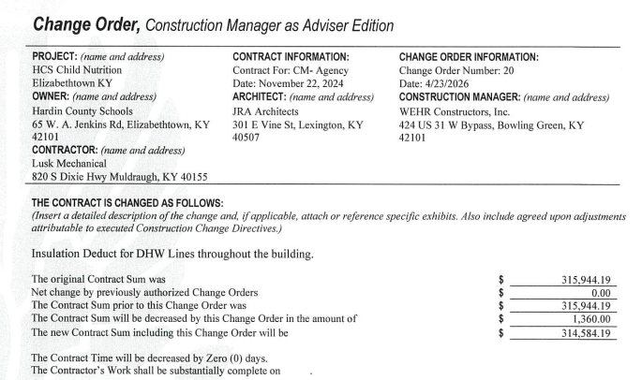

Change Order 21
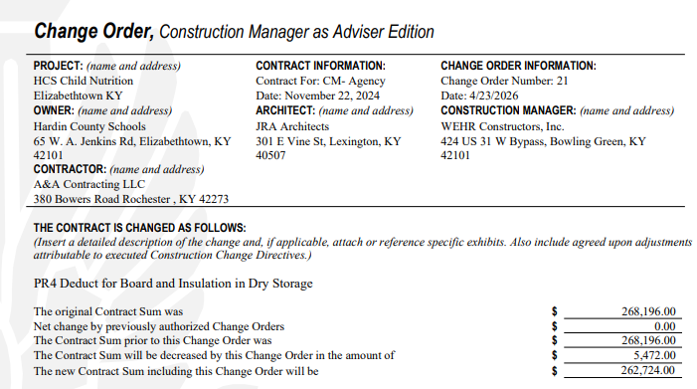

Change Order 22
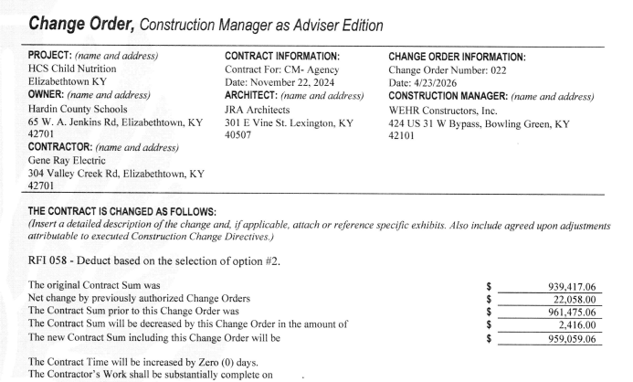

RECOMMENDATION
I RECOMMEND THE BOARD APPROVE CHANGE ORDERS 20, 21, and 22 FOR THE CHILD NUTRITION CONSTRUCTION PROJECT.

RECOMMENDED MOTION
I MOVE THE BOARD APPROVE CHANGE ORDERS 20, 21 and 22 FOR THE CHILD NUTRITION CONSTRUCTION PROJECT.

