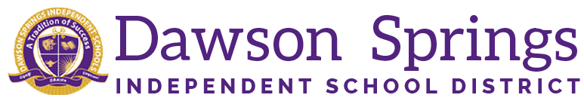

Dawson Springs Elementary School
Where the teachers and students give 100% every day and failure is not an option.
Panthers Prowling to Proficiency!

June 2026 Board Meeting
Elementary Principal Report
Jennifer Ward

- Academic Progress
  - 2026-2027 Master Schedule has been finalized. Expect minor changes to occur as things roll-out.
  - We are still working to fill open positions at DSES: special education teacher, lower primary position, and FMD teacher
  - Summer Professional Learnings are occurring
    - June 8 and 9 Mrs. Ward and 4 teachers attended the KY Reads to Succeed Conference in Louisville
    - July 13 3-5 grade reading and Special Education teachers will be engaged in UFLI Training at WKEC which is aligned with our CKLA curriculum:
      - UFLI, which stands for the University of Florida Literacy Institute, is a research-backed, systematic reading program grounded in the Science of Reading that focuses heavily on explicit phonics and word recognition. For students in grades 3–5, it is primarily utilized as a targeted Tier 2 or Tier 3 intervention to bridge persistent foundational gaps. Teachers use a diagnostic Intervention Placement Test to target precise decoding deficits. The program then employs fast-paced, 30-minute daily routines that include phonemic awareness, word-building chains, spelling practice, and "Heart Word" mapping for irregular high-frequency words. By systematically moving students from isolation practice to reading aligned decodable texts, UFLI helps older struggling readers build the automaticity and fluency required to successfully master complex, grade-level reading comprehension.
    - July 21 our Instructional Assistants will be engaged in the Para Educator Bootcamp at WKEC.
    - July 31 our special education teachers will be engaged in IEP training at WKEC.
  - August 11-14 will be our regular back to school scheduled Professional Learning days with all staff members.
    - CKLA and Bridges training will be in full swing during this time as well as our regularly scheduled district Professional Learning.

Upcoming Events:
August 18, 2026 students return to school

