Strategic Prevention Framework
I³: Inspired, Individualized, Inclusive
April 2026 - May 2026
Goal: To reduce the onset & progression of substance misuse & its related problems in Bellevue, KY, by supporting the development & delivery of community substance misuse prevention & mental health promotion services.
Objective 1: | By 9/29/2027, reduce the 30-day use of alcohol among tenth-grade students by 2% each year as measured by annual KIP survey data.
Objective 2: | By 9/29/2027, reduce regular (30-day) vaping use among tenth-grade students by 2% each year as measured by annual KIP survey data.
Objective 3: | By 9/29/2027, reduce regular (30-day) cigarette smoking among tenth-grade students by 2% each year as measured by annual KIP data.
Objective 4: | By 9/29/2027, tenth-grade students reporting serious psychological distress, according to the K6 KIP data, will decrease by 4% each year.
Objective 5: | By 9/29/2027, expand collaboration with community prevention partners, demonstrated by support from community prevention partners at least 2x each year documented by photographic evidence & meeting notes.

ASSESSMENT
Accomplishments | Description |  |  |  |  | Align
Monitoring school needs assessment activities: | Internal Referrals for mental health services  0 internal referrals for services (0 GES/0 BMHS)  0 internal referrals accepted  0 internal referrals in progress  0 students fading out of services  0 internal referral for prevention services (0 GES/0 BMHS)  0 internal referral assessments completed for prevention services (0 GES/0 BMHS)  0 student fading out of services (0 GES/0 BMHS) |  |  |  |  | 1-4
Monitoring schools needs assessment activities: | External Referrals for mental health & prevention services.  0 student/family external referral  0 student/family Care Solace referrals (0 GES/0 BMHS)  0 staff member's Care Solace referrals  0 external resources distributed |  |  |  |  | 1-4
Monitoring schools needs assessment activities: | Spring Universal Screenings  Completed 4/22/26 BMHS Spring 25-26 Universal Screener  Completed 4/15/26 GES Spring 25-26 Universal Screener
Monitoring schools needs assessment activities: | As required by SAMHSA, grant staff systematically collect and monitor comprehensive data on all grant-led initiatives. This includes indirect counts of individuals reached, direct counts of participants served, outreach and engagement efforts, progress monitoring, financial reporting, data sources, demographic and enrollment information, as well as data related to mental health and prevention services and substance use referrals. SPF Grant Data Dashboard |  |  |  |  | 1-5
CAPACITY
Accomplishments | Description |  |  |  |  | Align
Professional Development: | SPF Grant Staff:  - 04/09 - Corwin’s Belonging in Schools Virtual Institute  - 04/16 - Generation Be There Campaign  - 04/29 - Inside the Medicine Cabinet: Talking with Youth About Meds |  | - 05/05 - 5 Ways MTSS Goes Wrong at the District Level  - 05/05 - Helping youth Navigate Influence  - 05/13 - Aligning Behavioral Threat Assessment and Management with a MTSS |  |  | 5
Building internal coalitions: | Grant staff participated in the following monthly coalition/committee meetings: |  |  |  |  | 5
Building internal coalitions: | - Mental Health & Prevention Staffing  - SPF Weekly Initiatives Meeting  - GES BASE Meeting |  | - GES Referral Meeting  - BMHS BASE Meeting  - BMHS Referral Meeting
Building external coalitions: | Grant staff participated in the following monthly coalition/committee meetings: |  |  |  |  | 5
Building external coalitions: | - NKY ASAP  - SBMH Grant Committee Meeting  - TISS Grant Committee Meeting |  | - Regional Youth Summit Planning Meeting  - Campbell County Drug-Free Alliance General Meeting  - River Cities Drug-Free Coalition Meeting
Building external partnerships: | Grant staff meet with the following community agencies: |  |  |  |  | 5
Building external partnerships: | - Perfetti Van Melle | - Kroger | - Trader Joe’s
Community Conversations: | - New Riff  - CCDFA | - NKCES  - Boone County Alliance | - Academic Entertainment—assemblies |  |  | 5
Other infrastructure development: | - Review & update the MH&Prevention Webpage with resources weekly  - BISD Resource Mapping review & update support for students, staff, & families |  |  |  |  | 5
PLANNING
Accomplishments | Description |  |  |  |  | Align
Articulation of a vision for prevention activities: | Grant staff is working toward planning the following:  MAY  - 05/14 – SMILE Club - Staff Hydration Station  - 05/18 - SPF Advisory Meeting  - 05/21 - Mental Health Action Day  - 05/22 – Prevention Newsletter  Summer 2026  - Too Good For Drugs Facilitator Training  - Chaos2Confidence Conference  - KY Behavioral Conference  - Innovative School Summit |  | Ongoing Initiatives:  - TBD - First Friday: Spill the Tea  - SMILE Club (High School Tuesday)  - SMILE Club (Club Day last Wednesday of the month)  - SMILE Club (Middle School Thursday)  - Girls on the Run  - GES - Tier 2 Groups |  |  | 1-4
IMPLEMENTATION
Accomplishments | Description |  |  |  |  | Align
Specific community-level interventions being implemented: | APRIL  - Alcohol Awareness Month  - Stress Awareness Month  - 04/15 - BMHS ERD Spring Screening  - 04/18 - Prevention Newsletter #4  - 04/18 - Prom Initiative  - 04/22 – NKCES Water Bar  - 04/26 – 04/29 - NatCon  MAY  - Mental Health Awareness Month  - 05/01 – BMX Assembly  - 05/04 - Be There. Be Mindful. Campaign  - 05/06 – Sticker Shock Campaign  - 05/07 – Corwin Belonging in Schools  - 05/11 – Be There Certificate Fundraiser  - 05/11-05/13 – KPN Conference |  | Ongoing Initiatives:  - SMILE Club (High School Tuesday)  - SMILE Club (Middle School Thursday)  - Club Day: SMILE Club (Middle & High School)  - Girls on the Run  Tier 2 SEL Weekly Groups  - GES - Courage Group (Deanna)  - GES - Relationship Group (Deanna) |  |  | 1-4
NKCES Water: April 2026
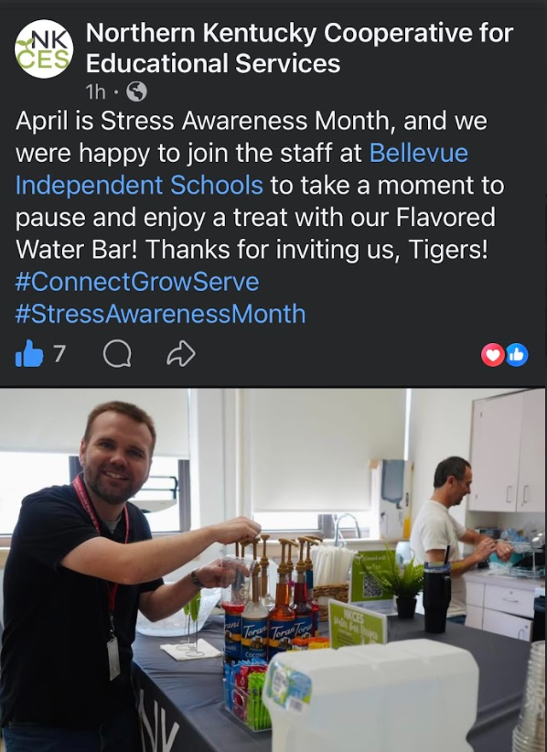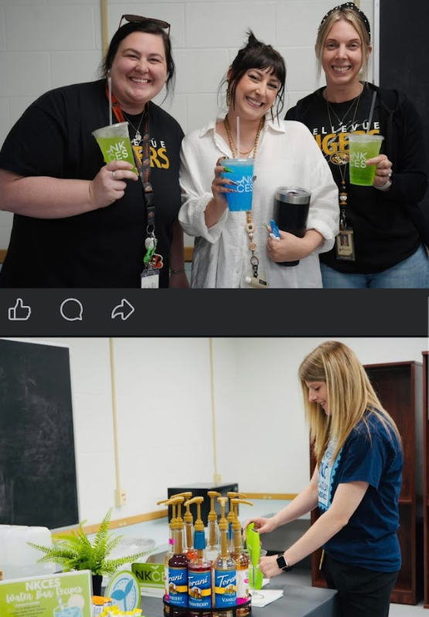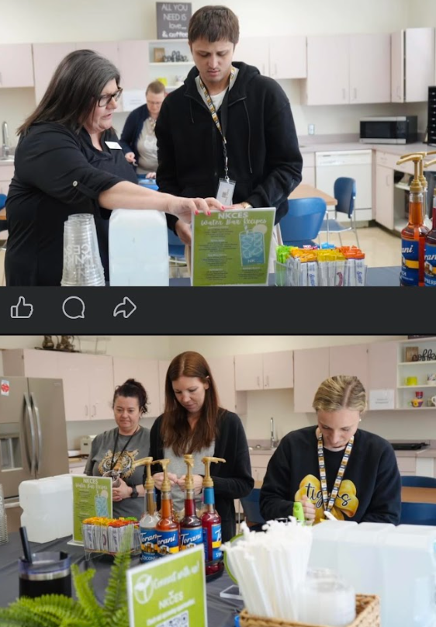
BMX Assembly: May 2026
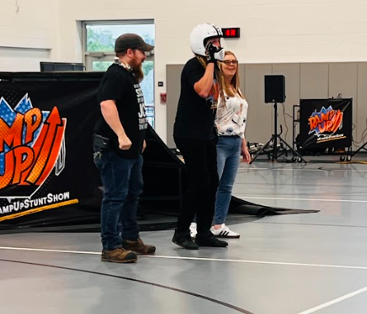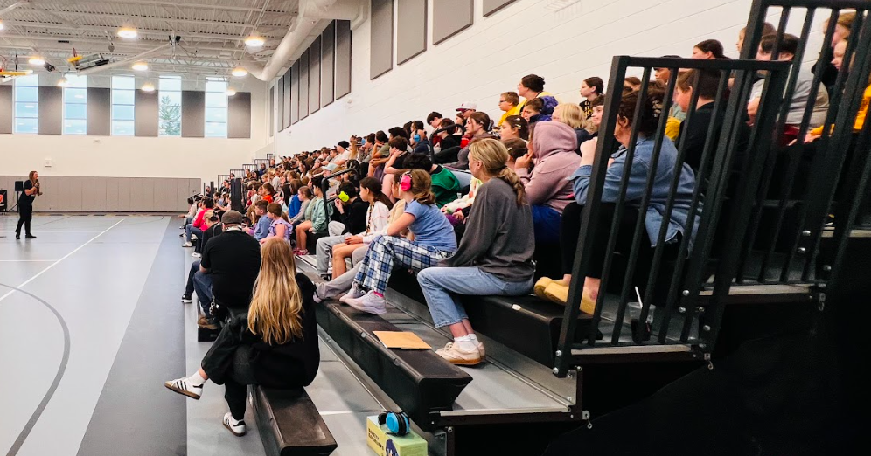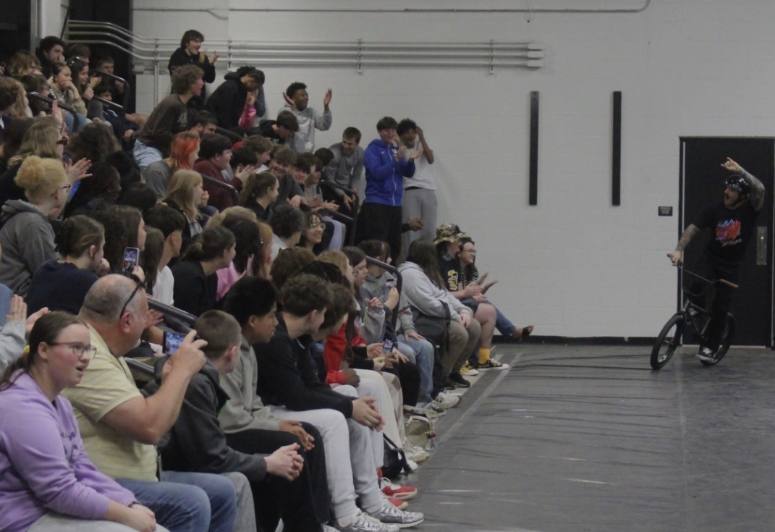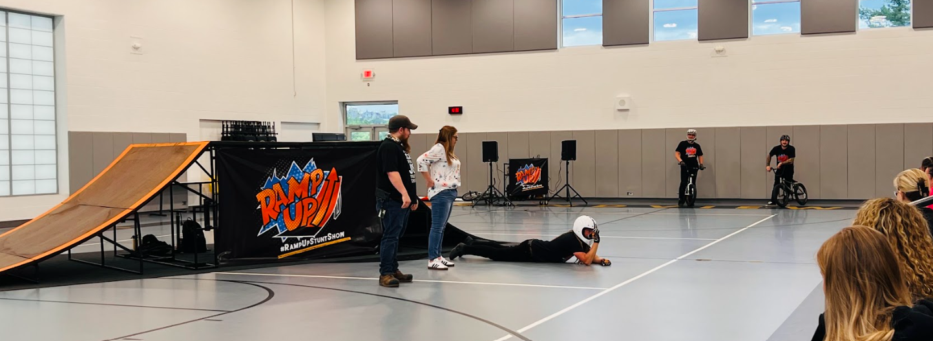
Be There. Be Mindful. Campaign: May 2026
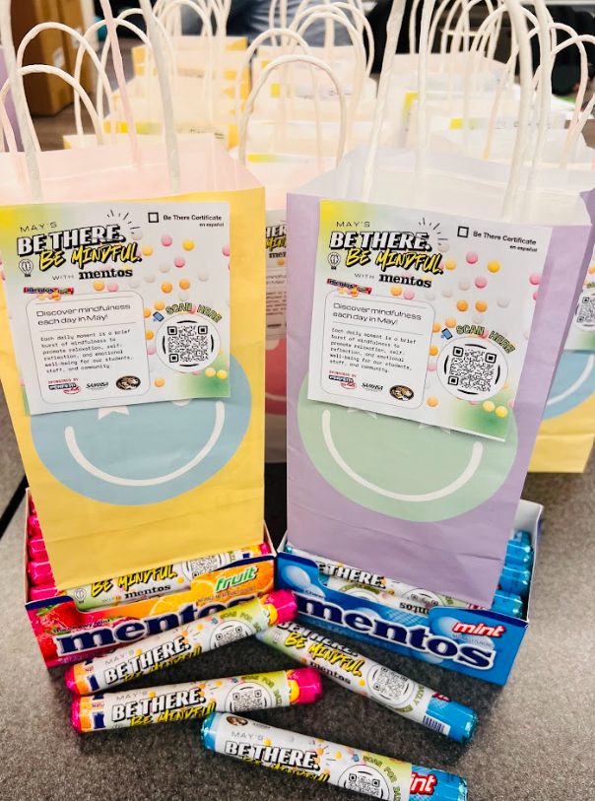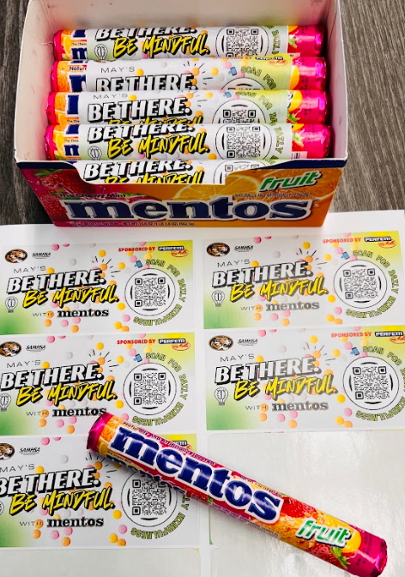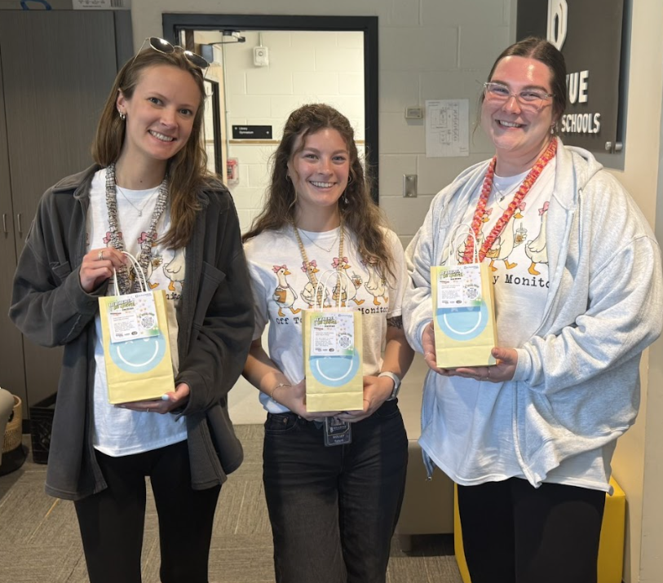

Sticker Shock Campaign: May 2026
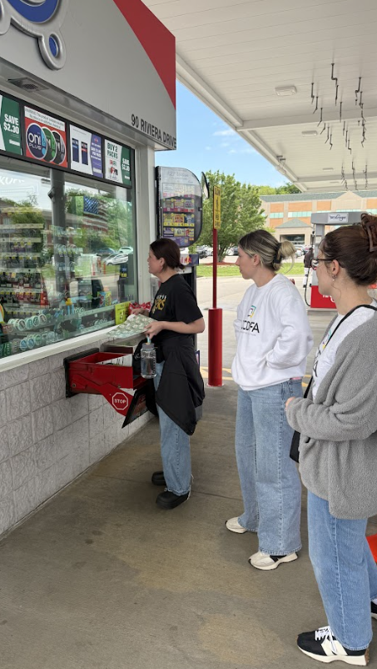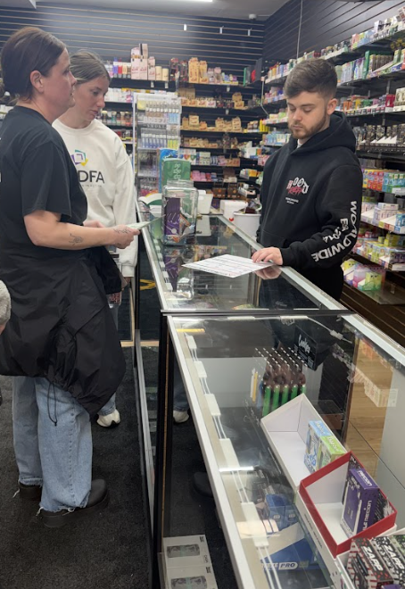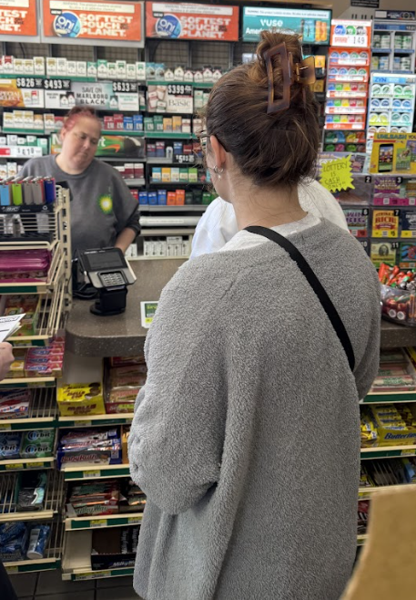
Implemented policies within organizations to facilitate interventions | Grant staff works with the following grants to create procedures for the BISD mental health & prevention team in response to students' & families' mental health & prevention needs. These align with the best practices.  - Trauma-Informed Grant  - Grant staff continues to work with TISS Grant to revise BISD’s trauma-informed plan & create action steps to ensure the implementation of best practices.  - Grant staff continues to work with SBMH Grant to review & revise BISD’s Mental Health plan & create action steps to ensure the implementation of best practices.  - School-Based Mental Health Grant  - Grant staff continues to work with SBMH Grant to review & revise BISD’s Mental Health plan & create action steps to ensure the implementation of best practices.  - Prevention  - Grant staff continues to review & revise BISD’s Prevention plan, creating action steps to ensure the implementation of best practices.  - Created district tobacco/nicotine-free procedure in response to HB-142; the procedure was added to the Code of Conduct and middle/high school behavior matrix. |  |  |  |  | 4
Specific community-level interventions being implemented: | SBMH Breakdown of time and/or student reached/seen:  - Direct: 0  - Total Sessions: 0  - Extra Sessions: 0 extra sessions 0 minutes = 0 hours  - Indirect: 0 minutes = 0 hours |  |  | SBMH Caseload Numbers:  - Active cases: 31  - Referrals: 0  - Pending: 0  - Tier 2 performance: 0  - Tier 2 small groups: 0  - Total fading out of services in last month: 0 |  | 4
Specific community-level interventions being implemented: | Tier 2 Breakdown of time and/or student reached/seen:  - Direct: 0  - Indirect: 0  - Total Sessions: 0  - Extra Sessions: 0 extra sessions 0 minutes = 0 hours  - Indirect: 0 minutes = 0 hours |  |  | Tier 2 Numbers:  - Active: 38 students GES; 19 students BMHS  - Referrals: 0  - Pending: 0  - Tier 2 Ms. Craig: 20 students  - Tier 2 performance: 12 students GES; 19 students BMHS  - Tier 2 small groups: 2 groups GES, 6 students; 0 groups BMHS, 0 students  - Total fading out of tier 2 in last month: 0 |  | 4
Specific community-level interventions being implemented: | Prevention Breakdown of time and/or student reached/seen:  - Total sessions: 3  - Total direct sessions: 4  - Total extra sessions: 0  - Groups: 2x/week  - Tier 2 performance: 2 CICO |  |  | Prevention Caseload Numbers:  - Active cases: 0  - Referrals: 0  - Pending: 0  - Tier 2 performance: 2  - Total referred, awaiting consent in last month: 0  - Total fading out of services in last month: 1  - Tier 2 small groups: 2 groups GES, 6 students |  | 1-4
Developed systems for distributing resources: | 0 lockbox distributed to families  - 24 distributed in total |  |  | 0 Deterra bags distributed to families |  | 1-3
EVALUATION
Accomplishments | Description |  |  |  |  | Align
Monitor & evaluate all activities: | As part of our federal grant requirements, staff collect and monitor data to ensure accountability and measure the impact of all grant-funded initiatives. This includes tracking how many students, families, and community members we reach, how many directly participate in programs, and the progress they make over time. We also review financial reports, demographic and enrollment information, and data on mental health services, prevention services and activities, and substance-use related behavior referrals or incidents. Collecting this information allows us to show how funds are used and how these efforts strengthen student well-being and community health. We continue to review and revise procedures/processes to enhance and increase data literacy and collection across the district level. In addition to SPF grant-specific data, we continue to collect and monitor data for the SBMH and TISS grants. We continue to review new system requirements for data collection and revise current data collection processes as needed. |  |  |  |  | 1-4
Monitor & evaluate all activities: | SPF Grant Data Dashboard  - Data collected through data sources including demographic information, enrollment data, mental health and prevention service lines data, substance-use related behavior referrals, count of directly served, count of directly reached  - Data recorded on SPF Grant Data Dashboard  - Data submitted to SPARS each quarter, then annually  - Data included in BOE reports monthly  - Reviewing new system requirements for data collection and revising current data collection processes |  |  |  |  | 1-5
Monitor & evaluate all activities: | KEY METRICS (SPF Grant Data Dashboard)  Academic YTD total reached: 11,398  Academic YTD total served: 2,479  Fiscal YTD totals:  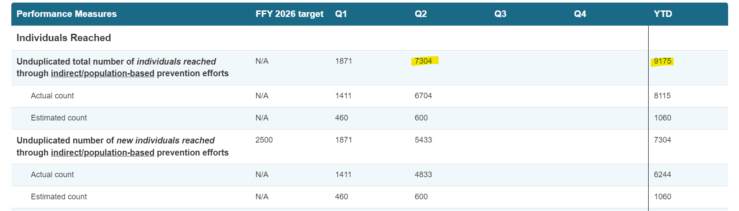  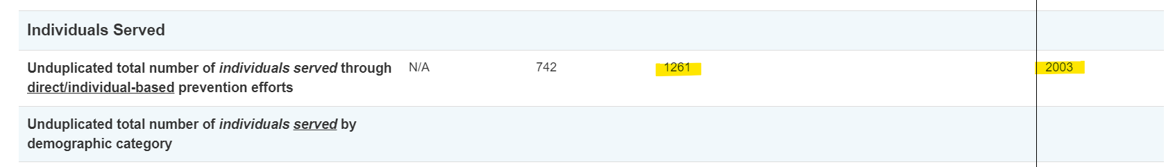 |  |  |  |  | 1-5
Monitor & evaluate all activities: | Care Solace Utilization & Key Performance Indicators  Inbound Interactions: 24  Communications Saved: 92  Warm Handoffs: 1  Family-Initiated Cases: 2  Total Unreachable: 0  Declined Services: 3  Total Appointments: 0  Anonymous Searches: 6 |  |  |  |  | 1-5
Grant Reporting: | - 10/31 – Annual Target Report – Approved  - 12/28 – Financial Report - Approved  - 12/28 – SPF eRa Commons Annual Performance Report – Submitted  - 12/28 – SPF eRa Commons Carryover – Approved  - 02/04 – SPF Continuation Report – Submitted  - 01/31 – SPF SPARS Quarter 1 Report – Approved  - 04/30 – SPF SPARS Quarter 2 Report – Submitted  - 07/31 – SPF SPARS Quarter 3 Report – Due  - 10/31 – SPF SPARS Quarter 4 Report – Due |  |  |  |  | 1-5

SUSTAINABILITY
Sustaining infrastructure: | Continue developing & improving the district's MTSS system & mental health support.  - Building Staff Capacity  - Embedding Prevention into Existing Systems  - Institutionalizing Data & Decision-Making  - Identifying Future Fundings

