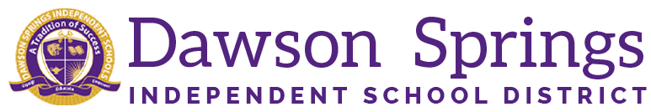

Dawson Springs Elementary School
Where the teachers and students give 100% every day and failure is not an option.
Panthers Prowling to Proficiency!

May 2026 Board Meeting
Elementary Principal Report
Jennifer Ward

- Academic Progress
  - Spring iReady Diagnostics are finishing up and most classes are completed
    - Kindergarten has shown the most growth in percentage of students at or above grade level at the end of the year in both reading and math with 80% or more of their students. We are super proud of those students and staff for their hard work!!
    - We have shown significant growth in Math this year and I give credit to our HQIR Bridges and of course our quality teachers in the classrooms every day.
    - Our students' dedication to hard work this year seems to be more evident than years past and it is exciting to see the rewards of that hard work.
    - CKLA is continuing to prove its worth in the area of reading as there is lots of growth there across the board as well. Not as many classes have completed their diagnostics in reading at this time, but those who have have definitely shown growth.
  - KSA Testing is completed!
    - Students who worked hard and earned their Good Faith Effort reward will get to participate in some inflatables along with the foam machine that was graciously donated to us by the 4-H Club here in Dawson Springs.
  - Academic Awards were held on Friday.
    - We want to thank the Al E. Orton Lodge #628 F & AM Masonic Lodge for their continued support and donations of bicycles for our students. 6 very deserving students were very happy with their reward of a brand new bicycle presented to them from this very gracious organization.
    - This is the 9th year they have donated bicycles to our students here at DSES.
    - Students received All As and All As/Bs awards as well as classroom academic awards.

Upcoming Events:
Monday May 18 - AR 100 point club field trip
Tuesday, May 19 - DSES Field Day
- 5 pm PK Graduation in big gym
Wednesday, May 20 - 1 pm Kindergarten Graduation in big gym
Thursday, May 21 - Last day for students
- AR Inflatable Awards for students who got their goals
- Good Faith Effort Inflatables and Foam Awards for grades 3-4-5
Friday, May 22 - Closing Day for Staff

