School Facilities Construction Commission
Finance and Administration Cabinet
200 Mero Street 5th Floor
Frankfort, Kentucky 40622
(502) 564-5582

May 5, 2026

Ms. Jessica Addison, Superintendent
Todd County Schools
205 Airport Rd
Elkton, KY 42220

Dear Ms. Addison:

In accordance with HB900 of the 2026 Legislative Session, the School Facilities Construction Commission has been authorized to make a cash grant to Todd County Schools in the amount of $500,000 to support renovations & upgrades to the district’s facilities in fiscal year 2027 and 2028.

These funds are to be used on the most needed facility projects in your district. The funds will be available to you by July 15 of each fiscal year. The SFCC will notify your district when the funds have been wired. Please note the SFCC will be requesting updates over the next biennium on the use of funds and your project completion.

Please do not hesitate to contact our office with any questions.

Sincerely,
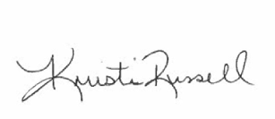
Kristi Russell
Executive Director

