

Todd County Preschool

Parent Handbook
2026-2027

Parent Handbook
2013-2014
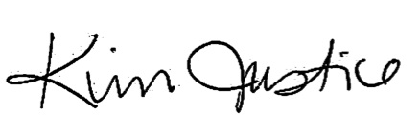
Dear Parent(s),

I am so pleased that you have chosen to enroll your child in the Todd County Preschool Program.
We are looking forward to having your child in our program this year. Early childhood education will help your child become more independent and will prepare him/her for the academic and social life which he/she will encounter in the years ahead.
This handbook will provide you with information about the preschool program and the program’s policies and procedures. A member of the preschool staff will review the handbook with you. Please keep it for future reference.
Feel free to contact me should you have any questions/concerns. I look forward to a great year!

Sincerely,

Kim Justice
Preschool Coordinator
(270) 265-2436
Todd County Schools -- Teaching, Caring, Serving
JESSICA ADDISON, SUPERINTENDENT 205 AIRPORT ROAD
BOARD OF EDUCATION: ELKTON, KENTUCKY 42220
ERIC HARRIS, CHAIRMAN TELEPHONE 270-265-2436
ANDREA JONES FAX 270-265-5414
JOSHUA MOSBY, VICE CHAIRMAN
GREG RUSSELL
TODD THOMAS

Table of Contents
Program Philosophy/Goals and Objectives | 2
Program Curriculum | 3
Required Health Records | 4
Kentucky System of Interventions/Special Services | 5
Class Size | 6
Attendance | 6
Preschool Calendar | 6
Inclement Weather | 6
Parent Involvement | 7
Meals | 8
Nutritional Guidelines | 9
Illness/Injury | 10
Diapering/Toilet Training | 11
Dental Hygiene | 11
School Supplies | 11
Clothing | 12
Toys From Home | 12
Discipline | 13
Preschool Bus Policy | 14
Petition for School Readiness | 15

Program Philosophy


It is the mission of Todd County Preschool to
provide a fully integrated preschool program which
fosters the growth and development of all children in the areas of social emotional development, self- help/adaptive behavior, motor development,
cognition, and communication. Teachers collaborate with families, staff members, and therapists to
provide program experiences which nurture and
encourage fun, warmth, security, exploration, and creativity in all children.
Skills to promote development will be integrated and embedded into the daily preschool routine which includes: arrival, meals, large and small group activities, music and movement experiences, gross motor play, story time, free-choice time (learning centers), and dismissal. A combination of child-directed and teacher-directed activities take place daily.
2
The goals and objectives of Todd County Preschool are:

• To provide opportunities for children to succeed and
develop their overall personality, a positive self-
image and a positive attitude toward school;
• To provide a supportive partnership between the
home and the school. We welcome all families to take
an active part in their child’s school experiences;
• To help children adjust to being in a group situation,
to learn the techniques of interaction, and to develop
self-control;
• To encourage the development of language, vocabulary, and positive communication;
• To support children’s sense of competence, curiosity, and creativity through experiences that involve creative exploration, discovery, and imaginative play; and
• To offer opportunities for development of reasoning and problem solving skills which lay the foundation for future success in school.
Goals and Objectives

Scholastic’s PreK on My Way is a comprehensive curriculum designed for use with preschoolers. Recent research has made it abundantly clear that, for many children, these years hold the key to children’s later academic success and social adjustment period.
PreK on My Way activities build the personal and social skills required to function well in a classroom community and to establish positive relationships
with peers and adults. PreK on My Way builds these
early academic and social skills by:
• supporting language skills throughout the day,
as teachers help to identify and reinforce
vocabulary and to strengthen conversation skills.
• building children’s mathematical knowledge,
including number concepts, basic computation,
geometry, and measurement.
• addressing Kentucky’s Early Childhood Standards
in a variety of content areas.
• providing a range of opportunities for children to
develop the social skills required in a variety of
settings.
• offering activities that help children become aware
of their feelings and those of others, and how to
regulate challenging behaviors.
• providing children with many opportunities to
experience success as a consequence of individual
effort and through guided practice in contexts
where adults provide necessary scaffolding.
• creating a classroom environment that designates
time daily for children to participate in such activities as: class meetings, a minimum of 120
minutes of free-choice activities (learning centers), story time, a minimum of 60 minutes of
gross motor play (gym time when inclement weather arises), songs, word plays, and letter
knowledge.
Teachers monitor and assess student progress continuously. This information is used to guide program instruction and to communicate each child’s progress with his/her family. Each
family will receive a computer-generated summary report based on the results of the teacher’s
assessments 3 times during the school year. This report encompasses all developmental areas.
Additionally, if your child has an Individualized Education Program (IEP), he/she will receive a
progress report addressing his/her individual goals 3 times during the school year.
3

Program Curriculum


Before attending school for the first time, each child
must have the following documents on file:
- Certified birth certificate with state seal (cannot be a
hospital copy);
- Immunization record on a Kentucky form
- Preventative Health Care Examination (school physical) on
a Kentucky form and within 6 months of school entry
- Eye examination by an optometrist/ophthalmologist on a
Kentucky form
- Household and Income Form
- Proof of Residency

Additionally, all students must have on file a Student Health Assessment form. If your child
has any special health needs such as allergies or chronic illness (e.g. asthma, hearing or
vision impairments, feeding needs, neuromuscular conditions,
urinary or other ongoing health problems, seizures, or
diabetes), he/she must also have on file forms specific
to his/her health and feeding needs. Some of these forms
must be filled out and signed by your child’s health care
provider. For children who have special feeding needs,
teachers will keep a daily record documenting the type and
quantity of food a child consumes and provide families with
that information. The program will ask families of a child
with food allergies to give consent for posting information
about that child’s food allergy and, if consent is given, will
post the information in the food preparation area and
areas of the facility the child uses.

Emergency Contact Information

It is imperative that each child has on file current emergency contact information. As this information changes, please notify your preschool teacher as soon as possible. In the event that your home address or phone number(s) change, a new student information sheet must be filled out immediately in order to update student records in our student information system.

4
Required Information
Special education services are available for children who are eligible to receive such services. These services include, but are not limited to, implementation of an IEP by the preschool teacher, speech therapy, physical therapy, and occupational therapy. The preschool teachers and the
Family Resource Youth Service Center will be available to aid families who request assistance in obtaining social services and/or health and medical needs.

Special Services
The Multi-Tiered System of Supports (MTSS) is a framework for providing systematic,
comprehensive services to address academic and behavioral needs for all students, preschool through grade 12. This system is comprehensive in that it looks at an individual child’s areas of potential delay to assess whether or not the delay(s) can be remediated by providing
interventions rather than initiating a referral for special education services. Interventions must be research-based and the PreK on My Way curriculum meets these requirements.
Todd County Preschool has developed the following procedures for implementing interventions with 3– and 4-year-old children who show a potential delay in any developmental area upon initial screening:

3-year-olds
Three year old children who show a potential delay upon screening will be allowed to attend preschool 2 days per week for a minimum of 4 weeks. After implementing interventions twice weekly for a minimum of 4 weeks, intervention progress monitoring will be reviewed to determine if a referral for special education services is warranted. If a referral is not warranted or your child is referred and does not qualify, he/she will no longer be eligible to attend preschool during the current school year. However, any new information that may impact eligibility (i.e. medical diagnosis, outside evaluation, etc.) will be considered at any time.

4-year-olds
Four year old children who show a potential delay upon screening will be allowed to attend preschool 2 days per week for a minimum of 4 weeks. After implementing interventions twice weekly for a minimum of 4 weeks, intervention progress monitoring will be reviewed to determine if a referral for special education services is warranted. If a referral is not warranted or your child is referred and does not qualify, he/she will no longer be eligible to attend preschool during the current school year unless he/she qualifies to attend based on income. However, any new information that may impact eligibility (i.e. medical diagnosis, outside evaluation, etc.) will be considered at any time.
5
Multi-Tiered System of Supports
6
If school is cancelled due to inclement weather, preschool will not be in session. Please listen to local radio and television stations for information regarding school closings.
The preschool program will run on the same calendar schedule as the Todd County School System, with the exception of preschool will begin one week later and will end one week earlier. Preschool’s days of operation are Monday, Tuesday, Wednesday, and Thursday. Students will be assigned to one of two sessions, either Monday/Tuesday or Wednesday/Thursday. In the event that changes to the preschool calendar must be made, you will be notified in advance.
Preschool Calendar
Inclement Weather
Although preschool attendance is not mandatory, it is important that your child attend
preschool regularly in order to reach his/her fullest potential. This is particularly important for those students who have been identified as having a disability and have an Individual
Education Program in place. In the event that your child will be absent for more than one day, please contact his/her preschool teacher. According to Kentucky Preschool Regulations, “A parent or legal guardian shall be contacted with respect to an enrolled child whose
participation in the program is irregular or who has been absent for four (4) consecutive
program days.”
Attendance
Classes in the preschool program are limited to a maximum number of 20 children. Each classroom is required to maintain a teaching staff-child ratio within group size of 1:10 at all times. This ratio is maintained during all hours of operation, including indoor time, outdoor time, and during transportation and field trips.
Every attempt is made to maintain continuity of relationships between teaching staff and children and among groups of children. If your child is enrolled in the program more than one year, he/she will remain in the same classroom each year.
Class Size

7
The preschool staff will communicate frequently with parents through newsletters, phone calls, and home visits. Kentucky Preschool Regulations require teachers to conduct a
minimum of 2 home visits per school year. The visits can take place in the home, school setting, or by phone. The purpose of home visits is solely to gain a better understanding of your child, as well as becoming better acquainted with you.
Families are encouraged to volunteer in their child’s preschool classroom or the school.
Volunteer services include, but are not limited to, working directly with children, attending field trips, assisting with classroom parties, or preparing teaching materials. A criminal
background check is required for all classroom volunteers. If you plan to accompany your child on class field trips, a criminal background check must be on file. It is understood that many parents work or cannot volunteer on a regular basis; therefore, no matter how great or small, your involvement will be greatly appreciated. If you have a desire to be placed in a leadership
position in the preschool program, please let your child’s teacher know. Leadership positions might include planning classroom parties or events, reading to children, sharing a special skill or talent, etc.
Parent programs will also be offered throughout the school year. These programs might
include lessons on parenting skills, such as positive discipline techniques, how to work with your child at home, making healthy food choices for your family, and other parent selected topics.
Parent Involvement

7

8

Lunch will be served daily. Todd County has been approved to participate in the Community Eligibility Option (CEO) program. The CEO program allows all children to receive free breakfast and lunch. Therefore, there will be no charge for meals from the cafeteria during the 2026-2027 school year.

If your child brings his/her lunch from home, the following requirements must be met:
• The food must meet the USDA’s Child and Adult Care Food Program (CACFP) guidelines;
• All foods and beverages from home are labeled with the child’s name and the date;
• Staff make sure food requiring refrigeration stays cold until served; and
• If a meal does not meet the above guidelines, food will be provided to supplement the meal.

Additionally, snacks will be provided in the morning and afternoon. The morning snack will be served as soon as the children arrive, and the afternoon snack will be served before the children depart.

The following foods will not be served in the preschool program due to choking hazards:
• Hot dogs, whole or sliced into rounds;
• Whole grapes;
• Nuts;
• Popcorn;
• Raw peas and hard pretzels;
• Spoonfuls of peanut butter; and
• Chunks of raw carrots or meat larger than
can be swallowed whole.

Meals
Nutritional Guidelines
9

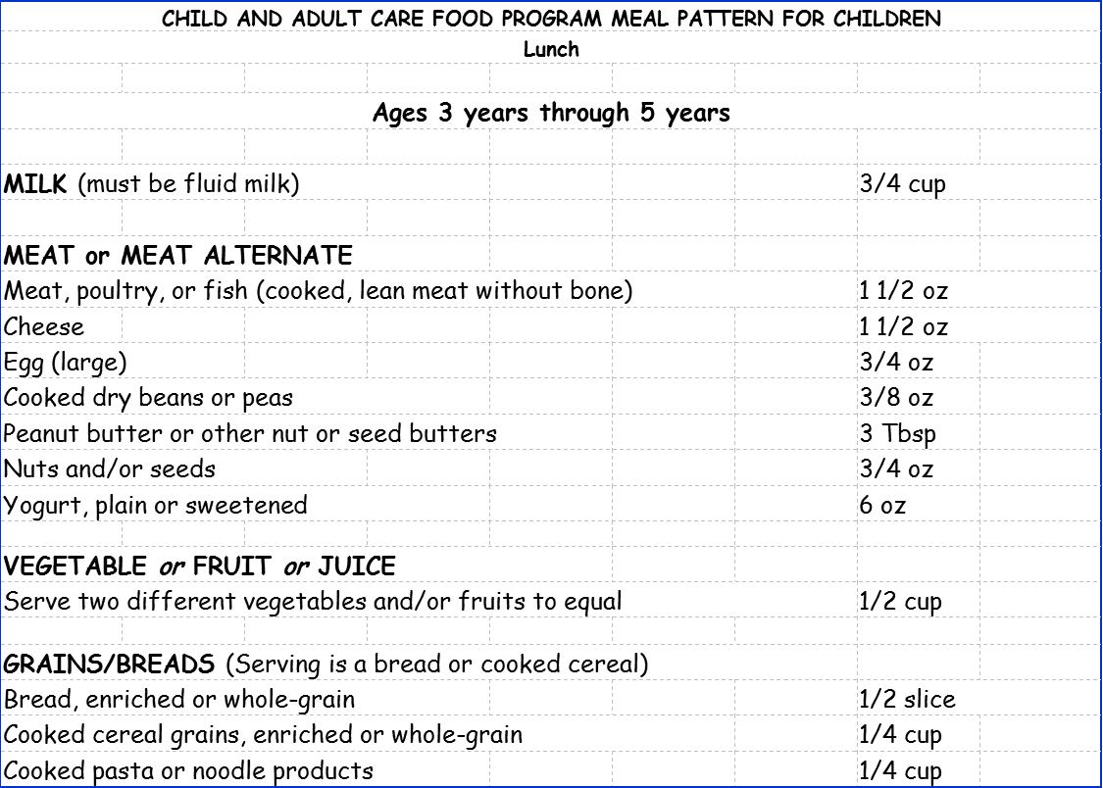

9
Families who choose to send lunch from home for their child must ensure that the lunch meets the Child and Adult Care Food Program (CACFP) guidelines for a nutritious lunch. The meal components used in the CACFP meal pattern for children are:
• Milk
• Meat and Meat Alternates
• Vegetables and Fruits
• Grains and Breads
Please ensure that your child’s lunch includes a drink, one meat or meat alternate, two foods from fruits and vegetables, and one grain or bread. An example of a nutritious lunch might include: a carton of milk, a peanut butter sandwich, orange slices, and broccoli.

Families are requested to refrain from sending their child to school if he/she shows any signs of illness or infection. Occasionally, children will develop symptoms of illness while at school. In such cases, your child will be made comfortable in a location where he/she is
supervised by a familiar caregiver, and where new individuals will not be exposed to the
illness. A staff member will notify you so that you may pick your child up from school.
Each preschool classroom is equipped with a first-aid kit which accompanies the class during gross motor play and/or on field trips. We strive to ensure that all staff members hold
current CPR and first-aid certification. However, when staff changes occur, CPR and first-aid training is obtained for the new staff members as quickly as
possible. We hope that you take comfort in knowing that at
all times there is at least one preschool staff member
present in each group with current CPR and first-aid
certification.
If your child requires medication while at school, the
medication must be labeled with your child’s first and last
name, name of doctor, expiration date, and manufacturer’s
instructions (or the original prescription label that details
the name and strength of the medication as well as directions
on administering and storing). Medication is administered only
with written permission of the parent or guardian and as
prescribed in writing by your child’s physician. If you request
over-the-counter medications to be used with your child, a
standing order from your child’s physician detailing the
specific circumstances, instructions, and individual dosing
must be on file if it will be administered for more than 3
consecutive days. All medication given must be documented on a medication log. Records must contain signature(s) of person(s) administering medication, dosage administered, and be kept on file.
In the event that an accidental injury or medical/dental emergency occurs to your child at school, you will be notified immediately. If we are unable to reach you, we will contact your child’s physician or seek emergency medical attention. Your child’s teacher will maintain a
consent form with your signature agreeing to this procedure. You will also sign consent that you assume responsibility for all medical expenses. It is to both your and your child’s benefit that we have correct home address, telephone number(s), and the name of the child’s physician on file at all times so that in the event of an emergency you may be reached. Once again, it is imperative that you notify your child’s teacher immediately if you have emergency contact changes.

10
Illness/Injury
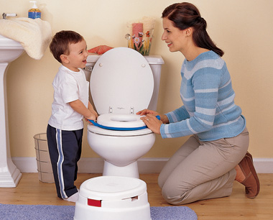
Diapering/Toilet Training


All supplies (glue, pencils, crayons, scissors, etc.) will be provided for your child. Please send a
standard-sized backpack with your child daily.
Occasionally your child’s teacher may send a wish list home requesting items for the classroom;
however, it is not required that you purchase items from the list.
School Supplies
11
It is not required that children have mastered
toilet training in order to attend preschool. However,
we strive to work as a team between home and school
to accomplish this skill. For children who are unable
to use the toilet consistently, the teaching staff
ensure that:
• parents provide only commercially available
disposable diapers or pull-ups unless the child has
a medical reason that does not permit their use (health provider documents reason);
• clothing that is soiled by urine or feces are immediately placed in a plastic bag (without
rinsing or avoidable handling) and sent home that day for laundering;
• diapers or pull-ups are checked and changed if needed at least every two hours;
• children’s diapers, pull-ups, or soiled clothing is changed in the class restroom or on the changing table;
• changing procedures, which are posted in the class restroom, are followed; and
• surfaces used for changing and on which changing materials are placed are not used for other purposes.
Clothing


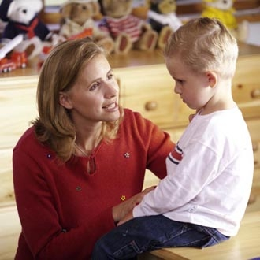
Todd County Preschool is very fortunate to have an abundance of developmentally appropriate toys and activities. We ask that your child not bring toys from home. If your child wishes to share a special toy or object with his/her classmates, please
contact your child’s teacher in advance to make
arrangements for this.
Toys from Home
Your child will be involved in many fun activities daily. Many art activities tend to be not only fun, but sometimes messy. Your child will spend time playing on the floor, as well as playing outdoors. Please dress your child comfortably, and remember to send jackets or sweaters on cool days.
On the first day of school please send a
complete change of clothing (including socks and underwear) in a gallon-sized Ziploc bag which can remain at school in case of accidents. Label the bag with your child’s name. Your child’s teacher will send his/her clothing home to be exchanged for more weather appropriate clothing as the seasons change.
12
Naps
13
Children will have a designated nap/rest time during the day for one hour. Mats will be provided during nap time. You may send a small blanket in your child’s backpack for him/her to use during nap time. The blanket will be sent home each day and should be laundered weekly or when soiled.
Discipline
Our preschool program utilizes the Pyramid Model framework for supporting the social and emotional development of our children. Our classroom staff will work together to ensure that children understand behavior expectations and receive instruction in social skills.
For children with challenging behavior, teachers will assess the function of the child’s
behavior and use positive behavior support strategies. When challenging behaviors become
serious or persistent, teachers, families, and other professionals will work as a team to develop and implement an individualized plan that supports the child’s inclusion and success.
14
Preschool Bus Policy
Bus transportation is provided for all preschool children. Please read the following policy completely. You will be asked to sign that you have read and understand this. Please share this information with any person (such as a babysitter) who will be responsible for getting your child on or off the bus.
It will be the parent’s (or authorized person’s) responsibility to provide safe supervision to and from the bus stop. This includes accompanying your child to the bus. If, when the bus stops at your home, they are on the opposite side of the road, the bus monitor will cross the road to meet the parent. The parent should not cross the road to meet the bus monitor for safety purposes. For your child’s safety, do not release them and let them run to the bus.
Continue to hold your child’s hand until you can transfer his/her hand to the monitor’s.
No child will be released to a person not authorized by a parent to pick the child up. In
order for a person to be authorized to pick up the child, their name must be listed on the child’s emergency form [including parent(s)]. The person receiving the child must be able to tell the bus monitor the child’s “code word”. The code word will have to be provided EVERY time the child gets off the bus. If the person cannot tell the monitor the code word, your child will be brought back to the school and you will be called to pick him/her up. If someone that knows the child’s code word and is an authorized person on the emergency form is trying to get the child off the bus at a stop other than the child’s regular stop, a note from the parent must be sent to the school stating that the child will get off at a spot other than his/her normal spot. An administrator may be contacted for approval for extenuating circumstances.
If an authorized adult is not present at the time the bus reaches the bus stop, the child will then be taken back to the school and the parent (or authorized person) must come and get the child. This person must know the child’s “code word”. If no one is available to meet the child on three (3) occasions, bus transportation may be terminated for the child.
Every effort is made to keep the buses on schedule. Please be on time to put your child on and off the bus. If no one is present at the bus stop upon arrival, the bus driver will wait for approximately one minute before continuing on the route.
Although occasional bus changes are necessary, we try to keep these to a minimum.
Therefore, if your child is to be picked up or dropped off somewhere other than his/her
regular bus stop, we must have written notice signed and dated by the parent (no phone calls). All changes must be to a place already on a preschool route. Once bus routes have been
established, any permanent changes for your child’s daily drop off or pick up must be
submitted five (5) days before the change is needed. All requests shall be submitted to the Director of Transportation for approval and each request will be reviewed and a decision made on an individual basis.


Todd County Schools’ Petition/Evaluation Process
for Determining a Student’s Readiness for School

Step 1: Parents/guardians may petition the Board of Education to allow their children to enter school earlier than permitted under statutory age requirements by submitting a letter to the Superintendent or designee to be considered for early entrance the following school year no later than May 1st.

Step 2: Following receipt of a letter, consent will be obtained from the parent/guardian to evaluate the student’s level of developmental, academic and social readiness using developmentally appropriate measures and observations, along with parent and teacher interviews. For a preschool child to be considered for advancement to kindergarten before reaching kindergarten age, the child should score at least one standard deviation above the mean on a developmentally appropriate, normed referenced assessment in the following developmental areas: cognition, social-emotional development, adaptive behavior, and communication. Additionally, anecdotal records, including observations, should reveal that the student follows group instruction, regulates his/her attention and focus for extended periods, and interacts appropriately with peers and adults.

Step 3: All evaluation data will be compiled in a written evaluation to be reviewed by a committee comprised of teachers, parents, psychologists, and district specialists, such as the gifted education coordinator. At least one member of the team should represent the district office and have an understanding of early childhood development. A written recommendation will be submitted to the Superintendent or designee.

Step 4: The Superintendent or designee will make a recommendation to the Board for approval.

Step 5: If it is determined the child will not enter kindergarten early, a plan will be developed to differentiate instruction in any areas in which the child excels.

References:
Entrance Age Policy 09.121
Kentucky Department of Education’s “Determining a Student’s Readiness for School: Evaluation Process”
Revised 6/7/2021

15
14

