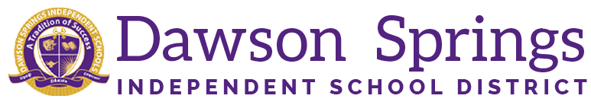

Dawson Springs Elementary School
Where the teachers and students give 100% every day and failure is not an option.
Panthers Prowling to Proficiency!

April 2026 Board Meeting
Elementary Principal Report
Jennifer Ward
  - Academic Progress
    - Spring iReady diagnostic is underway. Results will be presented at the next meeting.
    - End-of-Year assessments are continuing to occur.
    - April 23 was our first STEM night for students in grades PK-5. We had a great time with lots of families involved. We rotated to different stem projects in the MPR. Mr. Schultz did an amazing job. We had lots of families here that night. The projects we did were:
      - The Marshmallow Bridge
      - Cup Stacking Challenge
      - The Index Card Bridge
      - Build A Paper Rocket
      - The Lemon Volcano
      - Slime Time
      - The Earthquake-Proof Tower
  - PLC Conversations for the Month:
    - Tier 3 RTI data is being monitored to ensure we are meeting the needs of our students.
      - We are going to utilize UFLI as an RTI tool for next year for meeting the needs of Phonics and phonemic awareness
      - The program follows a carefully developed scope and sequence designed to ensure that students systematically acquire each skill needed and learn to apply each skill with automaticity and confidence. The program is designed to be used for core instruction in the primary grades or for intervention with struggling students in any grade.
      - Teachers will attend a training at WKEC this summer for UFLI
    - KSA preparation continues
      - Extended response questions are being administered weekly in tested grades
      - Spring Mock KSA assessments have been completed. Teachers have once again gone over the assessments with the students modeling correct responses and formatting concerns.
    - 2026/2027 Plans are starting to get underway
      - Master schedules are being finalized with Mrs. Seeger and Mrs. Graham.
      - DSES still has an open position in special education and a general education teacher position, as well as an Instructional Assistant`.
- Upcoming Events:
  - Spring iReady Window opened on April 9 and will go through the end of the year
  - April 30 will be our 5th grade Wax Museum in the gym hosted by Ms. Ipock as their end-of-year writing project
  - KSA testing will begin on Tuesday, May 4 and go through Friday, May 14.

