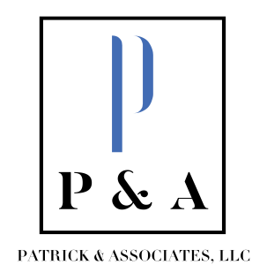
Tammy Patrick, CPA Beth Francis
tammy@patrickassoc.com beth@patrickassoc.com
(859) 808-1329 (859) 333-2360

April 17, 2026

Thank you for the opportunity to submit this audit proposal for the Anchorage Board of Education audit fiscal year ending June 30, 2026. We would be honored to perform the audit for the Board. All audits performed by Patrick & Associates, LLC are performed in accordance with all applicable accounting and auditing standards.
The auditors at Patrick & Associates, LLC are Tammy Patrick, CPA, and Beth Francis. Together we have a combined over 50 years of governmental auditing experience. Tammy Patrick is also a Certified Public Accountant licensed by the Kentucky State Board of Accountancy. We strive to deliver comprehensive, quality work with regular communication in a timely manner.
We estimate our fee for the financial audit to be $19,500 for fiscal year 2026. This quote will be the expected flat rate unless we encounter any unexpected allegations or missing records.
Please let me know if you have any further questions or need any additional information. We look forward to the opportunity to serve you.

Sincerely,
Tammy Patrick, CPA

