THIS IS A DECISION PAPER

TO: HARDIN COUNTY BOARD OF EDUCATION

FROM: TERESA MORGAN, SUPERINTENDENT

DATE: APRIL 16, 2026

SUBJECT: EC3 EXPANSION CONSTRUCTION PROJECT

ISSUE: CONSIDERATION OF EC3 CONSTRUCTION PROJECT BIDS

FACTS:

KDE requires boards to approve construction bids in order to proceed with a project. Total Construction Cost totaled $ 14,059,281.79
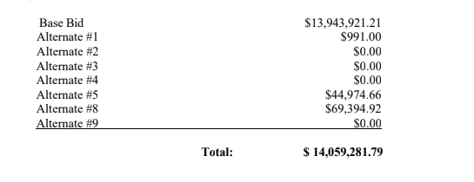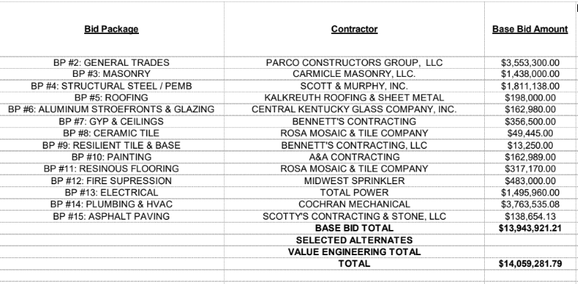

*See attached Documents

RECOMMENDATION:

I RECOMMEND THAT THE BOARD AWARD CONTRACTS FOR THE BID PACKAGES AS RECOMMENDED BY CODELL AND JRA, INCLUDING ALL THE ALTERNATES FOR THE EC3 EXPANSION CONSTRUCTION PROJECT.

RECOMMENDED MOTION
I MOVE THAT THE HARDIN COUNTY BOARD OF EDUCATION AWARD CONTRACTS FOR THE BID PACKAGES AS RECOMMENDED BY CODELL AND JRA, INCLUDING ALL THE ALTERNATES FOR THE EC3 EXPANSION CONSTRUCTION PROJECT.

