THIS IS A DECISION PAPER

TO: HARDIN COUNTY BOARD OF EDUCATION

FROM: TERESA MORGAN, SUPERINTENDENT

DATE: APRIL 16, 2026

SUBJECT: APPROVAL OF CHANGE ORDERS 16, 18, AND 19 FOR THE CHILD NUTRITION CONSTRUCTION PROJECT

ISSUE:
Change Order 16 is an increase of $ 3746.00 for additional electrical work. Change order 18 is an increase of $20,876.00 to meet additional chiller power requirements. Change order 19 is an increase of $1182.00 for power remediation at Buildings and Grounds.

FACTS:

CO 16
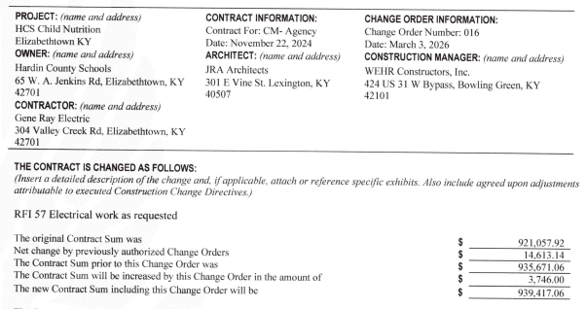

CO 18

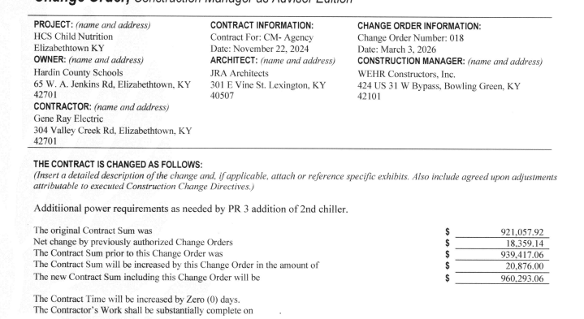

CO 19
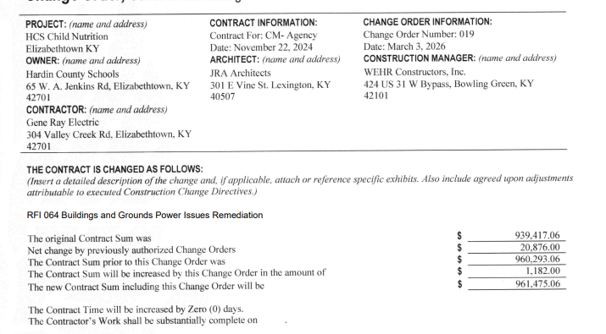

RECOMMENDATION
I RECOMMEND THE BOARD APPROVE CHANGE ORDERS 16, 18, AND 19 FOR THE CHILD NUTRITION CONSTRUCTION PROJECT.

RECOMMENDED MOTION
I MOVE THE HARDIN COUNTY BOARD OF EDUCATION APPROVE CHANGE ORDERS 16, 18, AND 19 FOR THE CHILD NUTRITION CONSTRUCTION PROJECT.

