FIELD OBSERVATION REPORT

West Hardin Middle School, 202280 -CA8
Date: 4/7/2026 Time: 12:30 PM Weather: Clear/75⁰
Observed by: Joseph Jones, AIA Report No: 34
Trades Observed on Site: General Trades, Masons, Erectors, Glazers, Floor Polishers, Plumbers, Mechanical, Electricians

- Work observed in Progress
Exterior work was continuing.
Masons were laying bricks on Area B.
Erectors were welding railings in the main corridor.
Glazers were installing curtainwall windows.
Floor polishers were grinding the concrete slabs in the vocal music suite.
Plumbers were roughing in piping.
Mechanical ductwork was being hung in Areas A and B.
Electrical rough-ins in Areas A and B.

- General Observations

 | Concrete curbs had been poured to the loading dock area. | 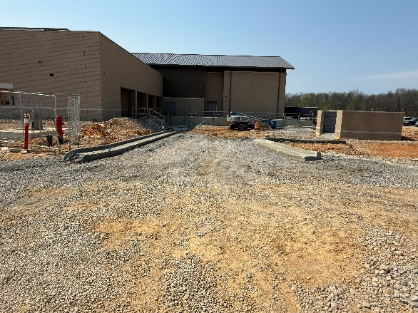
 | More curtainwall windows were being installed in Area C. | 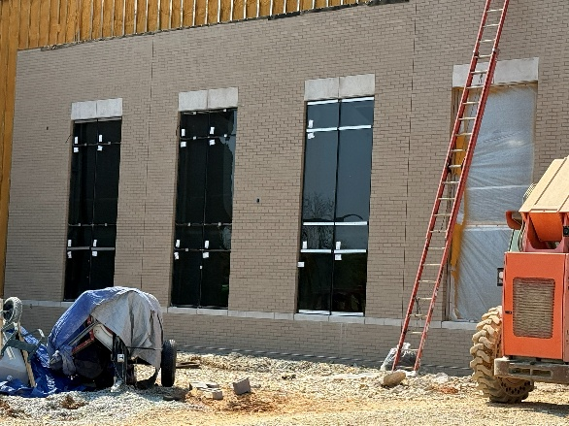
 | Area A will be the last area to be covered with bricks. It is a rather large area so a considerable amount of time will be required to complete this task.  It appeared that almost all the concrete blocks were installed for the project. | 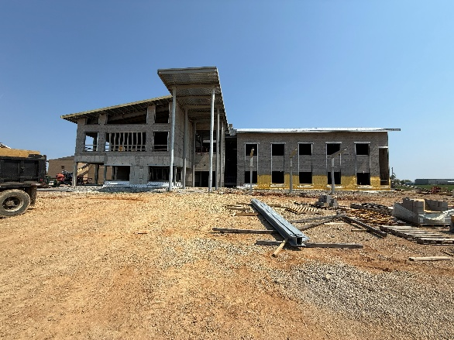
 | The three classroom wings were being covered with spray foam insulation and then bricks. The Area B wing was mostly covered with the two Area A wings were about 20% complete. | 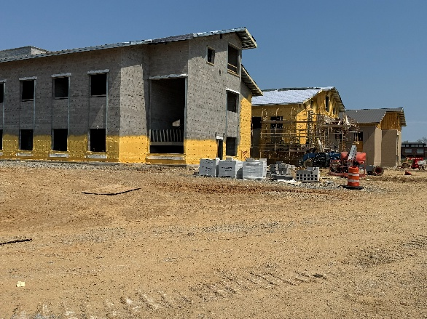
 | The brickwork on the classroom wings appears to be good with almost no chipped and out of plane bricks. | 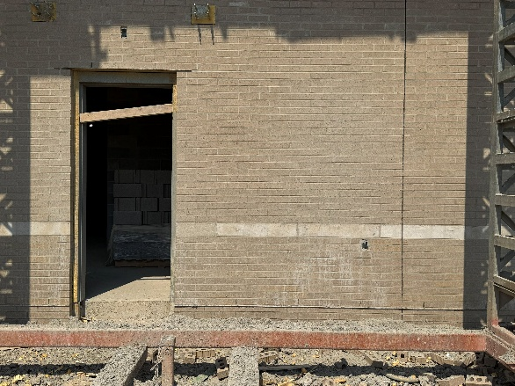
 | It was determined that the spray foam insulation installer had unnecessarily sprayed the areas behind the insulated spandrel glass window units between floors. The foam will need to be removed at the curtainwall framing but can remain in place behind the spandrel glass. | 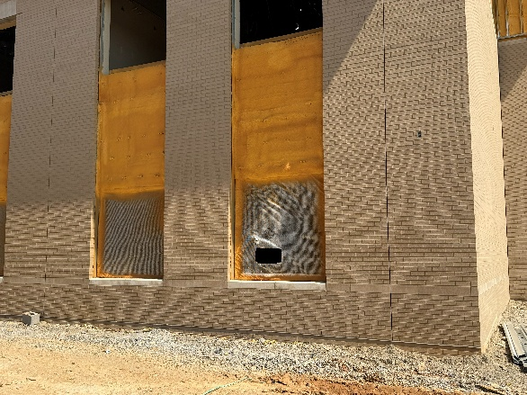
 | The south elevation demonstrates the level of completeness of Area D to the left and the incompleteness of Area A.  With the roof structure over Area A in place, the whole building will be dried in with at least the bottom plies of roofing system in the near future. | 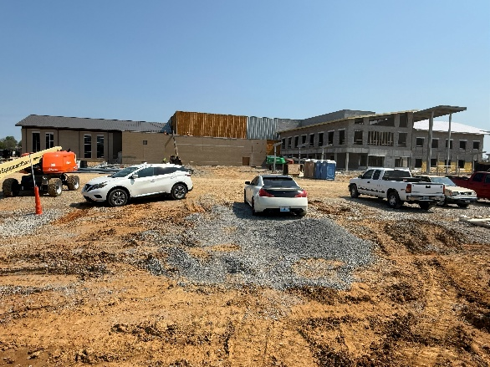
 | The galvanized steel framing was in place for the walkway to the toilets in the concessions building. | 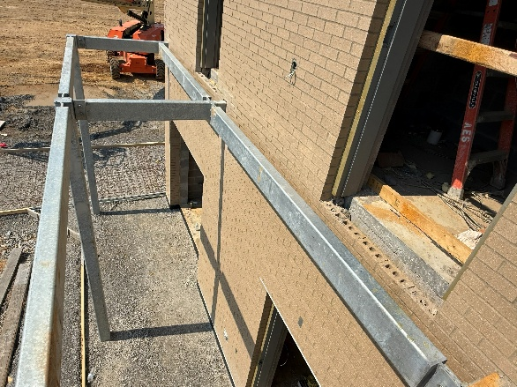
 | The concrete pad for the bleachers at the playing field was formed and being made ready for the concrete pour. | 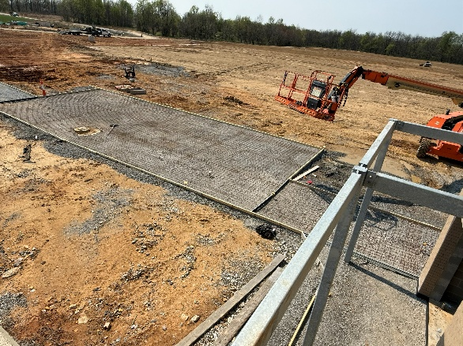
 | Forms for concrete walks at the concessions building were being made ready for concrete pours. | 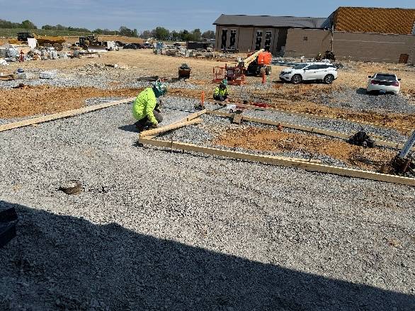
 | The steel stair at the south end of the main corridor was in place.  Soffit framing for wallboard soffits around the stair opening were in place. | 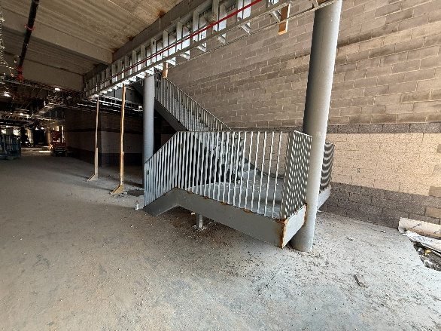
 | The steel framing for soffits around the main stair in the central corridor were in place. The roof deck over the mechanical platform above the second floor was in place. | 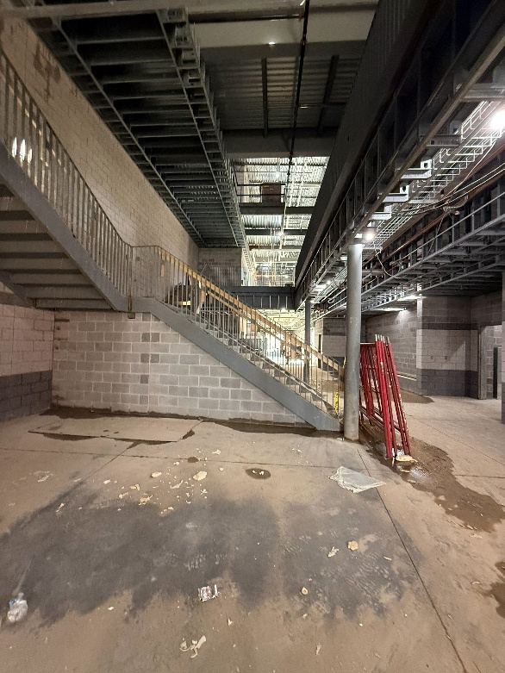
 | The ceiling and ductwork over the gym were painted.  Jeremy has been coordinating the requirements to hang the basketball goal supports. These will be hung before the flooring begins. | 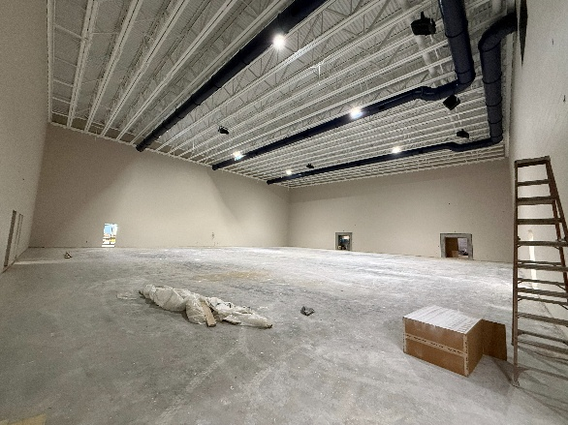
 | The instrument storage lockers in the band room were in place. | 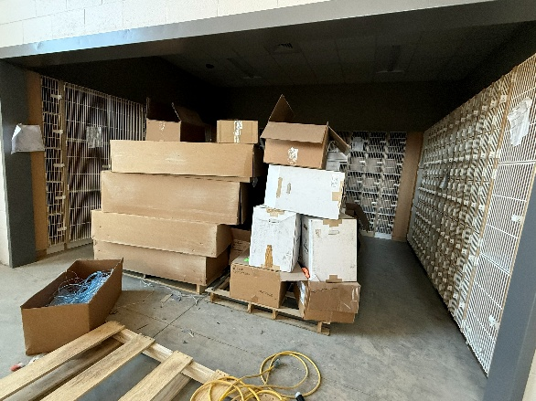
 | Curtainwall windows were installed in the exterior openings for the band room. | 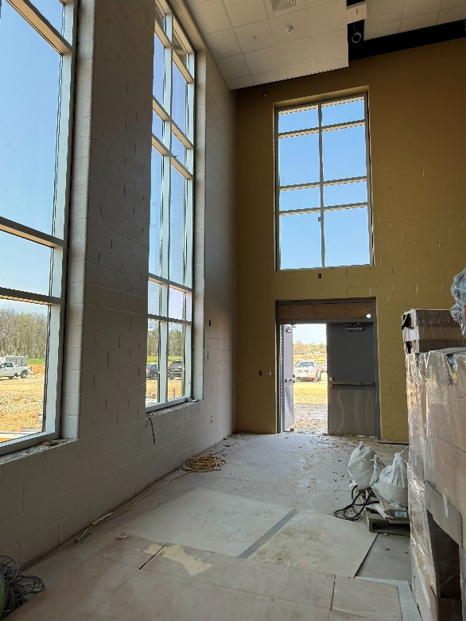
 | Floor polishers were on site grinding the concrete floors in the music suite. | 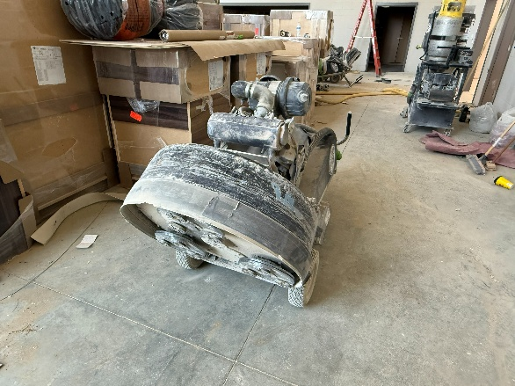
 | Floor grinding and polishing were in progress in the practice rooms. | 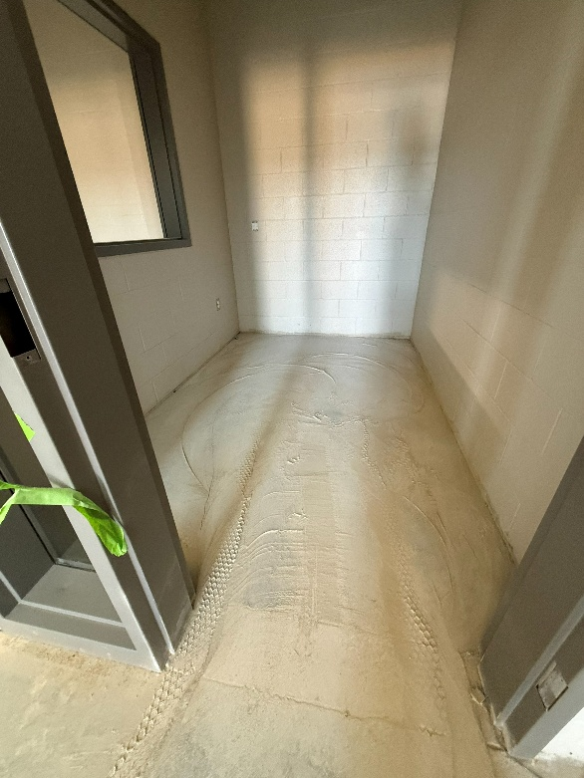
 | Floor grinding and polishing operations were in progress in the vocal music room. | 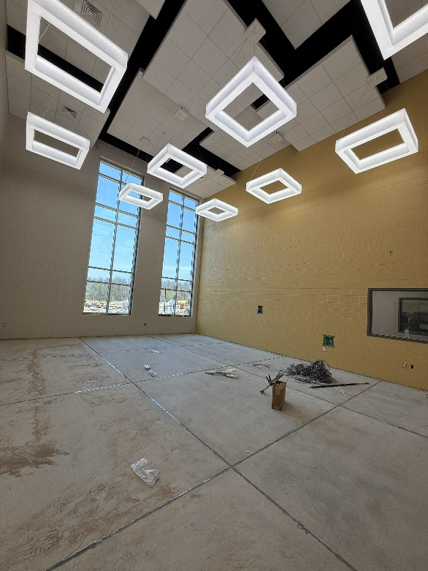
 | CMUs had been added to create the entry portals to the student toilets in Area D. | 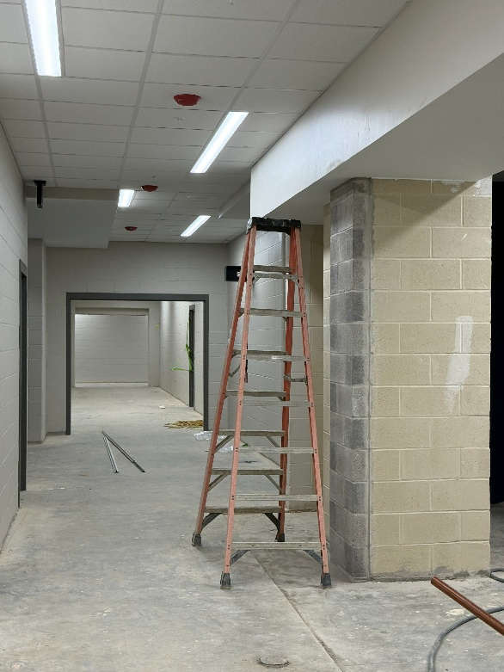
 | Remedial work had been done on the wallboard soffit in the cafeteria to make the fascia more in an even plane. | 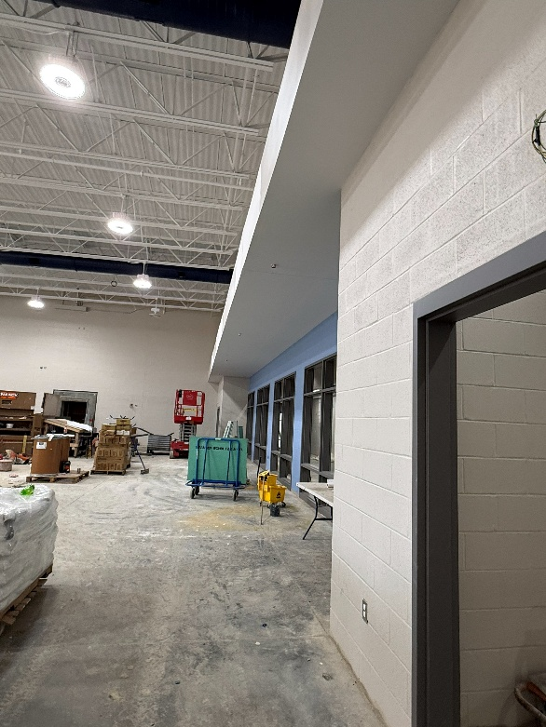
 | Food service equipment was being placed in the kitchen. | 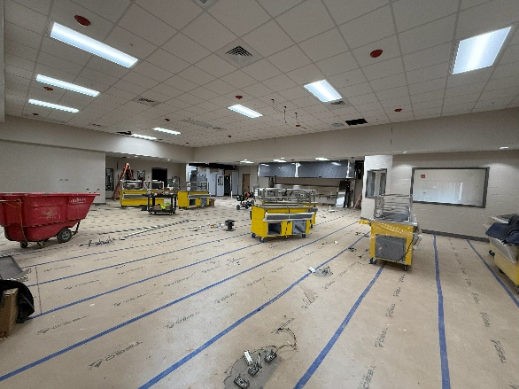
 | With the gym being made ready for the wood flooring installation, materials and tools were moved to the cafeteria. | 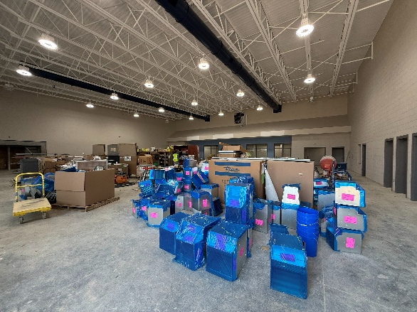

- Stored Material Observed:
    - Concrete accessories.
    - Concrete block, brick and accessories.
    - Storm piping and structures.
    - Sanitary piping and fittings,
    - Mechanical ductwork, units, GRDs, and equipment.
    - Electrical conduits, fixtures, trim and fittings.

- Follow up items:
- Special inspection reports with emphasis on the storm shelter area.
- Keep as-builts up to date.
- Provide punch lists for block defects in Area D.
- Make corrections as indicated in the above ceiling report and alert JRA when the corrections are made.

Follow up by:
Architect, Owner, MEP Engineer, Structural Engineer,
Civil Engineer Construction Manager, Other

Respectfully submitted,
JRA Architects
Joseph Jones, AIA, Construction Contract Administrator
Cc: 202280, CA8, HCS, Wehr, Icon, STW, EDG, JRA

