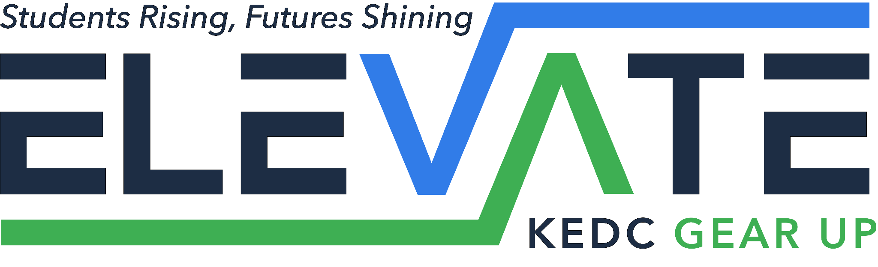

Apr 13, 2026
Dear Parents and Guardians,

The Elevate Gear Up team is excited to provide an upcoming STEM (Science, Technology, Engineering, and Mathematics) field trip opportunity for your child. This experience is designed to enhance classroom learning through hands-on activities and real-world explorations. Field trip details are as follows:

Location: Newton’s Attic- Lexington, KY
Date: Tuesday Jun 2, 2026
Time: Student drop off at BCMS between 7:30-8:00 A.M.
Student pick up at BCMS between 1:00-1:30 P.M.
Cost: Free- (Students may bring money for the gift shop.)
Breakfast/Lunch: A light breakfast will be provided prior to leaving school. Lunch will be provided upon our return to school.

During this trip, students will have the opportunity to engage in interactive activities that support the STEM curriculum. This experience aims to spark curiosity, encourage critical thinking, and make learning fun and meaningful. Students need to wear comfortable clothing and closed toed shoes (NO sandals, flip flops or slides). Students will be expected to follow all school behavior expectations. If you’d like more information on Newton’s Attic you can visit:
www.newtonsattic.com

This trip is limited to the first 50 students that return the attached permission form.
We ask that you please fill out the attached permission form and return it to their homeroom teacher no later than Tuesday Apr 21, 2026.

If you have any questions please feel free to contact one of the Gear Up Success Coaches at:
lisa.combs@bourbon.kyschools.us
terence.brooks@bourbon.kyschools.us
andrea.watkins@bourbon.kyswchools.us

