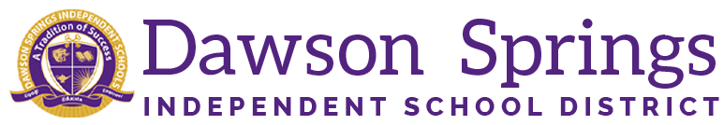

Dawson Springs Elementary School
Where the teachers and students give 100% every day and failure is not an option.
Panthers Prowling to Proficiency!

March 2026 Board Meeting
Elementary Principal Report
Jennifer Ward

- Academic Progress
  - 3rd - 5th graders will participate in the second Mock KSA assessment after spring break.
  - Tier 3 RTI data is still being monitored to ensure we are meeting the needs of all of our students.
    - Small group pull-outs are occurring daily to meet needs in both reading and math.
  - KSA preparation continues
  - Our 5th grade students competed in the Amazing Shake on Monday sponsored by Shannon Garrett and our FRYSC office.
    - This program teaches them how to greet someone, shake hands, eye contact, body language etc. Then they compete by having a 1 minute interview with staff who act as judges to give praise and constructive criticism.
    - The top score earners were: Gwenyth Larimore and Ariana Kontominas
    - Second place winners include: Sawyer Young, Chloe Fisher, and Emmah Day
- PLC Conversations for the Month:
  - KSA preparation continues
    - Extended response questions are being administered weekly in tested grades
    - Spring Mock KSA assessment will be on April 14. The format will mirror the KSA exam for the end of the year along with accommodators and who they will be servicing.
  - Our math teachers were in Professional Development on Tuesday.
    - This training covered the use of our current HQIR Bridges and the resources it has for RTI instruction.
  - CKLA and Bridges PLCs continue with HQIRs fidelity being monitored weekly.
- Upcoming Events:
  - March 27 - Student of the Month Assembly in the big gym
  - March 27 - 3rd and 5th grade Math Team competition at MCC lead by Coach Emma Thorp
  - April 23 will be the first DSES STEM night in conjunction with the PTO meeting. This will be from 5-7 PM in the MPR.
  - Spring iReady Window opens on April 9 and will go through the end of the year
  - KSA testing will begin on Tuesday, May 4 and go through Friday, May 14.

