THIS IS A DECISION PAPER

TO: HARDIN COUNTY BOARD OF EDUCATION

FROM: TERESA MORGAN, SUPERINTENDENT

DATE: MARCH 19, 2026

SUBJECT: APPROVAL OF CHANGE ORDER 17 FOR THE CHILD NUTRITION CONSTRUCTION PROJECT

ISSUE:
Change Order 17 is an increase of $ 4117.50 for an additional concrete chiller pad.

FACTS:

CO 17

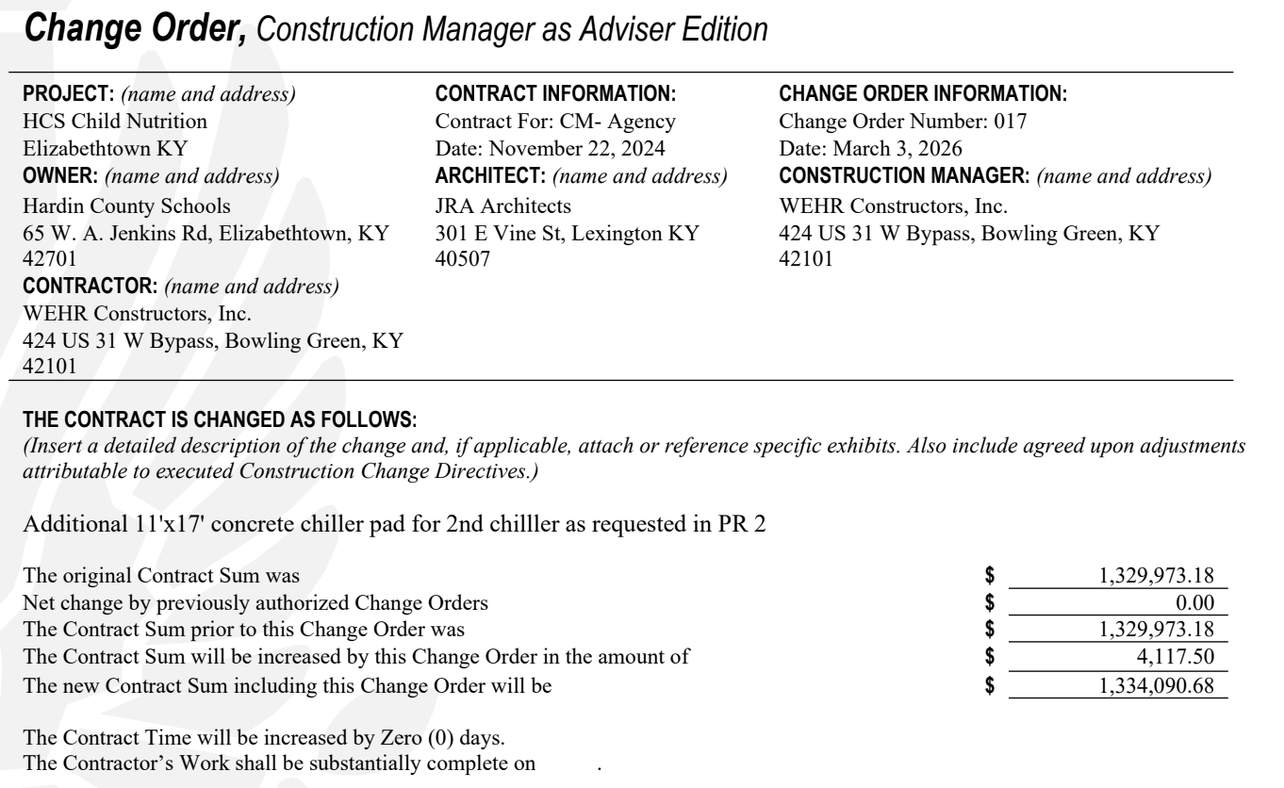

RECOMMENDATION
I RECOMMEND THE BOARD APPROVE CHANGE ORDER 17 FOR THE CHILD NUTRITION CONSTRUCTION PROJECT.

RECOMMENDED MOTION
I MOVE THE HARDIN COUNTY BOARD OF EDUCATION APPROVE CHANGE ORDER 17 FOR THE CHILD NUTRITION CONSTRUCTION PROJECT.

