THIS IS A DECISION PAPER

TO: HARDIN COUNTY BOARD OF EDUCATION

FROM: TERESA MORGAN, SUPERINTENDENT

DATE: March 19, 2026

SUBJECT: APPROVAL OF CHANGE ORDER FOR LAKEWOOD ROOF PROJECT

ISSUE:
Lakewood Elementary School is currently undergoing a roof project. Adding gutters and a downspout system to the school would provide a positive roof drainage system to direct stormwater away from the building perimeter. Adding these gutters during the current roofing project comes at a cost of $352,632.00. The roofing contractor is also requesting additional time to complete the project.

FACTS:
See attached quote from Kalkreuth Roofing and Sheet Metal to add gutters and downspouts to the current roof project.

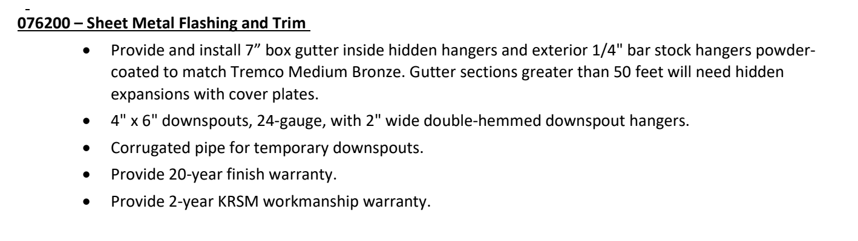

RECOMMENDATION
I RECOMMEND THE BOARD APPROVE THE CHANGE ORDER FOR THE LAKEWOOD ROOF PROJECT TO ADD GUTTERS AND A DOWNSPOUT SYSTEM.

RECOMMENDED MOTION
I MOVE THE HARDIN COUNTY BOARD OF EDUCATION APPROVE THE CHANGE ORDER FOR THE LAKEWOOD ROOF PROJECT TO ADD GUTTERS AND A DOWNSPOUT SYSTEM.

