I. CALL TO ORDER, INVOCATION, PLEDGE OF ALLEGIANCE TO FLAG
Mr. Phillip West, Board Vice Chairman, called the meeting to order at 6:00 PM, offered the invocation, and led the audience in the pledge of allegiance to the flag.

a. Review of District Mission Statement
Mr. West reviewed the district mission and vision statements:
Mission: “At Russellville Independent Schools, we are United in Trust, Guided by Compassion, Committed to Respect, Driven by Opportunity, and have Pride in Who We ‘R’.”
Vision: “Prioritizing all Panthers in an inclusive learning environment that is overflowing with pride and possibilities.”

II. AGENDA APPROVED
Order #091 – Motion Passed: Approval of board agenda passed with a motion by Mrs. April Triplett, second by Ms. Shawnri Gamble.

Mr. James Milam Absent
Mr. Phillip West Yes
Mrs. Lovis Patterson Yes
Mrs. April Triplett Yes
Ms. Shawnri Gamble Yes

III. PUBLIC COMMENT

IV. PRESENTATIONS
- Recognition of Russellville Middle School and Russellville High School Wrestling Teams
Mr. Conrad Reding and Mr. Drew Teel recognized athletes from their respective team for their historic achievements as Russellville School District first wrestlers.
- Honorary Golden Panther Award
To celebrate Mrs. Robin Cornelius’ retirement on February 28, 2026, she was recognized for her years of service and commitment to the students of Russellville.

VI. CONSENT AGENDA ITEMS APPROVED
Order #092 – Motion Passed: Approval of the Consent Agenda Items passed with a motion by Mrs. Lovis Patterson and a second by Mrs. April Triplett.

Mr. James Milam Absent
Mr. Phillip West Yes
Mrs. Lovis Patterson Yes
Mrs. April Triplett Yes
Ms. Shawnri Gamble Yes

- Minutes: January 20, 2025, Regular Called Meeting
- Payment of Claims & Contract Salaries and Financial Reports
- Report of Personnel Actions Taken by the Superintendent
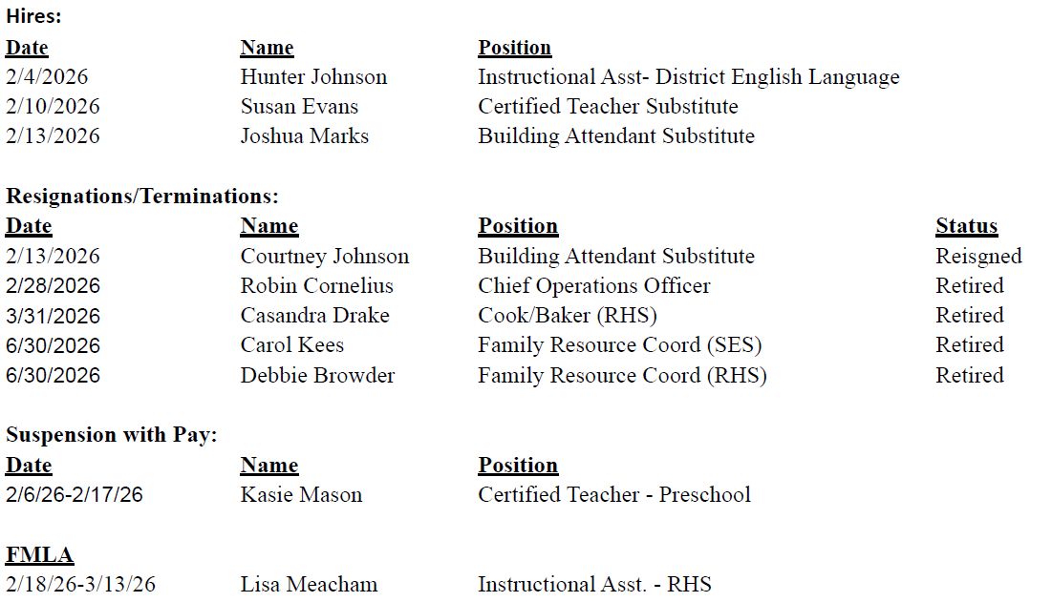

- Fundraiser/Overnight Travel
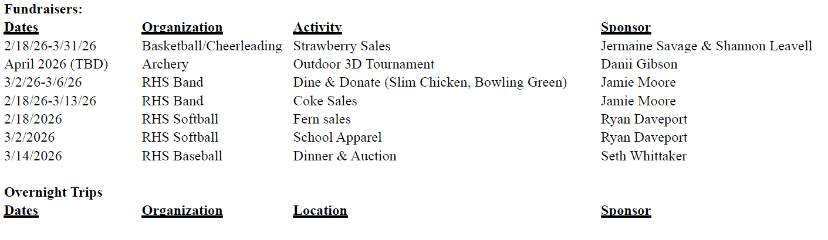
- Updated District Organizational Chart
- Shortened School Day for Student 002
VI. UPDATE/INFORMATION ON DISTRICT PROGRAMS/ACTIVITIES
- Amended 2025-2026 School Calendar
Order #093 - Motion Passed: Approval of the amended 2025-2026 school calendar passed with a motion by Mrs. April Triplett and a second by Ms. Shawnri Gamble. The amended calendar has been made part of the minutes.

Mr. James Milam Absent
Mr. Phillip West Yes
Mrs. Lovis Patterson Yes
Mrs. April Triplett Yes
Ms. Shawnri Gamble Yes

- Revised BG-1 for the Russellville High School HVAC Project (BG25-108)
Order #94 - Motion Passed: Approval of revised BG-1 for RHS HVAC project (BG25-108) passed with a motion by Mrs. Lovis Patterson and a second by Mrs. April Triplett.

Mr. James Milam Absent
Mr. Phillip West Yes
Mrs. Lovis Patterson Yes
Mrs. April Triplett Yes
Ms. Shawnri Gamble Yes

- BG-4 for Russellville High School HVAC Project (BG25-108)
Order #95 - Motion Passed: Approval of BG-4 for RHS HVAC project (BG25-108) passed with a motion by Mrs. April Triplett and a second by Mrs. Lovis Patterson.

Mr. James Milam Absent
Mr. Phillip West Yes
Mrs. Lovis Patterson Yes
Mrs. April Triplett Yes
Ms. Shawnri Gamble Yes

- BG-5 for Russellville High School Culinary Project (BG25-203)
Order #96 - Motion Passed: Approval of BG-5 for RHS culinary project passed with a motion by Mrs. April Triplett and a second by Ms. Shawnri Gamble.

Mr. James Milam Absent
Mr. Phillip West Yes
Mrs. Lovis Patterson Yes
Mrs. April Triplett Yes
Ms. Shawnri Gamble Yes

- BG-5 Stevenson Roof Project (BG25-074)
Order #97 - Motion Passed: Approval of the BG-5 for the Stevenson roof project (BG25-074) passed with a motion by Mrs. Lovis Patterson and a second by Mrs. April Triplett.

Mr. James Milam Absent
Mr. Phillip West Yes
Mrs. Lovis Patterson Yes
Mrs. April Triplett Yes
Ms. Shawnri Gamble Yes

VII. NEW BUSINESS

- FY2025 Audit Report
Order # 098 – Motion Passed Approval of the 2024-2025 audit passed with a motion by Mrs. Lovis Patterson and a second by Mrs. April Triplett.

Mr. James Milam Absent
Mr. Phillip West Yes
Mrs. Lovis Patterson Yes
Mrs. April Triplett Yes
Ms. Shawnri Gamble Yes

- Author Contracts for Author Fest 2026
Order #099 - Motion Passed: Approval of author contracts passed with a motion by Mrs. Lovis Patterson and a second by Ms. Shawnri Gamble.

Mr. James Milam Absent
Mr. Phillip West Yes
Mrs. Lovis Patterson Yes
Mrs. April Triplett Yes
Ms. Shawnri Gamble Yes

- Updated Section 504 District Procedures
Order #100 - Motion Passed: Approval of revised 504 procedures passed with a motion by Mrs. April Triplett and a second by Mrs. Lovis Patterson.

Mr. James Milam Absent
Mr. Phillip West Yes
Mrs. Lovis Patterson Yes
Mrs. April Triplett Yes
Ms. Shawnri Gamble Yes

- FY2027 Student Accident Insurance Renewal Packet
Order #101 - Motion Passed: Approval to renew FY2027 student accident insurance renewal and keep the current coverage (plan 3) passed with a motion by Mrs. April Triplett and a second by Ms. Shawnri Gamble.

Mr. James Milam Absent
Mr. Phillip West Yes
Mrs. Lovis Patterson Yes
Mrs. April Triplett Yes
Ms. Shawnri Gamble Yes

- School Facilities Construction Commission (SFCC) Offer of Assistance
Order #102 – Motion Passed: Approval of the SFCC offer of assistance passed with a motion by Mrs. Lovis Patterson and a second by Mrs. April Triplett.

Mr. James Milam Absent
Mr. Phillip West Yes
Mrs. Lovis Patterson Yes
Mrs. April Triplett Yes
Ms. Shawnri Gamble Yes

VIII. ADMINISTRATIVE REPORTS
  - Strategic Plan Update – Pillar “I”
  - CDIP Public Posting
  - Attendance Report

IX. SUPERINTENDENT’S REPORT

X ADJOURNMENT
Order #103 - Motion Passed: passed with a motion by Mr. Phillip West and a second by Mrs. April Triplett.

Mr. James Milam Absent
Mr. Phillip West Yes
Mrs. Lovis Patterson Yes
Mrs. April Triplett Yes
Ms. Shawnri Gamble Yes

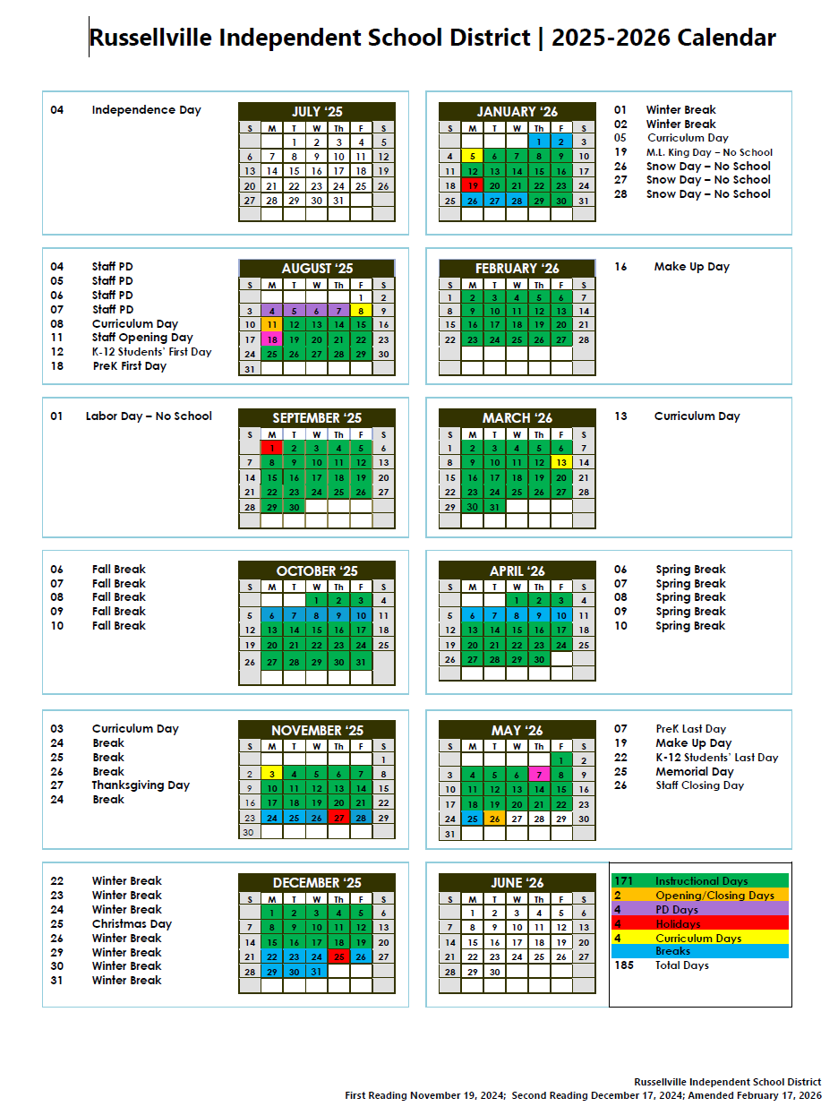
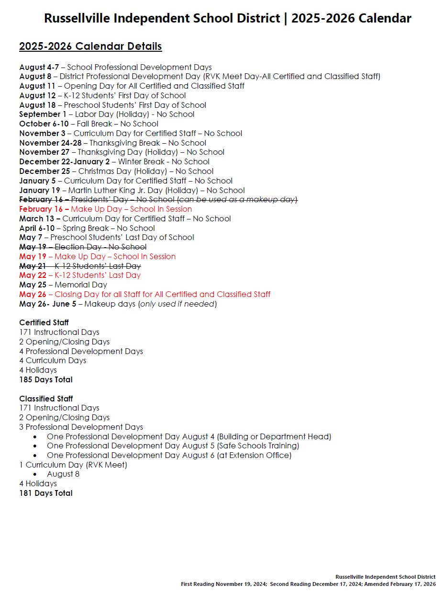

Chairman __________________________ Secretary_____________________

