THIS IS A DECISION PAPER

TO: HARDIN COUNTY BOARD OF EDUCATION

FROM: TERESA MORGAN, SUPERINTENDENT

DATE: FEBRUARY 19, 2026

SUBJECT: APPROVAL OF CHANGE ORDERS 14, 15, and 16 FOR WEST HARDIN MIDDLE SCHOOL PROJECT

ISSUE:
Change Order 14 is an increase of $3,968.45 for mechanical platform revisions. Change Order 15 is an increase of $35,177.36 to run power to the road front signage. Change Order 16 is an increase of $12,779.72 for additional steel work.

FACTS:

CO 14

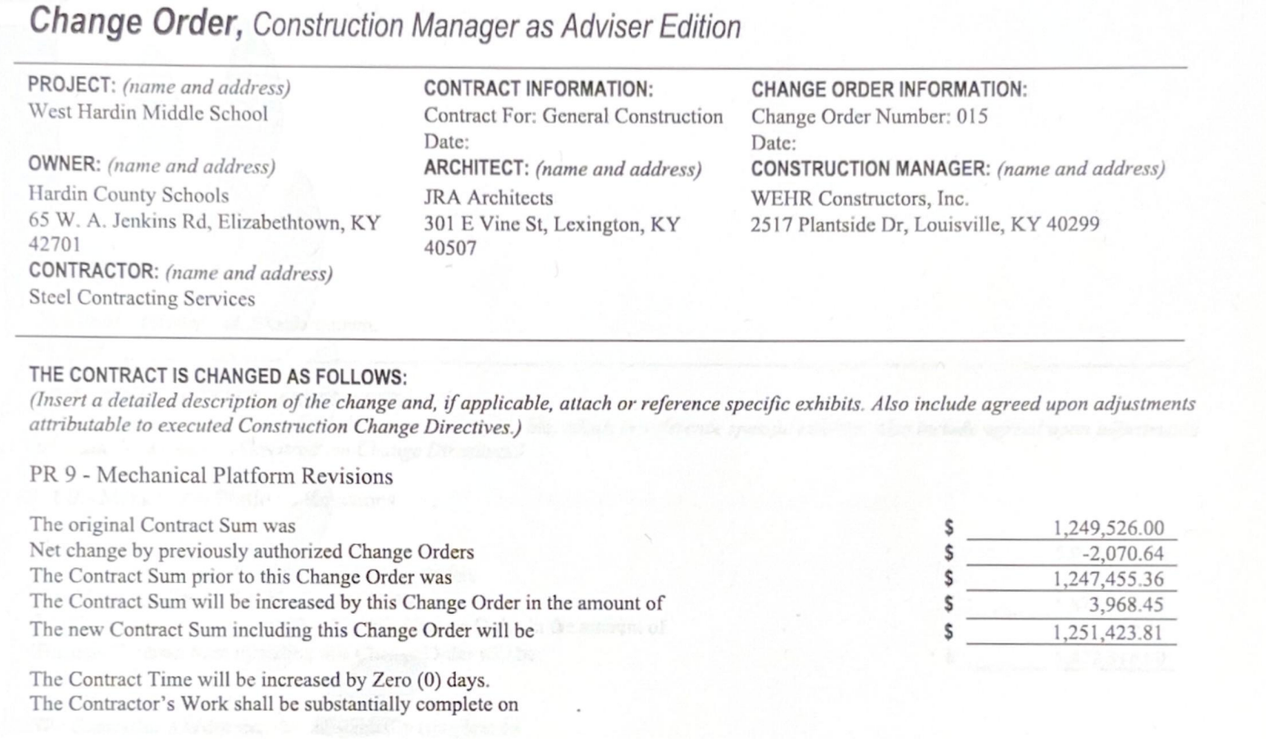
CO 15

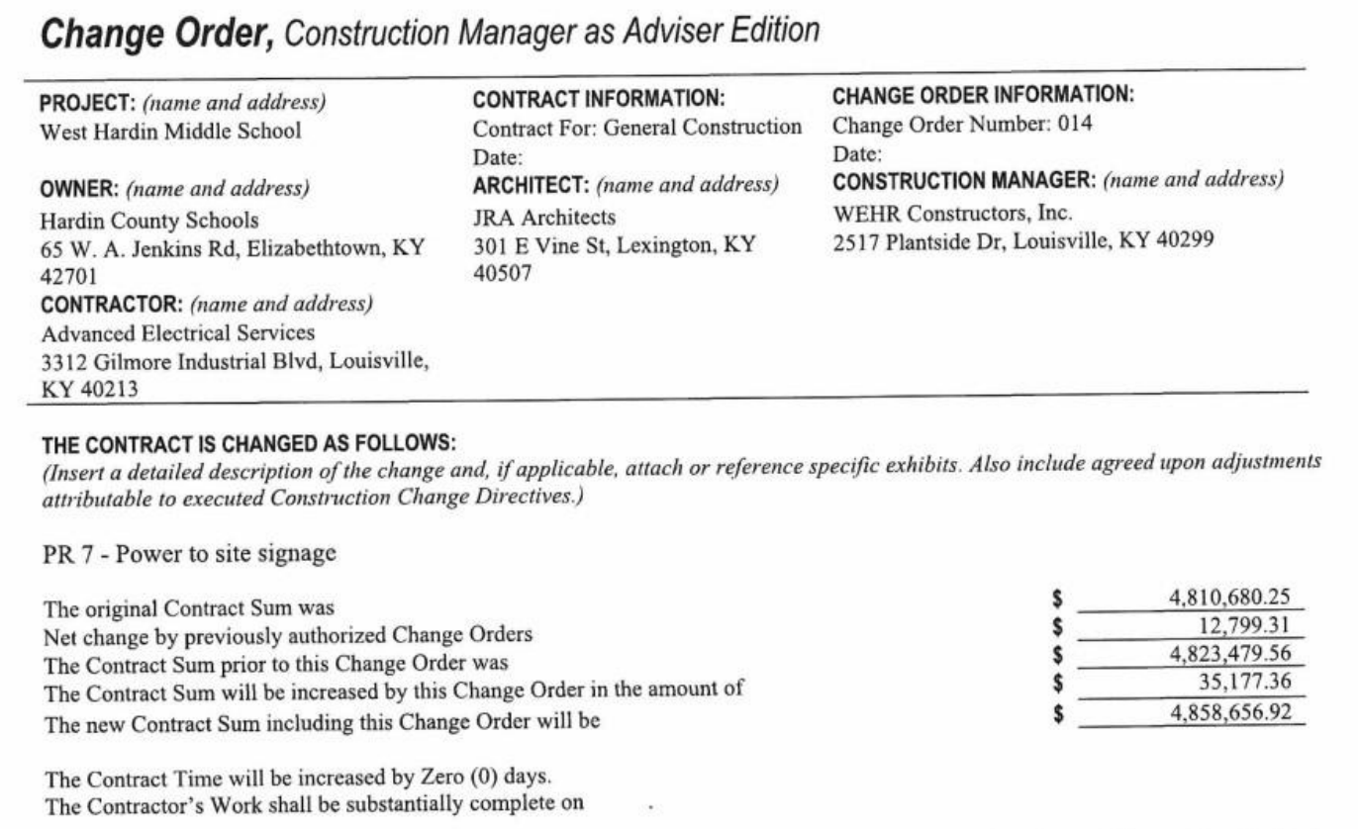

CO 16

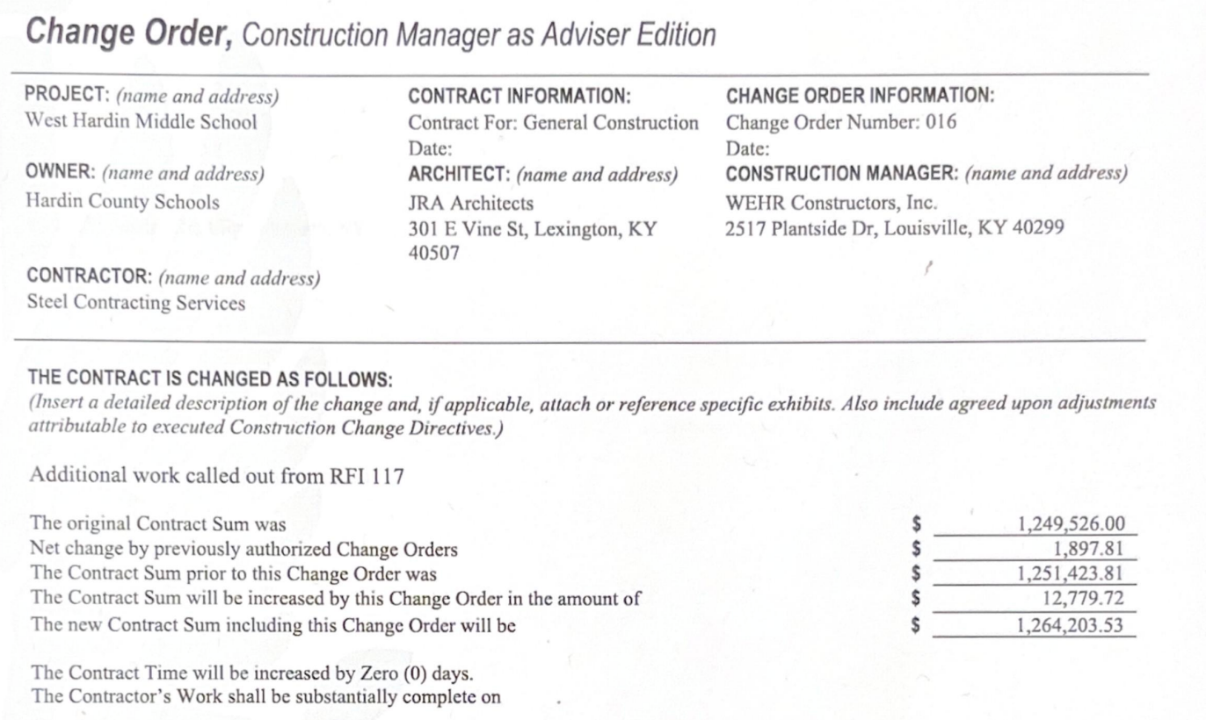

RECOMMENDATION
I RECOMMEND THE BOARD APPROVE CHANGE ORDERS 14, 15 AND 16 FOR THE WEST HARDIN MIDDLE SCHOOL PROJECT.

RECOMMENDED MOTION
I MOVE THE HARDIN COUNTY BOARD OF EDUCATION APPROVE CHANGE ORDERS 14, 15 AND 16 FOR THE WEST HARDIN MIDDLE SCHOOL PROJECT.

