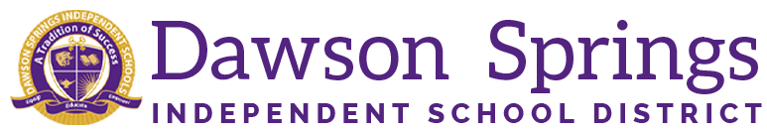

Dawson Springs Elementary School
Where the teachers and students give 100% every day and failure is not an option.
Panthers Prowling to Proficiency!

January 2026 Board Meeting
Elementary Principal Report
Jennifer Ward

- Academic Progress
  - Academic Progress
    - Winter iReady Diagnostics are complete.
    - Reading results for winter show Kindergarten, 3rd, and 4th grade with the most students at or above grade level
    - Math results for winter show Kindergarten, 1st, and 4th grade with the most students at or above grade level
    - Results have already been analyzed and instructional delivery has been adjusted/modified to enhance student learning and achievement in all grade levels.
  - Teachers in grades 3, 4 and 5 have used the mock KSA results to coach students in areas where growth is needed. These results will continue to be used to enhance assessment development for the remainder of the year to ensure alignment to the state test at the end of the year and ensure students are ready for the final exam.
    - Students are exposed to these types of questions on a weekly basis through Pear Assessment (online testing format) in their classrooms to ensure high quality, rigorous assessments on a regular basis in all subject areas.
  - GREAT NEWS: Through our partnership with the Kentucky Department of Early Literacy (DEL) Bright Spots, Dawson Springs Elementary School has been selected to help showcase the instructional work happening through PLCs coaching, and leadership support. We will show our examples of practice and strong examples of instructional practice here at DSES. Our hard work and dedication to the education of our students is something that we are very proud of and are being recognized for along with the help of Amanda Melton, State Literacy Coaching Specialist, who has been with us during the 24/25 and current school year. I can not stress enough how proud I am of the hard work and dedication the teachers and staff put forth every single day here at DSES.
- PLC Conversations for the Month:
  - All reading intervention plans, based on our winter iReady diagnostic data have been entered and that information has been shared out with parents.
    - Our RTI groups have been adjusted based on these results as well.
    - Several students have moved up out of Tier 3 RTI and we have had a few move into Tier 3 RTI.
    - Adjustments have also been made to our math instruction to better meet the needs of our students in this area as well. Groupings have been shifted as well as the instructional delivery during math RTI time.
  - Thank you to everyone who participated in our Capturing Kids Hearts Family Survey.
    - Mrs. Dyer’s class and Mrs. Walker’s class had the highest number of participation and they will receive a pizza party!
    - The results of the survey showed us that we are using the CKHs internally very well, but we need to communicate more with families about what these items are. For example, we need to share out more what exactly our Classroom Contracts are and what exactly they mean.
- Upcoming Events:
  - Friday, January 23, 2026 - Script Spelling Bee at 1 PM
  - Friday, January 30, 2026 - January Student of the Month Assembly, Club Day, and KSA Awards for current 4th, 5th, and 6th grade students
    - Invitations will be sent to families whose students will be receiving an award

