THIS IS A DECISION PAPER

TO: HARDIN COUNTY BOARD OF EDUCATION

FROM: TERESA MORGAN, SUPERINTENDENT

DATE: JANUARY 15, 2026

SUBJECT: APPROVAL OF CHANGE ORDERS 15-4, 2-8, 2-10, AND 2-11 FOR CHHS PHASE 2 PROJECT

ISSUE:
Change Order 15-4 is an increase of $6,415.67 for installation of breakers at welding booths. Change Order 2-8 is an increase of $157,850.00 for elevator upgrades in Area H. Change Order 2-10 is an increase of $7,363.66 for transformer screen wall and foundation. Change Order 2-11 is an increase of $1,186.24 for sanitary napkin disposal boxes.

FACTS:

CO 15-4
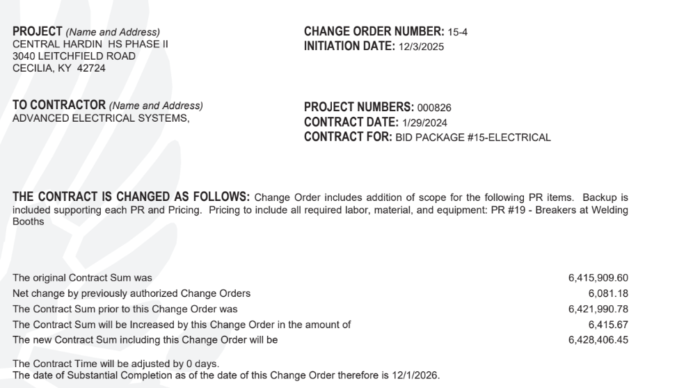

CO 2-8
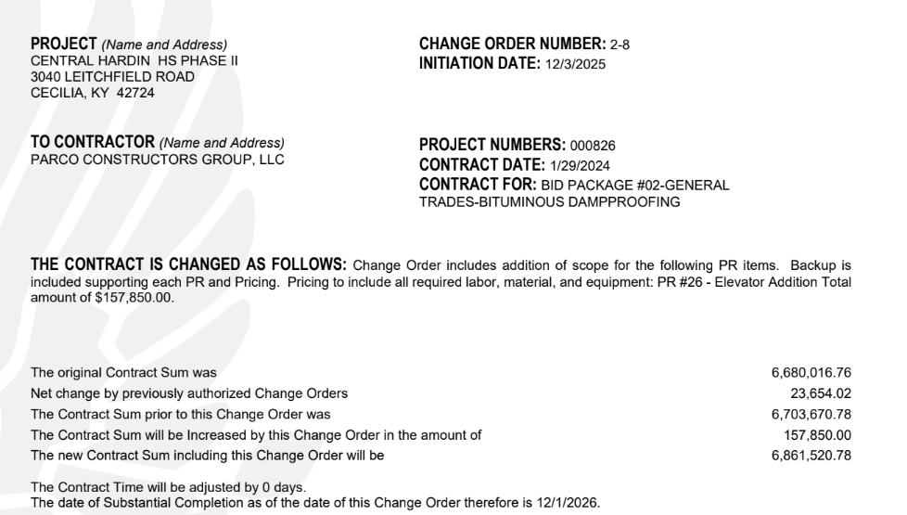
CO 2-10
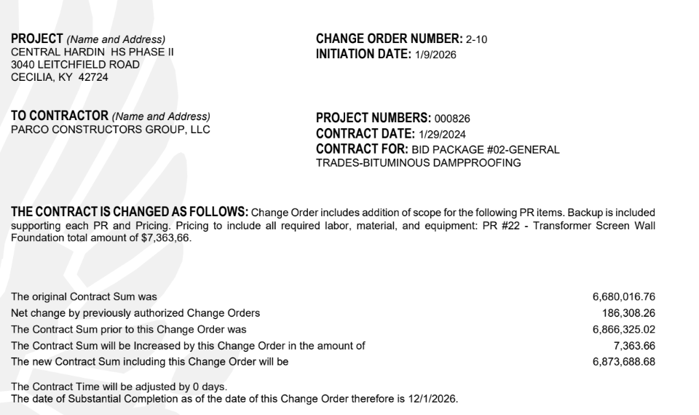

CO 2-11

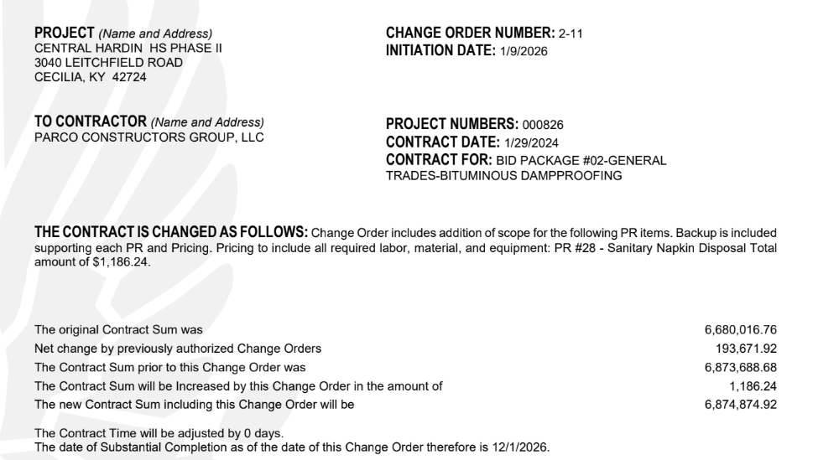

RECOMMENDATION
I RECOMMEND THE BOARD APPROVE CHANGE ORDERS 15-4, 2-8, 2-10, AND 2-11 FOR THE CHHS PHASE 2 PROJECT.

RECOMMENDED MOTION
I MOVE THE HARDIN COUNTY BOARD OF EDUCATION APPROVE CHANGE ORDERS 15-4, 2-8, 2-10, AND 2-11 FOR THE CHHS PHASE 2 PROJECT.

