THIS IS A DECISION PAPER

TO: HARDIN COUNTY BOARD OF EDUCATION

FROM: TERESA MORGAN, SUPERINTENDENT

DATE: JANUARY 15, 2026

SUBJECT: APPROVAL OF CHANGE ORDER 12 FOR THE CHILD NUTRITION CONSTRUCTION PROJECT

ISSUE:
Change Order 12 is an increase of $ 2,762.00 for the installation of required GFI panels and ground fault sensor.

FACTS:

CO 12

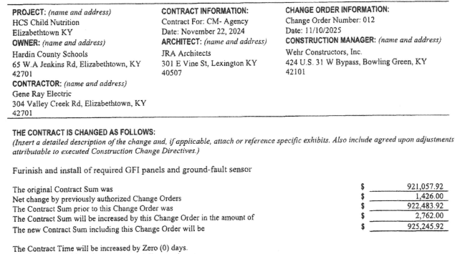

RECOMMENDATION
I RECOMMEND THE BOARD APPROVE CHANGE ORDER 12 FOR THE CHILD NUTRITION CONSTRUCTION PROJECT.

RECOMMENDED MOTION
I MOVE THE HARDIN COUNTY BOARD OF EDUCATION APPROVE CHANGE ORDER 12 FOR THE CHILD NUTRITION CONSTRUCTION PROJECT.

