Memorandum of Understanding between
Webster County Schools
and
The Kentucky Department of Education, Office of Career and Technical Education

- Purpose
This Memorandum of Understanding establishes an agreement between the Kentucky Department of Education (KDE) and Webster County Schools regarding access to student educational records of students attending the Webster County Area Technology Center by Webster County Schools technology staff in accordance with the Family Educational Rights and Privacy Act of 1974 (FERPA).
- Agreement
For purposes of this agreement, pursuant to the Family Educational Rights and Privacy Act of 1974 (FERPA) (20 USC 1232g; 34 CFR Part 99), KDE hereby designates the Webster County Schools technology staff as school officials with a legitimate interest in the educational records of students who attend the Webster County ATC, regardless of their home district, to the extent that access to such records is required for the district technology staff to carry out the necessary functions of the district’s technology program.
The District agrees to:
  - Access and use student educational records solely for the purposes outlined above.
  - Maintain the conﬁdentiality of all education records in accordance with FERPA and applicable state and federal laws.
  - Ensure that all district technology staff with access to student records are trained in
FERPA compliance and data privacy protocols.
  - Prevent unauthorized disclosure or use of student information.

- Duration and Termination
This agreement shall remain in effect from date of execution by all parties to end of fiscal year 2028, unless terminated earlier by either party with written notice. Amendments may be made upon mutual agreement in writing.

By affixing signatures below, the parties to this MOU agree that electronic approvals may serve as electronic signatures. In addition, the parties verify that they are authorized to bind the parties to this MOU and that they voluntarily accept the terms of this MOU.

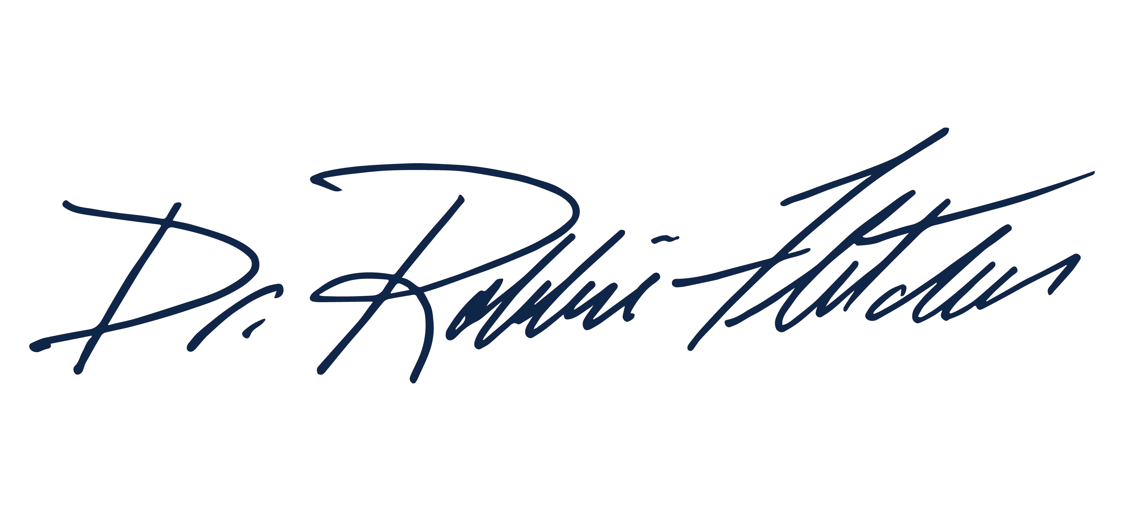
Commissioner of Education
Kentucky Department of Education:
Signature
Title

Dr. Robbie Fletcher 11/21/2025
Printed Name Date

Webster County Schools

Signature Title

Printed Name Date

