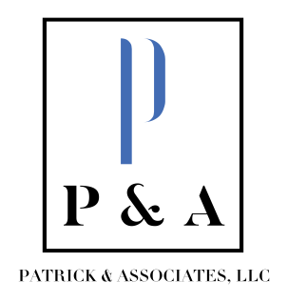
Tammy Patrick, CPA Beth Francis
tammy@patrickassoc.com beth@patrickassoc.com
(859) 808-1329 (859) 333-2360

January 7, 2026

Superintendent Stull and Members of the Board of Education of the Garrard County School District:
We have completed the independent audit of the Garrard County School District for the fiscal year that ended June 30, 2025 and have issued an unmodified opinion, which is a clean opinion (please see the audit report page 1). Our audit work found no evidence of fraud of misappropriation of funds in examining the school district’s finances. We also found no issues related to compliance or internal control related to the District’s major federal programs or school activity funds.
We greatly appreciate the courtesy extended to our staff during the audit. Mrs. Coffey and her staff were cooperative and professional during the audit and did an excellent job of providing information as it was requested throughout the audit.
Financial Highlights:
The District’s governmental fund balances decreased by $12,521,376 (please see the audit report page 14), resulting in ending fund balances of $7,409,890. This large decrease is due to construction expenditures funded for the construction of Garrard County High School athletic projects which was funded by bonds issued by the district in a prior year.
The District’s business type activities (school food services and community education services) fund balances increased by $119,917 resulting in ending fund balances of $1,281,038 (please see the audit report page 20).
The District’s ending net position also increased by $5,577,075 (please see the audit report page 11).
Overall revenues for the FYE in comparison to the prior FYE increased by $4,106,260 and expenditures decreased by $928,119 (please see audit report page 8)
Again, we want to thank and commend Mrs. Coffey and her staff for the excellent work they have done.
Please feel free to contact us if you have any questions.
Sincerely,
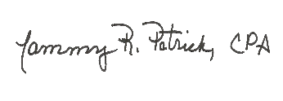
Tammy R. Patrick, CPA
Patrick & Associates, LLC

