THIS IS A DECISION PAPER
TO: HARDIN COUNTY BOARD OF EDUCATION
FROM: TERESA MORGAN, SUPERINTENDENT
DATE: DECEMBER 18, 2025
SUBJECT: JHHS BASEBALL FIELD REPAIRS
ISSUE: The JHHS Baseball field is holding water and student athletes are unable to use the field for practice or games.
FACTS:
Carlisle’s Rock and Dirt reviewed the site and made a recommendation for bringing the field to grade using baseball field mix dirt.

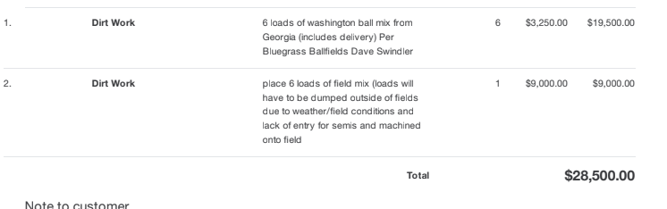

FUNDING SOURCE: General Fund

RECOMMENDATION
I RECOMMEND THE HARDIN COUNTY BOARD OF EDUCATION ACCEPT THE PROPOSAL FROM CARLISLE’S ROCK AND DIRT IN THE AMOUNT OF $28,500 TO REPAIR THE BASEBALL FIELD AT JOHN HARDIN HIGH SCHOOL.
RECOMMENDED MOTION
I MOVE THE HARDIN COUNTY BOARD OF EDUCATION ACCEPT THE PROPOSAL FROM CARLISLE’S ROCK AND DIRT IN THE AMOUNT OF $28,500 TO REPAIR THE BASEBALL FIELD AT JOHN HARDIN HIGH SCHOOL.

