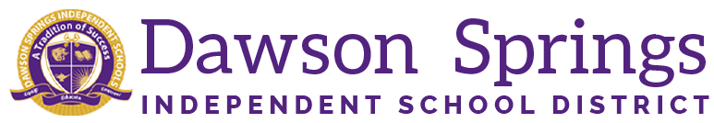

Dawson Springs Elementary School
Where the teachers and students give 100% every day and failure is not an option.
Panthers Prowling to Proficiency!

December 2025 Board Meeting
Elementary Principal Report
Jennifer Ward

- Academic Progress
  - Academic Progress
    - Winter iReady Diagnostics have gotten up and going this week.
    - So far teachers are seeing growth in reading overall.
    - Results will be shared at the next board meeting.
  - Students started participating in the first Mock KSA Exam for the year this week
    - These results will be used to adjust instructional delivery and check rigor in the classrooms
  - Teachers are using the KSA individualized student results to target individualized students and adjust instruction for those “bubble” students and make sure we are reaching everyone in the lessons and delivering instruction so that all students are successful and reaching the highest potential.
- PLC Conversations for the Month:
  - RTI continues to be monitored.
  - Capturing Kids Hearts is continuing to be implemented in all classrooms.
  - We have sent out the Parent Survey. We appreciate everyone who has completed that for us so far. If you haven’t done that yet, there is a link on your parent square, just hop on there and do that for us. It doesn’t take but just a few minutes.
    - The class with the most surveys completed will win a prize this week!!
- Upcoming Events:
  - December 19 will be our student of the month morning assembly for December in the big gym starting at 8 AM.
  - Christmas break begins Monday, December 22, 2025

